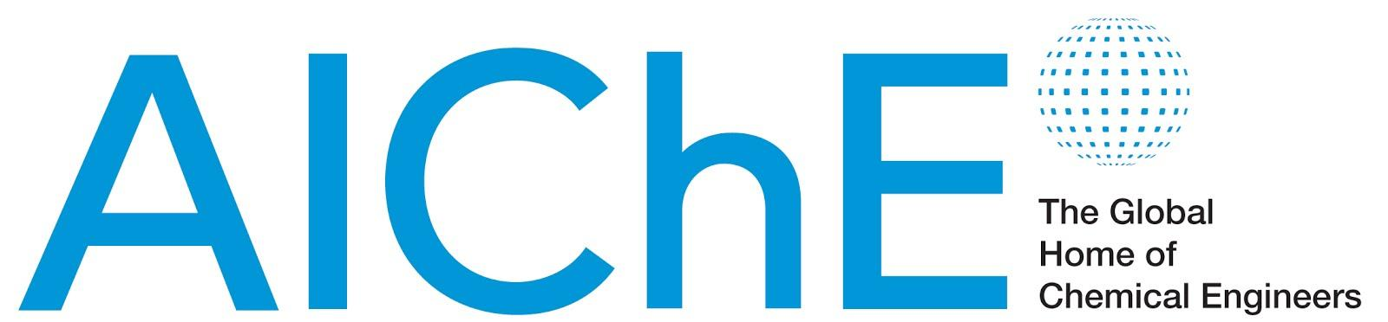

August 28, 2014

FOR IMMEDIATE RELEASE Contact: Jeanette Krebs
Phone: 717-214-2200
Email: krebs@thebravogroup.com

AIChE Focuses on Women Engineers’ Retention and
Re-entry in the Workforce
Special session will be held on Nov. 17 at 2014 Annual Meeting in Atlanta, Georgia

NEW YORK – To ensure that every chemical engineer achieves his or her career potential, the American Institute of Chemical Engineers (AIChE) is addressing the issues of women’s career navigation, work/life integration, and professional development with a new initiative, Women’s Workplace Retention and Re-entry. Dubbed W2R2, the effort will debut with a special session on November 17 during AIChE’s 2014 Annual Meeting in Atlanta, Georgia.

According to a 2012 report entitled “Stemming the Tide: Why Women Leave Engineering” — published by Dr. Nadya Fouad, a researcher at the University of Wisconsin-Milwaukee’s Center for the Study of the Workplace — women comprise more than 20 percent of engineering school graduates. Yet, only 11 percent of practicing engineers are women — despite decades of academic, governmental, and employer efforts to close the gender gap.

Women leave engineering for myriad reasons, including dissatisfaction with workplace culture as it applies to women engineers, inflexible work schedules for women who must also handle familial responsibilities, and the persistent pay disparity between women engineers and their similarly qualified male counterparts.

Organized by AIChE’s Societal Impact Operating Council, W2R2 is designed to help women engineers take control of their work lives. The session will kick off with a luncheon featuring a keynote talk by Dr. Fouad, an expert on employment issues, particularly in understanding the work choices of women and under-represented minorities in the engineering workplace.

Following the keynote speech, Dr. Fouad will join a panel discussion including representatives from several women’s and professional organizations, each of whom will discuss how her employer is addressing women’s recruitment, retention, and re-entry. Roundtable discussions will give participants a chance to discuss their own workplace experiences and employment strategies, with topics ranging from career change to flexible work schedules to arranging temporary periods away from the workplace.

The feedback received during the session will lay the foundation for a plan to help AIChE and employers better support women engineers on issues related to workplace retention and re-entry.

W2R2’s organizers assert that the competitiveness of today’s employers depends upon their ability to accommodate the changing needs of the workforce. “Women must work together with their employers to create the kind of workforce infrastructure that will allow them to make much-needed contributions to a global society facing significant challenges,” says Zenaida Otero Gephardt, Chair of AIChE’s Societal Impact Operating Council.

Gephardt says that the W2R2 initiative is a crucial step in the right direction for women chemical engineers and society, adding, “We simply cannot afford to exclude the contributions women engineers can and want to make.”

To find out more about W2R2 or to contribute to discussions about women in engineering, contact either of the W2R2 session co-chairs, Selma Mededovic (smededov@clarkson.edu) or Zenaida Otero Gephardt (gephardtzo@rowan.edu).

# # #
About AIChE:
AIChE is a professional society of nearly 45,000 chemical engineers in 100 countries. Its members work in corporations, universities and government using their knowledge of chemical processes to develop safe and useful products for the benefit of society.
Through its varied programs, AIChE continues to be a focal point for information exchange on the frontier of chemical engineering research in such areas as energy, sustainability, biological and environmental engineering, nanotechnology, and chemical plant safety and security. www.aiche.org.

