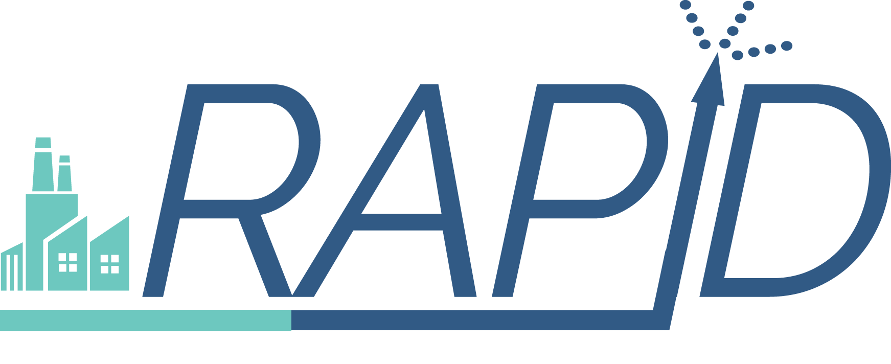


FOR IMMEDIATE RELEASE Contact: Steve Kratz
December 9, 2016 Phone: 1-717-214-2200
Email: kratz@thebravogroup.com

U.S. DEPARTMENT OF ENERGY TAPS AIChE TO LEAD
RAPID MODULAR PROCESS INTENSIFICATION INSTITUTE

National public-private consortium brings companies, universities, government laboratories and agencies together to take on manufacturing challenge.

NEW YORK, NY & WASHINGTON, DC — The U.S. Department of Energy (DOE) has announced that the Rapid Advancement in Process Intensification Deployment (RAPID) Manufacturing Institute of the American Institute of Chemical Engineers (AIChE) will be the newest, and tenth, member of the nation’s network of Manufacturing USA Institutes. Earlier this year, DOE called for the establishment of a Manufacturing Innovation Institute on Modular Chemical Process Intensification for Clean Energy Manufacturing. AIChE developed the RAPID Institute proposal in collaboration with the Savannah River National Laboratory and the Georgia Institute of Technology. To date, RAPID has enlisted 75 companies, 34 academic institutions, 7 national laboratories, 2 other government laboratories, and 7 non-governmental organizations from all regions of the country. These partners have committed to cost shares that leverage DOE’s $70 million contribution over 5 years, with total project spending exceeding $140 million. RAPID’s partners come from energy-intensive industries and range from small to large enterprises.

In making the announcement at the U.S Council on Competitiveness 2016 National Competitiveness Forum, DOE Acting Assistant Secretary of the Office of Energy Efficiency and Renewable Energy David Friedman said, “Our investment in this cross-cutting technology is an investment in the future of manufacturing in the U.S.” “As we expand the Manufacturing USA network, we provide greater opportunities for businesses of all sizes to solve their toughest technology challenges and unleash major savings in energy-intensive sectors like oil and gas, pulp and paper-making and other industries,” he added.

RAPID Chief Executive Officer Karen Fletcher said “the RAPID team is thrilled and energized by DOE’s decision.” “We are confident we can meet DOE’s goals of reduced energy usage and feedstock waste, and improved productivity, through our focus on integrating unit processes into single modular hardware elements that are cost effective, with high efficiency and scalability,” she explained. Fletcher, who, came to RAPID from a distinguished career at DuPont, was most recently, chief engineer and vice president of engineering, facilities and real estate.

- More –
2

Fletcher urged any interested organization to consider joining the effort. “We are an inclusive initiative, and welcome those, like us, who see RAPID as a distinctive way to serve our manufacturing base, the chemical engineering community, and the broader society by increasing efficiency and decreasing environmental impacts,” she added.

AIChE Executive Director June Wispelwey said that RAPID’s ability to address the process intensification challenge “builds on AIChE’s decades of experience managing technical centers,” such as the Center for Chemical Process Safety. She explained that “our RAPID partners, especially our national laboratory partners like Savannah River, each bring unique areas of expertise in process intensification,” ranging from separations, catalysis and transport processes, to kinetics and reaction engineering, to bear on this important manufacturing challenge.

Wispelwey emphasized that RAPID will work closely with the other Manufacturing USA Institutes, which have common goals but distinct concentrations, to assure cooperation and share approaches to commercializing “step-change” innovations. To that end, she said AIChE will use its substantial educational resources to train students and the workforce in the application of the new modular process intensification tools. She also stressed that, before undertaking this challenge, she made sure that there are solid plans for RAPID to become financially self-sustaining within the five years of DOE’s support.

Reacting to the announcement, T. Bond Calloway, AIChE’s President-elect and the Associate Laboratory Director for Clean Energy at Savannah River National Laboratory, said “I am very proud to be part of the RAPID effort, in which chemical engineers are making such an important contribution to advancing American manufacturing.” AIChE President Greg Stephanopoulos, the W.H. Dow Professor of Chemical Engineering at MIT, echoed Calloway’s sentiment, adding that “RAPID is clearly aligned with AIChE’s mission to advance chemical engineering not just in theory, but in practice.” He said that AIChE’s “record of fostering innovation through collaboration” would assure RAPID’s success.

Additional information about the RAPID Manufacturing Institute and its objectives can be found at www.processintensification.org.

###
About AIChE
AIChE is a professional society of more than 53,000 chemical engineers in 110 countries. Its members work in corporations, universities and government, using their knowledge of chemical processes to develop safe and useful products for the benefit of society. Through its varied programs, AIChE continues to be a focal point for information exchange on the frontiers of chemical engineering research in such areas as energy, sustainability, biological and environmental engineering, nanotechnology, and chemical plant safety and security. More information about AIChE is available at www.aiche.org.

