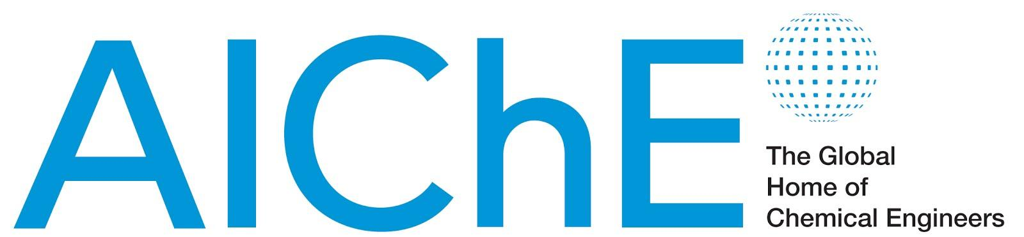

June 6, 2014

FOR IMMEDIATE RELEASE Contact: Danielle Gross
Phone: 717-214-2200
Email: dgross@thebravogroup.com

American Institute of Chemical Engineers Expands International Conferences
Specialty meetings devoted to chemical plant safety and bioengineering will be held on five continents in Summer 2014

NEW YORK – The American Institute of Chemical Engineers (AIChE) is growing its roster of international conferences. In Summer 2014, AIChE will sponsor or co-sponsor conferences in six countries, devoted to topics such as industrial safety, advances in and biological and metabolic engineering, and alternative fuels.

For more than a century, AIChE has kept chemical engineers and allied scientists informed and connected through its major conferences, which, in the past, have most frequently been held in the United States. The participants discuss trends in engineering and how technology can help solve important global challenges — such as the need for new sources of energy, protection of the environment, improved health care options, and safe and sustainable industrial practices.

AIChE’s new international meetings add value and impact not only because of the diversity of experiences and perspectives embodied by the participants, but because of their focus on specific technologies and industries, and the unique challenges that need to be addressed in each geographic location.

In Summer 2014, AIChE is organizing or collaborating on the following conferences at sites in Europe, Asia, Australia, and South America and North America:

Metabolic Engineering X Conference
June 15-19, 2014, Westin Bayshore Hotel, Vancouver, British Columbia, Canada
Organized by the International Metabolic Engineering Society, a community within AIChE’s Society for Biological Engineering, this tenth biennial conference promotes metabolic engineering — the optimization of the genetic and regulatory processes within cells — as an enabling science for bio-based production of advanced materials, pharmaceuticals, food ingredients, chemicals, and fuels.

Research Coordination Network Conference on Pan American Biofuels and Bioenergy Sustainability
July 22-25, 2014, Golden Tulip Recife Palace, Recife, Brazil
Funded by the U.S. National Science Foundation, and organized in partnership with AIChE and other scientific societies, this conference unites science and engineering researchers in North America, South America, and Central America, to work on challenges related to new and sustainable sources of alternative energy and fuels, including fuels derived from biological sources.

2014 AIChE CCPS Asia-Pacific Conference
August 7-8, 2014, Perth, Australia
Sponsored by AIChE’s Center for Chemical Process Safety (CCPS), this second AIChE CCPS Asia-Pacific Conference will bring together oil and gas industry professionals from Asia, Australia, the Pacific Island nations, and beyond, to discuss advances in process safety and chemical engineering technology that apply to industries in the region.

21st International Congress of Chemical and Process Engineering
August 23-27, 2014, Clarion Congress Hotel, Prague, Czech Republic
Organized by the Czech Society of Chemical Engineers, with the cooperation of AIChE, the European Federation of Chemical Engineers, and other European engineering societies, this conference is a venue for engineers, scientists, technologists, and students to present their research and industry best practices, and includes sessions devoted to processes that save energy and reduce pollution.

2nd Center for Chemical Process Safety (CCPS) China Conference on Process Safety
August 28-29, 2014, Qingdao, China
Presented in collaboration with the China University of Petroleum (Beijing) and the China Chemical Safety Association, this conference brings together engineers, government representatives, and academic researchers in China and internationally to share advances in process safety. The conference is an offshoot of CCPS’s annual Global Congress on Process Safety, which is held in connection with AIChE’s Spring Meeting — the next installment of which will be held April 26-30, 2015, in Austin, TX.

59th Annual Safety in Ammonia Plants and Related Facilities Symposium
September 7-11, 2014, Hyatt Regency Vancouver, Vancouver, British Columbia, Canada
This long-established annual conference — one of AIChE’s first to be held regularly at international locations — is dedicated to helping engineers and chemical plant managers in the ammonia, nitric acid, methanol, and related industries around the world to innovate safe processes and run safe operations. Hundreds of representatives from dozens of countries participate at each year’s symposium.

6th Latin American Conference on Process Safety
September 15-17, 2014, Plaza Hotel, Buenos Aires, Argentina
Another satellite conference of the Center for Chemical Process Safety’s (CCPS) Global Congress on Process Safety, the Latin American Conference is a recent addition to AIChE’s and CCPS’s worldwide effort to prevent industrial accidents by promoting lifelong learning and continual improvement in process safety. The conference’s technical presentations and lectures are offered with English and Spanish translations.

Information about these and other conferences sponsored by AIChE and its affiliates is available at www.aiche.org/conference.
# # #
About AIChE:
AIChE is a professional society of nearly 45,000 chemical engineers in 100 countries. Its members work in corporations, universities and government using their knowledge of chemical processes to develop safe and useful products for the benefit of society.
Through its varied programs, AIChE continues to be a focal point for information exchange on the frontier of chemical engineering research in such areas as energy, sustainability, biological and environmental engineering, nanotechnology, and chemical plant safety and security. www.aiche.org.

