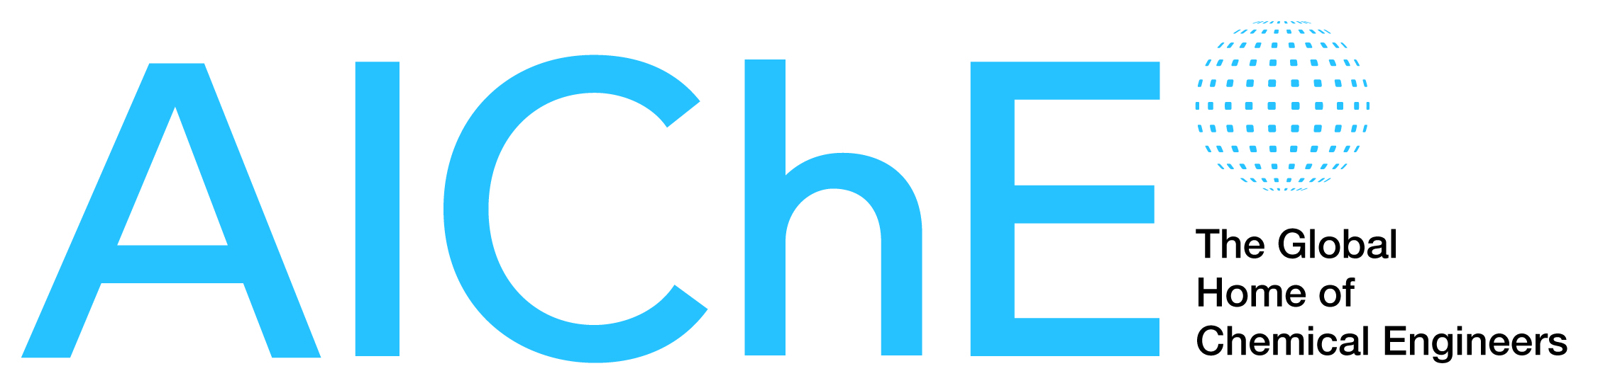

FOR IMMEDIATE RELEASE Contact: Danielle Gross
Phone: (717) 418-9001
January 28, 2014 Email: dgross@thebravogroup.com

CCPS EXECUTIVE DIRECTOR SCOTT BERGER ANNOUNCES RETIREMENT

Search for successor begins.

NEW YORK – Scott Berger has announced plans to retire as executive director of the Center for Chemical Process Safety (CCPS) of the American Institute of Chemical Engineers (AIChE), effective December 31, 2014. AIChE’s leadership has begun a search for Berger’s successor, in order to assure a smooth and effective transition. After retirement, Berger will support AIChE on key initiatives.

Berger, a Fellow of AIChE and CCPS, has served as executive director since July 2002. In the interim, CCPS has grown from 62 member companies to more than 165 and has established a broad global presence in the chemical, energy and pharmaceutical industries. During this period, CCPS released key new guidelines that continue to reshape engineering practice and it has launched a new continuing education effort. The Global Congress on Process Safety, created in 2005 by combining several AIChE process safety efforts, has grown more than three-fold. It has also spawned regional process safety conferences in Latin America and Asia.
Berger’s responsibilities also include AIChE’s conference programming, the Design Institute for Physical Properties (DIPPR), the Design Institute for Emergency Relief Systems, and AIChE’s sales efforts. All have grown under his leadership. AIChE’s Spring Meeting has been significantly strengthened through the addition of the Global Congress on Process Safety and its Annual Meetings have been setting attendance records. DIPPR has also experienced renewed growth, and a web-based advertising program was launched.
AIChE Executive Director June Wispelwey said that Berger’s “many contributions, his dedication and his expertise will be sorely missed.” “Scott has been the driving force behind one of the profession’s signature accomplishments—a dramatic improvement in process safety knowledge and performance,” she added. AIChE volunteer leaders and staff “are grateful for Scott’s astute direction and deep commitment to CCPS, our meetings, our sales efforts and so many other AIChE programs,” Wispelwey said.
Prior to his CCPS appointment, Berger held a series of leadership positions in chemical engineering and safety, health and environment at Rohm and Haas Company and Owens Corning. Throughout his career he contributed to AIChE as a volunteer.
Berger holds B.S. and M.S. degrees in chemical engineering from the Massachusetts Institute of Technology.
# # #

About AIChE:

AIChE is a professional society of more than 45,000 chemical engineers in 100 countries. Its members work in corporations, universities and government using their knowledge of chemical processes to develop safe and useful products for the benefit of society. Through its varied programs, AIChE continues to be a focal point for information exchange on the frontiers of chemical engineering research in such areas as energy, sustainability, biological engineering, nanotechnology, and chemical plant safety and security. More information about AIChE is available at www.aiche.org

About CCPS:
CCPS is a not-for-profit, corporate membership organization that identifies and addresses process safety needs within the chemical, pharmaceutical and energy industries. Founded by AIChE in 1985, CCPS brings together manufacturers, government agencies, consultants, academics, and insurers to lead the way in improving industrial process safety. CCPS member companies, working through project subcommittees, have defined and developed more than 100 useful, time-tested guidelines that have practical application and a record of improving process safety performance. More information is available at www.aiche.org/ccps.

