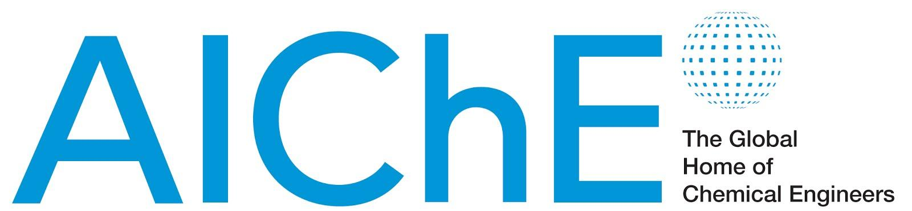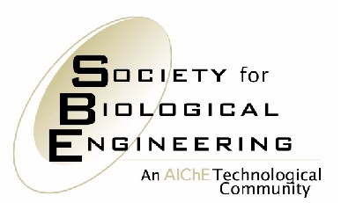

May 29, 2014

FOR IMMEDIATE RELEASE Contact: Danielle Gross
Phone: 717-214-2200
Email: dgross@thebravogroup.com

Hal Alper Receives Jay Bailey Young Investigator Award in Metabolic Engineering
Chemical engineering researcher will be honored at the Metabolic Engineering X conference
in Vancouver, British Columbia, June 15–19

NEW YORK – Hal Alper, an assistant professor of chemical engineering and Fellow of the Paul D. and Betty Robertson Meek Centennial Professorship at The University of Texas at Austin (UT), has been selected by the International Metabolic Engineering Society (IMES) to receive its Jay Bailey Young Investigator Award in Metabolic Engineering. The award recognizes original and creative research accomplishments by a young investigator in the field of metabolic engineering, and is named in honor of the late James E. Bailey, an influential chemical engineering teacher and a pioneer in the field of bioengineering, particularly metabolic engineering.

The Young Investigator Award will be presented to Alper at the Metabolic Engineering X conference, June 15–19, in Vancouver, BC, Canada. The biennial conference is organized by IMES, a community within the American Institute of Chemical Engineers’ (AIChE’s) Society for Biological Engineering.

Dr. Alper is being honored, in particular, for a July 2012 article in the journal Metabolic Engineering, in which Alper and his research team demonstrated that xylose transporter capacity (and subsequently catabolic rates) can be altered through the directed evolution of molecular transporter proteins, thus improving those proteins for biotechnological applications. This research established the principle for “molecular transporter engineering,” which can be applied not only to carbohydrate transporters but also to an array of influx and efflux pumps. Alper’s work expanded the scope of metabolic engineering, particularly at the interface of protein engineering, and has also established the foundation for subsequent rewiring of sugar transporter preference.

Alper’s laboratory at UT focuses on metabolic and cellular engineering in the context of biofuel, biochemical, and biopharmaceutical production, with a strong emphasis on fungal host systems. Moreover, his work applies and extends the approaches of related fields such as synthetic biology, systems biology, and protein engineering. He has received numerous honors, including the Camille and Henry Dreyfus New Faculty Award (2008); the Texas Exes Teaching Award (2009); the DuPont Young Investigator Award (2010); the Office of Naval Research Young Investigator Award (2011); the UT Regents’ Outstanding Teaching Award (2012); the Biotechnology and Bioengineering Daniel I. C. Wang Award (2013); and the Camille Dreyfus Teacher-Scholar Award (2014). Alper earned his BS in chemical engineering at The University of Maryland, College Park, and his PhD in chemical engineering at the Massachusetts Institute of Technology (2006).

The International Metabolic Engineering Society promotes the use of metabolic engineering — the optimization of the genetic and regulatory processes within cells — as an enabling science for bio-based production of advanced materials, pharmaceuticals, food ingredients, chemicals, and fuels. One of its venues for collaboration and information exchange is the Metabolic Engineering Conference, where practitioners share knowledge and discuss current developments in the field.

# # #

About SBE:
Established in 2004, the Society for Biological Engineering is a technological community for engineers and applied scientists integrating biology with engineering. Members of SBE come from a broad spectrum of industries and disciplines and share in SBE’s mission of realizing the benefits of bioprocessing, biomedical and biomolecular applications. http://bio.aiche.org.

About AIChE:
AIChE is a professional society of nearly 45,000 chemical engineers in 100 countries. Its members work in corporations, universities and government using their knowledge of chemical processes to develop safe and useful products for the benefit of society.
Through its varied programs, AIChE continues to be a focal point for information exchange on the frontier of chemical engineering research in such areas as energy, sustainability, biological and environmental engineering, nanotechnology, and chemical plant safety and security. www.aiche.org.

