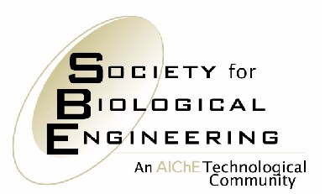
3 PARK AVENUE

NEW YORK, NY 10016

For Immediate Release Contact: Sean Connolly

Phone: 717.214-2200
Cell: 717.525.3004
Email: Connolly@thebravogroup.com

Society for Biological Engineering

Honors Harvey Blanch

2010 James E. Bailey Award Goes to Innovator in Biofuels

NEW YORK, November 9, 2010 – The Society for Biological Engineering (SBE) of the American Institute of Chemical Engineers has awarded the 2010 James E. Bailey Award to Dr. Harvey Blanch for research in transport, kinetics, and thermodynamics in enzymatic and microbial processes in ways that have advanced the development of biofuels.

Blanch is the Merck Professor of Biochemical Engineering at the University of California, Berkeley. His research has provided an understanding of gas-liquid mass transfer, mixing, and rheology in fermentations. He has developed enzymatic and microbial routes for the conversion of lignocellulosic materials to sugars and their subsequent fermentation to biofuels such as ethanol.

“Professor Blanch epitomizes the modern biochemical engineer who has combined the core concepts of chemical engineering with modern and creative ways to derive novel solutions to important problems of the chemical, biological and fuels industries,” says Professor Gregory Stephanopoulos of the Massachusetts Institute of Technology and Chair of the SBE Board.

Blanch delivered the Bailey Award Lecture today at AIChE’s Annual Meeting in Salt Lake City. The title of his talk was, “Evolving Biological Engineering.” The award, which is endowed by Cytos Biotechnology, honors the memory of James E. Bailey, who is widely recognized as the father of modern bioprocess engineering. It is presented each year to an individual who has had an important impact on bioengineering and whose achievements have advanced the biological engineering profession.

About SBE:
Established in 2004, the Society for Biological Engineering is a technological community for engineers and applied scientists integrating biology with engineering. Members of SBE come from a broad spectrum of industries and disciplines and share in SBE’s mission of realizing the benefits of bioprocessing, biomedical and biomolecular applications. http://bio.aiche.org.
About AIChE:

AIChE, founded in 1908, is a professional association of 40,000 chemical engineers in 92 countries. Its members work in corporations, universities and government using their knowledge of chemical processes to develop safe and useful products for the benefit of society. For more information, please go to www.aiche.org.

# # #

