

2021 Logistics for the AIChE Chem-E-Car Competition Day

**This document outlines the logistics of the competition day for the AIChE Chem-E-Car Competition®. It includes the following**

1. Facilitators of the event and their responsibilities
2. Program for the entire competition (**assuming start time 9:30 am**)
3. Logistics on how each run will be executed
4. Additional Notes from Safety Judges

**Facilitators of this event and their responsibilities:**

|  |  |
| --- | --- |
| **Roles** | **Responsibility** |
| Emcee | * 1. Interact with teams   2. Call on teams to the track   3. Make overall announcements |
| Spotlight/Zoom Tech | * 1. Spotlight video of each team to maximize visibility of car during run   2. Keep track of and announce time allotted to each team (2 minutes to get to start line; 2 minutes for run) |
| Distance Recorder | * 1. Record distance provided by each team into the main spreadsheet |
| Safety Judge | * 1. Ensure Rule and Safety Adherence |

**Program for the entire competition:**

* **09:00 AM – Teams can join 30 minutes early**
* **09:30 AM  – Official Start of ChemE Car Prep**
  + Teams will have the direct zoom link to join sent ahead of the competition
  + Teams will name all their cameras as “UNIVERSITY - A, B and so on”
  + Teams will show their workstation.
  + Participants on the zoom call who are not team members showing work station or track, a judge, or a facilitator will be asked to leave the zoom call.
  + Teams should have marked their track at every 1 meter mark with tape and labeling each tape exactly in the figure shown below. All teams **must** follow these marking rules. Please also refer to the camera guideline document for more information

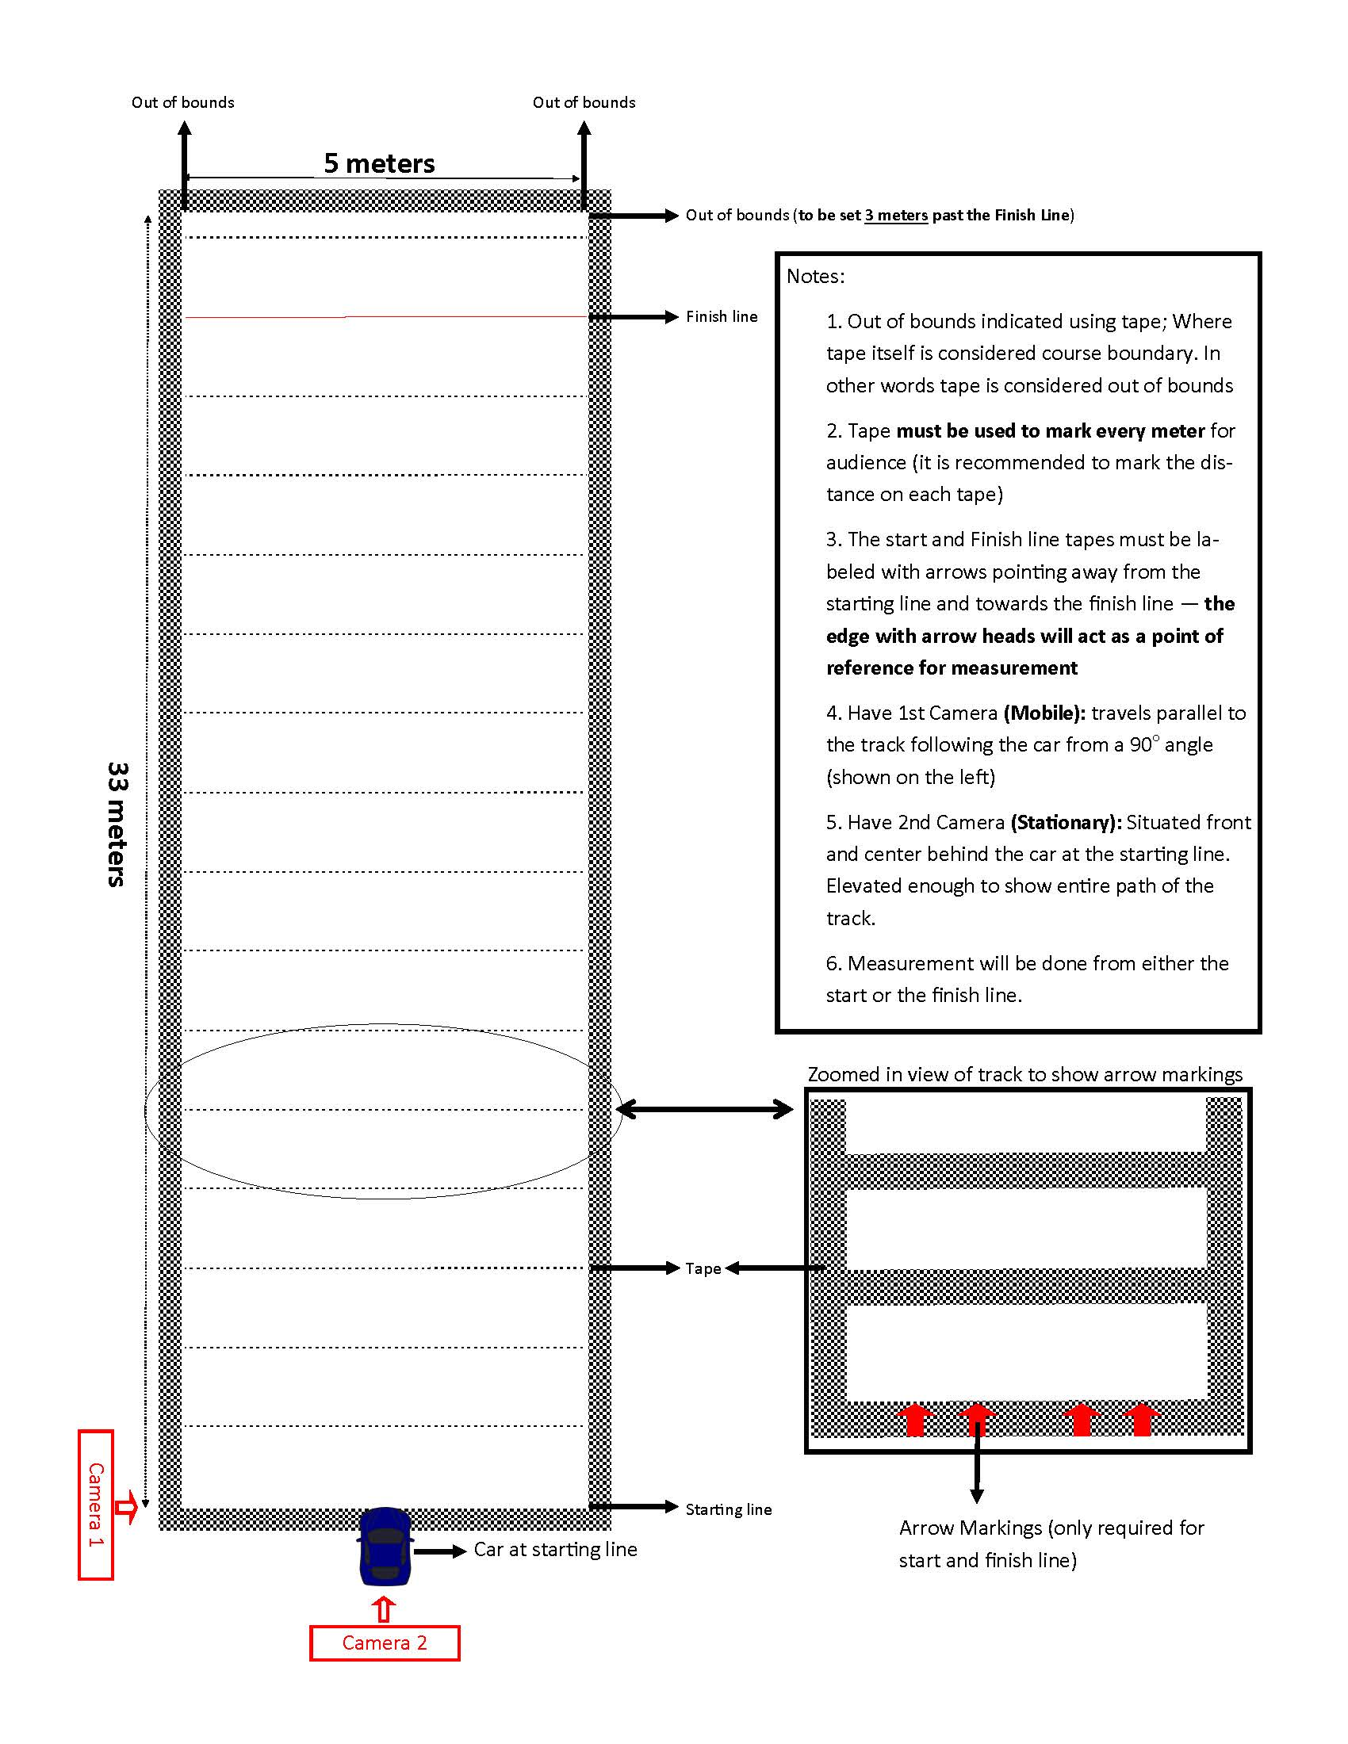

|  |  |  |  |  |  |
| --- | --- | --- | --- | --- | --- |
|  |  |  |  |  |  |

* **10:00 AM – Captains Meeting (Optional; Left to the safety coordinator’s discretion)**
  + All team Captains review rules, notes and communication with Safety Judges
* **10:30 AM – Distance and Track Run Order Announced** 
  + All teams will mark the finish line distinctly on their tracks;
  + All teams will have the same distance
  + Order of cars will be shown
  + Teams will use the following nomenclature: "# - UNIVERSITY - A, B and so on" where # is the track run order and the letter represents a different camera feed.
* **11:25 AM – Emcee welcomes everyone to the AIChE Chem-E-Car Competition**
  + Emcee will announce the run order and the following rules
    - Each team gets a 2 minute warning to get their car to the starting line.
    - After 2 minutes the Emcee announce that team’s "2 minutes for run time start now"
    - Each team will have an additional minute to measure their distance and report it to the **Distance Recorder** through chat.
    - Teams will report distance in meters to the nearest hundredth place. (Ex: ##.##m)
* **11:30 AM – Chem-E-Car Round 1 BEGINS!**
  + Teams follow logistics of the car run as written below
  + Teams continue safety precautions and rules adherence
* **12:45 PM – 15 minute break/Awards Intermission**
  + Emcees show standings for overall competition
* **1:00 PM – Kick-Off Round 2 BEGINS!**
  + Same order of runs is followed
  + Teams continue safety precautions and rules adherence
* **2:15 PM – Awards Finals** 
  + All teams join Track 1 for final awards for Awards Final

**Logistics on how each run will be executed:**

1. **Emcee will announce** "Team A is up next, Team B is on deck, Team C is in the hole; Team A, you have 2 minutes to bring your car to your starting line starting now"
   1. At this moment, Spotlight tech will begin 2 minutes
   2. Spotlight tech will announce 60 sec, 30 sec time stamps
   3. Judges will use this time to direct teams to show appropriate camera angles if need be.
   4. Teams show their cars at starting line similar to the photo shown below using a straight edge.

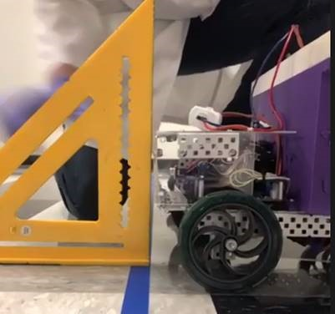

* 1. At the end of 2 minutes, teams are expected to have their car on their starting line

1. **Spotlight tech will announce** "Team A, Your 2 minutes for the run time start now"
   1. 2 min run time begins
   2. Spotlight tech will spotlight the appropriate feed for spectators and announce when time is up
   3. Teams will show their car's entire run
   4. Team members will use these two minutes to explain their car chemistry, mechanism and design to all the spectators
2. **Spotlight tech will announce** "Time is up. Please provide your measurements in chat"
   1. Teams will submit their distance traveled to the nearest hundredth place in meters (##.## meters)
3. **Once the distance measurement is shown sufficiently on camera, the competition moves on to the next team. With the judge’s permission, Emcees call Team B up next and so on.**

**Additional Notes from Safety Judges:**

1. **Each team will be have the same distance but they are limited to their track’s width. This means that your track’s width is your Out-of-bounds.**
2. The penalty for out of bounds will be 3 meters
   1. Width: if car hits your track’s sidelines/walls (Tape is course boundary) that will result in a 3 meter penalty
   2. Length: If distance is set to x meters, out of bounds will be x + 3 meters**. If your car hits the x + 3 meter mark, that will a 3 meter penalty.**
3. **No chemicals being poured, syringed, pipetted, etc. at the starting line is allowed**.  If a syringe is used to add a chemical, it must be pre-attached before the car is brought up to the starting line.  This rule will be strictly enforced.  Teams can have a “ready” table close by the starting line, with sufficient working space, where last minute additions can be made, if the site, OSJ, and advisor allows (must follow university/department rules here).
4. Review rules regarding prohibited starting line actions, like can’t push the car to start it moving, no picking up the back of the car to let the tires start moving, etc.
5. Teams have the option to have a ready table next to the starting line in order to on load any chemical before their run if space is available.
6. Once the distance is announced, teams cannot do any trial runs on their track.  A camera should be set up showing the team’s track after the distance is announced if possible (not required).
7. Please have an additional offline recording for the run of the car on a separate phone (not through zoom). This is in case judges need to review the footage in case of connection issues.
8. Distance measurement MUST be done either from the Starting line or the Finish line (not from a reference point); Teams are also required to use a measuring tape that is at least 35 meters in total length. We recommend purchasing a [product similar to this](https://www.amazon.com/dp/B085CC32X3?pd_rd_i=B085CC32X3&pd_rd_w=CMMdr&pf_rd_p=51cf0d17-50cf-4c89-b1a7-606703cfac11&pd_rd_wg=wuo2w&pf_rd_r=M266MDG04TPX846CQFWK&pd_rd_r=08533897-b320-491d-afb5-7478dbede25e).