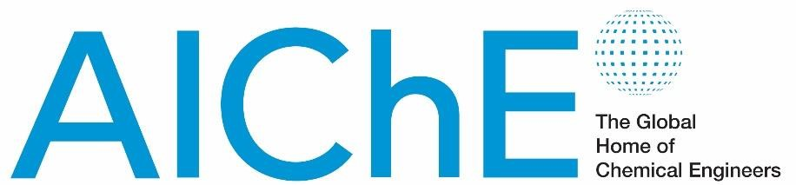

ChemE Cube Competition Chemical Order Form
Annual Student Conference 2023 | Orlando, FL

In efforts to eliminate lost chemicals and make this event more sustainable, AIChE will be placing 1
Master Order through Fisher Scientific for all hazardous chemicals needed for the 2023 Annual Student Conference ChemE Cube Competition. ChemE Cube Teams are not permitted to order their own hazardous materials/chemicals to Phoenix. The only items that teams are permitted to purchase/bring themselves are items available for purchase in a grocery store (example: vinegar, 3% H2O2, corn starch). Please fill out the table below with the chemicals you will need for the competition in Phoenix, AZ and return to RAPID @ chemecube@aiche.org by Friday, September 22, 2023.

RAPID recommends that teams calculate the amount of each chemical required for the two duels. This will ensure that we have plenty of material available for your team. Please indicate this calculated value for each chemical in the column titled “Quantity required for the Competition.”

AIChE will be ordering Laboratory, Technical or Reagent grade for all materials. If your team believes that you require a higher purity grade of chemical, you must indicate this in the column below titled
“Special purity grade required.” Note that if you do require a special grade, your team will probably need to pay for the entire bottle, which will increase your costs. If you do not require any special purity or grade, please leave this column blank.
Chemical Name | Chemical  State (Solid, Liquid, Gas) | Concentration  (with units!) | Quantity required for competition  (with units!) | Special purity grade required?

