Modular On-Demand Water Purification for Developing Countries
2021-2022 Challenge Water Testing Procedures (updated 11.03.22)

Challenge Water Makeup
The challenge water will have the characteristics/components listed in table 1, shown below.
Table 1: Challenge Water Characteristics/Components
Contaminant | Reduction/ Maximum Level | Notes | Contaminant
Bacteria (Brewer’s yeast surrogate) | Log reduction of 6 | 99.9999% removal¹² | Bacteria (Brewer’s yeast surrogate)
Virus (no surrogate) | Log reduction of 4 | 99.99% deactivation¹² | Virus (no surrogate)
Oocyst (Polymer microspheres surrogate) | Log reduction of 3 | 99.9% removal¹² | Oocyst (Polymer microspheres surrogate)
Chlorine (if applicable) | 4.0 mg/L;  0.8 mg/L;  250 mg/L | As Cl₂ or chloriamines; as chlorine dioxide⁶; as chloride⁹ (see problem statement if other disinfectant is used) | Chlorine (if applicable)
pH | 7.0 ± 0.5 | Secondary water regulation⁹ | pH
Turbidity | 5 NTU | Recommendation from the Sphere handbook¹¹ | Turbidity

Required Equipment & Materials (with images)

Micropipettes (0.5 μL- 10 μL) and pipette tips | 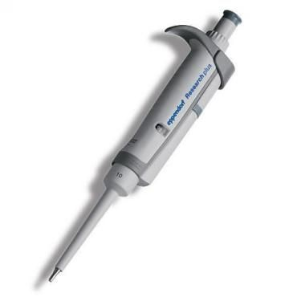  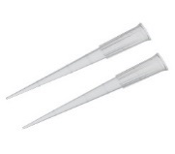
Beakers | 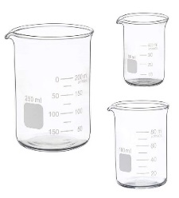
Graduate Cylinders | 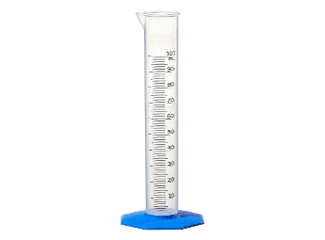
Light Microscope | 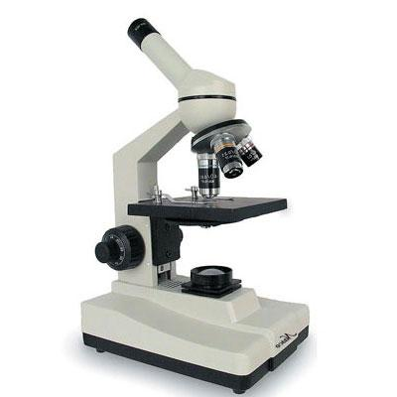
Hemocytometer | 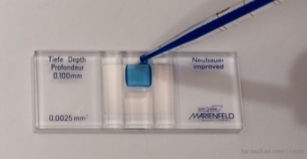
Eppendorf tube | 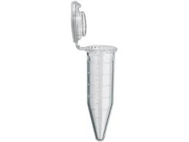
Hotplate & Magnetic Stirrer | 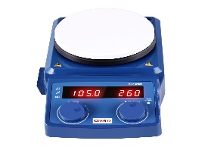
Turbidity meter kit | 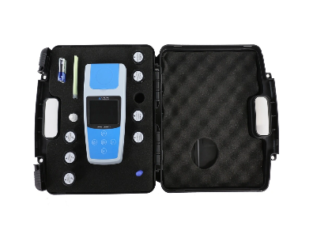
Digital Balance | 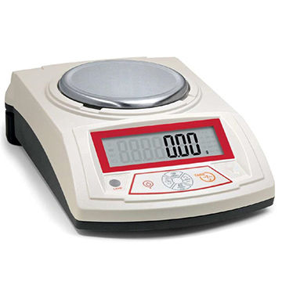
Luer-Lok Filter | 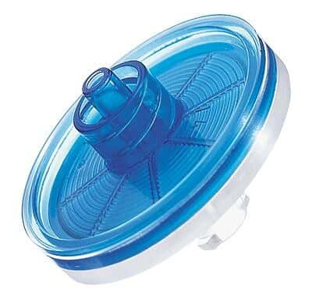
Sterile Syringe | 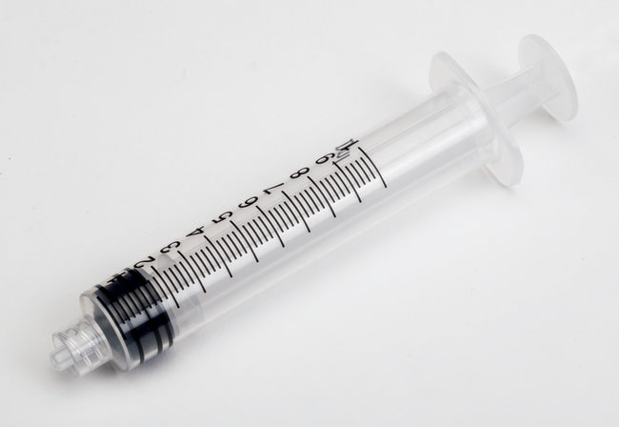
Chlorimeter | 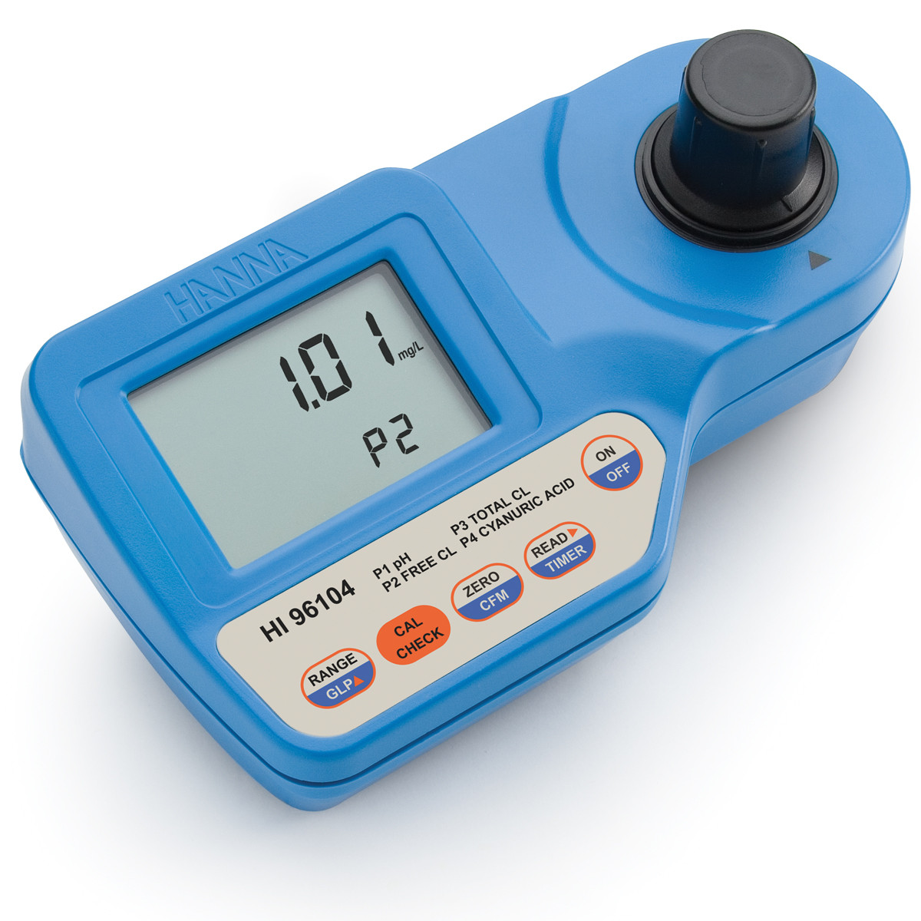

Addressing Criteria
After a duel has been completed, ChemE Cube staff will collect the product water from both teams. The water will be tested to determine if criteria on the rubric have been met. The criteria and how they will be determined are the following:
Criterion #1: “Product meets or exceeds 6 log reduction of bacterial surrogate”
Category: Product
Method: Cell count though hemocytometer or filter.
Procedure:
- Ensure the product water is well mixed to allow accurate measurements for the following steps.
- Prepare the hemocytometer and the microscope to receive a sample of the product water
- Dispense ~10-50 μL of product water into both counting chambers of the hemocytometer.
- Use the microscope and attempt to count the number of observed yeast cells and microspheres. This may address criteria 1 & 2.
  - If the yeast cells are hard to distinguish from the microspheres and test dust, follow steps 3 & 4 in the Challenge Water Makeup Procedures without dilution.
  - If there are less than 5 cells in each square of the counting chamber, follow step 5-13.
- Prepare the luer-lok filter by doing the following:
  - Insert a 25 mm, 0.45 μm filter into the bottom half of the filter holder.
Note: Use gloves and/or tweezers to handle filters to prevent contamination
  - Place the silicone O-ring on top of the filter.
  - Screw the top piece of the filter holder.
  - Tighten down the filter holder with the use of two tongue and groove pliers.
- Use a 100mL luer-lok syringe to collect 50 mL of the product water.
- Attach the filter holder with filter onto the end of the filled syringe.
- Push the product water through the syringe.
- Push at least 100 mL of air through the filter to air in drying.
- Remove the filter from the syringe.
- Place the filter on a microscope slide.
- Cover the filter with the counting grid.
- Use the counting method listed here.
Criterion #2: “Product meets or exceeds 3 log reduction of oocyst surrogate”
See criterion 1.
Category: Product
Method: Cell count through hemocytometer or filter
Procedure:
- Ensure the product water is well mixed to allow accurate measurements for the following steps.
- Prepare the hemocytometer and the microscope to receive a sample of the product water.
- Dispense ~10-50 μL of product water into both counting chambers of the hemocytometer.
- Use the microscope and attempt to count the number of observed yeast cells and microspheres. This may address criteria 1 & 2.
  - If the yeast cells are hard to distinguish from the microspheres and test dust, follow steps 3 & 4 in the Challenge Water Makeup Procedures without dilution.
  - If there are less than 5 cells in each square of the counting chamber, follow step 5-13.
- Prepare the luer-lok filter by doing the following:
  - Insert a 25 mm, 0.45 μm filter into the bottom half of the filter holder.
Note: Use gloves and/or tweezers to handle filters to prevent contamination
  - Place the silicone O-ring on top of the filter.
  - Screw the top piece of the filter holder.
  - Tighten down the filter holder with the use of two tongue and groove pliers.
- Use a 100mL luer-lok syringe to collect 50 mL of the product water.
- Attach the filter holder with filter onto the end of the filled syringe.
- Push the product water through the syringe.
- Push at least 100 mL of air through the filter to air in drying.
- Remove the filter from the syringe.
- Place the filter on a microscope slide.
- Cover the filter with the counting grid.
- Use the counting method listed here.

Criterion #3: “Product meets turbidity specifications (≤ 5 NTU)”
Category: Product
Method: The portable turbidity meter can measure the product’s turbidity.
Procedure:
- A sample of the product water will be tested for turbidity to assess criterion 3 using the Apera TN400 Turbidity meter. Please make sure the meter is calibrated and follow measurement procedures found on page 11 of the instruction manual.

Criterion #4: “Product average flowrate meets or exceeds specifications
(≥ 18 mL/min)”
Category: Cube Operation
Method: The amount of time it takes for the student’s cube to fill the required volume (90 mL) will determine the flowrate. Note that exceeding 40 mL/min will result in not meeting this requirement
Procedure:
- The average flow rate for criterion 4 will be calculated by diving the volume reached by the time it took to reach said volume.
$$Average Flowrate=\frac{Volume \left(mL\right)}{Time (min)}$$

Criterion #5: “Product is within specified pH range (7 ± 0.5)”

Category: Product
Method: Litmus paper will be used to estimate pH. If it is uncertain if the pH range is between 7 ± 1 or 7 ± 0.5, a pH probe will be used.
Procedure:
- The pH will be determined via litmus paper test for criterion 5. If it is uncertain whether the pH is between 7 ± 1 or 7 ± 0.5, a pH probe will be used.

Criterion #6: “Product chemical disinfectant concentration acceptable or non-chemical disinfection means provided for virus”
Category: Product
Method: Students must incorporate a chemical disinfectant to be considered in this competition. For teams using chlorine disinfectant methods, the acceptable limit provided in the rubric will be used to judge a given team’s product water. Teams that use a non-chlorine based chemical disinfection must provide a testing method to measure the concentrations of their cube’s disinfectant, along with citations justifying the acceptable concentration limit for the non-chlorine based disinfection method.
Procedure:
- A small sample of the product water is tested for chemical disinfectant concentration levels:
  - For chlorine disinfectants, the safe drinking water upper limit according to the EPA should be detected: HOCl, OCl⁻, Cl₂ (dissolved), and/or chloramines (total Cl): ≤4.0 mg/L; ClO₂ or chlorine dioxide: ≤0.8 mg/L; Cl⁻ or chloride: ≤250 mg/L.
    - Take a clean cuvette and fill it with 10 mL of unreacted output water from a given team’s produced water. Place the plastic stopper and cap on the cuvette.
    - Insert the cuvette into the chlorimeter and press Zero.
    - Remove the cuvette.
    - Add the content of 1 packet of total chlorine reagent to the filled cuvette. Shake gently for 20 seconds.
    - Insert the cuvette into the chlorimeter and press Read. To skip the timer, press Read twice. Record the result in mg/L or ppm of chlorine.
  - For hydrogen peroxide (H₂O₂) disinfectants, the safe drinking water upper limit according to the EPA should be detected: ≤50 ppm.
    - Take the hydrogen peroxide test strip provided and dip it in a given team’s produced water sample.
    - Record the detected hydrogen peroxide level based on the color of the strip using the color chart provided on the test strip container.
This will address criterion 6.

Criterion #7: “Fills required volume (90 mL) of product before competitor in ‘The Duel’”
Category: Cube Operation
Method: Takes less time than the competitor to fill the competition’s required volume (90 mL) of water.
Procedure:
- During the duel, each cube’s average flow rate will be measured by independently (as opposed to using a timer for both cubes) timing the period of time in which the cube starts producing water to when the cube reaches the required volume. When the required volume is reached, the cube’s time will be stopped and recorded. The team with the lowest time in the duel receives points for criterion 7.

Criterion #8: “Weighs less than its competitor in ‘The Duel’”
Category: Cube Operation
Method: Weight will be determined in the safety pre-inspection. This is a comparison between the two competitors in a single duel,
Procedure:
- During the safety inspection, each cube will be weighed-in by the safety judge.

Criterion #9: “Consumes the least amount of electricity in ‘The Duel’”
Category: Cube Operation
Method: Determined through an in-line power meter. Additionally, if a team is using a power plug (as opposed to banana plugs or post connectors), it must be a standard 120V US grounded electrical connector.
Procedure
- Divide the power consumption by the time to determine the winner of criterion 9 using the formula below
$$Power consumption=\frac{Power (W)}{Time (min)}$$

Overall Testing Procedure
- During the duel, each cube’s average flow rate will be measured by independently (as opposed to using a timer for both cubes) timing the period of time in which the cube starts producing water to when the cube produces the required volume of 90 mL. When the required volume is reached, the cube’s time will be stopped and recorded. The team with the lowest time in the duel receives points for criterion 7.
- The power consumption (in Watts) will be displayed on the in-line power meter. Record said value
- Divide the power consumption by the time to determine the winner of criterion 9 using the formula below
$$Power consumption=\frac{Power (W)}{Time (min)}$$
- The average flow rate for criterion 4 will be calculated by diving the volume reached by the time it took to reach said volume.
$$Average Flowrate=\frac{Volume \left(mL\right)}{Time (min)}$$
- Each cube’s product will be collected and brought to the testing area for analysis.
- The pH will be determined via litmus paper test for criterion 5. If it is uncertain whether the pH is between 7 ± 1 or 7 ± 0.5, a pH probe will be used.
- A sample of the product water will be tested for turbidity to assess criterion 3 using the Apera TN400 Turbidity meter. Please make sure the meter is calibrated and follow measurement procedures found on page 11 of the instruction manual.
- A small sample of the water is taken to test for chemical disinfectant concentrations, if necessary. This will address criterion 6.
- Ensure the product water is well mixed to allow accurate measurements for the following steps.
- Prepare the hemocytometer and the microscope to receive a sample of the product water
- Dispense ~10-50 μL of product water into both counting chambers of the hemocyotmeter.
- Use the microscope and attempt to count the number of observed yeast cells and microspheres. This may address criteria 1 & 2.
  - If the yeast cells are hard to distinguish from the microspheres and test dust, follow steps 3 & 4 in the Challenge Water Makeup Procedures without dilution.
  - If there are less than 5 cells in each square of the counting chamber, follow step 13-27.
- Prepare the luer-lok filter by doing the following:
  - Insert a 25 mm, 0.45 μm filter into the bottom half of the filter holder.
Note: Use gloves and/or tweezers to handle filters to prevent contamination
  - Place the silicone O-ring on top of the filter.
  - Screw the top piece of the filter holder.
  - Tighten down the filter holder with the use of two tongue and groove pliers.
- Use a 100mL luer-lok syringe to collect 50 mL of the product water.
- Attach the filter holder with filter onto the end of the filled syringe.
- Push the product water through the syringe.
- Push at least 100 mL of air through the filter to air in drying.
- Remove the filter from the syringe.
- Place the filter on a microscope slide.
- Cover the filter with the counting grid.
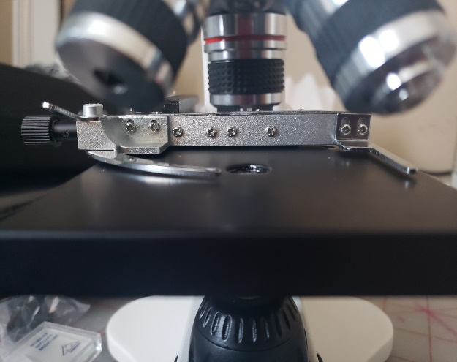
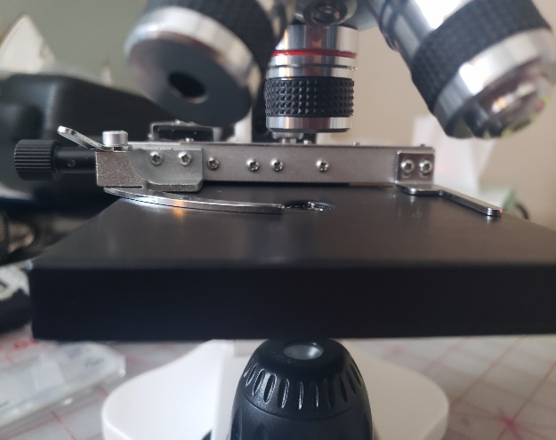
- Adjust the slide holder in the microscope down, as shown in the image below:
- Draw an X on a filter and use that filter to help focus the microscope.
- Place the slide-filter sandwich on the microscope slide holder.
- Use the grid on the microscope slide to count the number of yeast and microspheres (separately) per square.
- Take an average count of 6 different squares for microspheres and yeast.
- Multiply the average by ratio of the filter area and the observed area: 54.5
$$Multiplier=\frac{491 mm^{2}}{9 mm^{2}}=54.5$$
- This number represents the total in the 50 mL, so simply divide this number by 50 to get the concentrations of yeast cells and microspheres, respectively. This will assess criteria 1 & 2.

