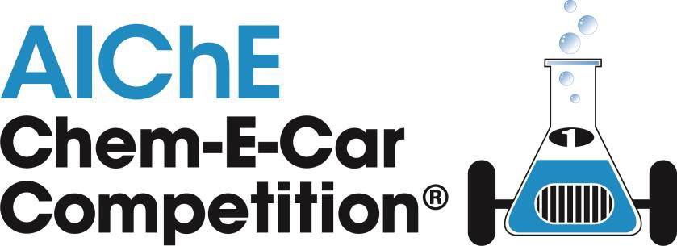

Chem-E-Car Competition® Safety Inspector’s Checklist

University:

Inspector(s):

1. Disallowed Vehicles: All of the items listed below are not allowed. Please check any box that you believe may exist in the design of the car.
Item | Explanation
(a) Flames and/or smoke | Both inside and outside the vehicle, except for commercial internal combustion engines. See ChemE car rules for using commercial internal combustion engines.
(b) Liquid Discharge | Liquid may not be discharged under normal operating  conditions.
(c) Open and/or  improperly  secured containers | Containing chemicals having a GHS rating of 4 or lower. All  containers with these chemicals must have secure lids and must be secured to the vehicle. All containers brought to the starting line must have lids, be properly labeled, and proper personal protective equipment must be used.
(d) Chemical pouring at  starting line | Any chemicals with a GHS rating of 4 or lower. Use a holding  vessel on vehicle, with valve, to load starting chemicals.
(e) Regulated Chemicals | A number of chemicals are listed by OSHA as a special hazard.  See the list below. OSHA has a special regulation for each chemical. See www.osha.gov for details.
(f) Highly Reactive /  Unstable Chemicals | Any chemical, raw material, intermediate, or product with a  GHS reactivity/instability rating of A.
(g) Hydrogen Peroxide | Hydrogen peroxide at concentrations of greater than 30% is not  allowed.

Regulated chemicals: asbestos, coal tar pitch volatiles, 4-nitrobiphenyl, alpha-napthylamine, methyl chloromethyl ether, 3,3'-dichlorobenzidine, bis-chloromethyl ether,
beta-naphthylamine, benzidine, 4-aminodiphenyl, ethyleneimine, beta-propiolactone,
2-acetylaminofluorene, 4-dimethylaminoazo-benezene, n-nitrosodimethylamine, vinyl chloride, inorganic arsenic, benzene, 1,2-dibromo-3-chloropropane, acrylonitrile, ethylene oxide, formaldehyde, 4,4'-Methylenedianiline, 1,3-butadiene, methylene chloride.

2. Safety Management: All items listed below must be available and in satisfactory form.
Item | Availability | Status
(a) JSA: | Present Absent | Satisfactory Unsatisfactory
(b) Complete Engineering  Documentation package: | Present Absent | Satisfactory Unsatisfactory
(c) MSDS: | Present Absent | Satisfactory Unsatisfactory
(d) Personal Protective  Equipment: | Present Absent | Suitable Unsuitable

3. Vehicle Primary Hazards Checklist: Check the left-hand column box if the hazards listed below exist on the vehicle. Then check the applicable means of control for each hazard.
Hazard  (check if present) | Control
(a) Pressure | Anything greater than 5 psig? Must meet all requirements below:  Pressure gauge (must read to 2x max. operating pressure)  Emergency relief device set to no more than 1.1 times max. operating pressure. Relief sizing calculations must be provided.  Emergency relief device in the proper location.  Pressure certification – see Pressure Vessel Testing Protocol  Proper management system to prevent over or mis-charging.  All car components exposed to pressure must be certified to operate at  that pressure. Provide manufacturer’s pressure specifications.  No PVC, cPVC, or polyethylene terephthalate (PETE or PET)  plastics in pressure service  Must have measurements or calculations to prove maximum operating pressure.  See Chem-E-Car rules for more details on these requirements.
(b) Toxic | Any chemicals with a GHS toxicity of 4 or lower?  Doubly contained and handled properly.
(c) Flammable | Any chemicals with a GHS flammability rating of 4 or Lower?  Doubly contained and handled properly
(d) Reactive | Any chemicals with a GHS self reactive substance rating of B, C, or D.  Chemicals with a GHS self reactive substance rating of A are not allowed.  Doubly contained and handled properly.
(e) Temperature | Any exposed surface greater than 150 deg. F or under 32 deg F?  Insulation or barrier to prevent contact.
(f) Electrical | Exposed wiring and electrically energized components are ignition,  electrocution, and a shorting / fire hazard. Alligator clips and twisted wire connections are not allowed – use binding posts or banana plugs for a more secure connection.  Proper electrical insulation and connections provided.
(g) Mechanical | Any fast-moving parts (meshing gears, belts, or chains) that are pinch  hazards?

 | Guards present and adequate.
(h) Oxygen | All components exposed to oxygen must be  certified for oxygen service.  thoroughly cleaned of contaminants as per instructions in rules. not used previously for other types of service.
(i) Biohazards | No biohazards greater than biohazard level 1 either during the design,  development, preparation or competition phases of your car.

4. Operating Experience: Team must have at least ten hours of operating experience. This is verified by the Certification document signed by the faculty advisor. Please ensure this form is signed by the advisor, and that advisor has attended safety training.

Satisfactory Unsatisfactory

5. Engineering Documentation Package: The engineering documentation package must contain the following items. In some instances, where pressure is not used above 5 psig in the car’s design, pressure sizing calculations and testing of pressure relief devices are not required.

a. Description of the car and how it works. Satisfactory Unsatisfactory
(May be contained in JSA)
b. Complete list of every piece of equipment on the car in Table format, this list should include the manufacturer of the equipment or indicate that it was custom built.
Satisfactory Unsatisfactory

c. Manufacturer’s spec sheets or specs for custom built equipment.
Satisfactory Unsatisfactory

d. Standard Operating Procedure Satisfactory Unsatisfactory
(May be contained in JSA)

e. Have the students explain the chemistry. Rate their understanding of any chemical hazards present. Satisfactory Unsatisfactory

f. Check the design basis for pressure relieving load.
Satisfactory Unsatisfactory

g. Check the sizing calculations for a pressure relief device against the manufacturer’s
spec sheet. Satisfactory Unsatisfactory

h. Check the student’s test procedure and results for a pressure relief.
Satisfactory Unsatisfactory

i. Ensure they have a diagram of the laboratory floor plan in the documentation package. Satisfactory Unsatisfactory

j. Ask about the management system for chemical use and disposal during the competition. Satisfactory Unsatisfactory

k. Ensure there are MSDS sheets for each chemical in use during the competition.
Satisfactory Unsatisfactory

l. Ensure the pictures of the car in the documentation package match the actual car in front of you. If there are changes, ask to see the MOC document documenting the changes. Satisfactory Unsatisfactory

m. Check the comments from the paperwork audit and ensure that all comments made by the first reviewer have been properly addressed.
Satisfactory Unsatisfactory

FINAL INSPECTION STATUS: PASSED FAILED

INSPECTOR’S SIGNATURES:

Provide any additional supporting comments below. List any additional hazards not covered in Table 2 (Biohazards, lasers, ionizing radiation, etc) that might affect the safety of the vehicle. State whether the control is satisfactory.

