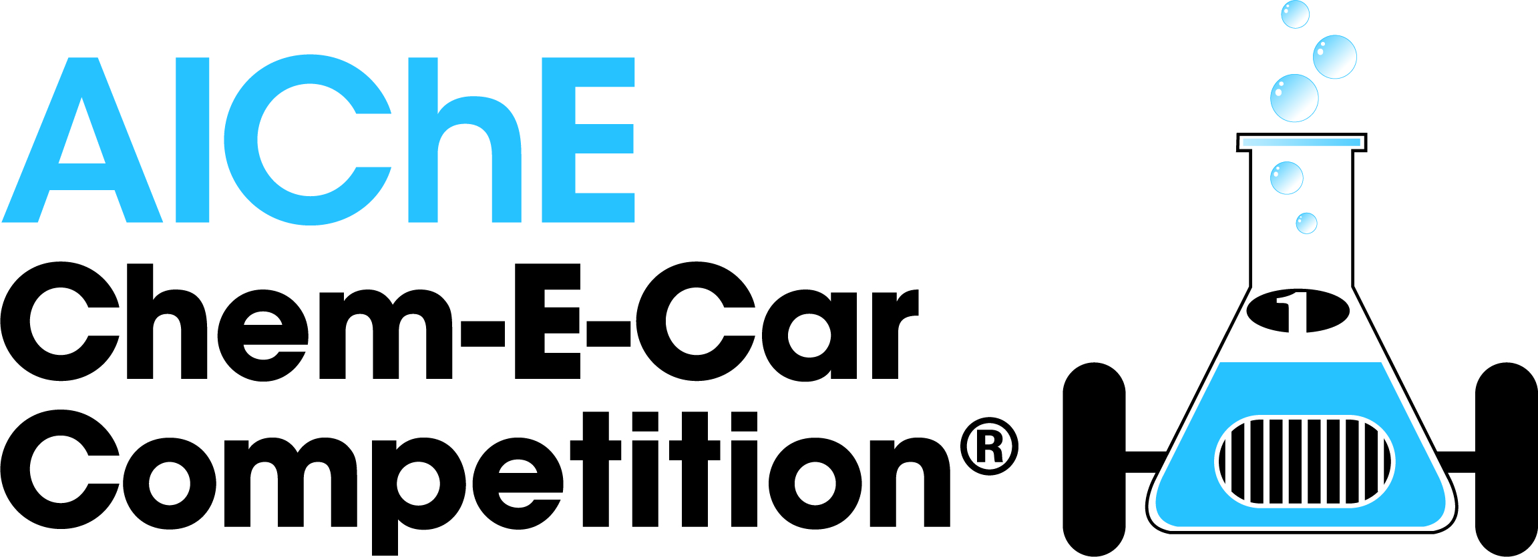

2021 Regional Virtual Competition Safety Rules

Chem-E-Car Safety Program Overview

The objectives of the AIChE Chem-E-Car Competition Safety Program are to ensure the safe preparation and operation of vehicles during all phases of the competition, including construction, testing and the competition. An audit of your system design and safety compliance will be conducted from the documentation your team provides.

The safety audit of your vehicle will occur in two stages:
- Online audit where teams will submit a fully completed Engineering Documentation Package (EDP) electronically and receive feedback. A member of AICHE staff will communicate EDP instructions to all teams. Failure to meet the posted deadline and by not submitting a fully completed EDP will result in exclusion from the competition. The EDP template is available for download on the Chem-E-Car Competition Rules Website at www.aiche.org/chemecar.
- In Person: Onsite Audit on competition day where teams must bring printed EDP, EDP Supplement, EDP feedback and MOC Form in a folder or binder and be ready to answer questions from safety reviewer. For Virtual: Onsite Audit will be done ahead of the competition day by the Onsite Safety Judge; teams must provide printed EDP, EDP Supplement, EDP Feedback and MOC Form in a folder or binder Failure to pass this stage of the competition will result in receiving a disqualification from the competition.

Changes in the Chem-E-Car Safety Rules for the 2021 Regional Virtual Chem-E-Car Competition
- 1.1.2: Teams need to provide multiple detailed views of the car.
- 15.1.1: The MAWP has been changed from 500 psig to 200 psig
- 28 COVID Guideline

Competition Safety Rules

- Safety Audit: Online
  - EDP. An engineering documentation package (EDP) for your Chem-E-Car must be fully completed and submitted by the posted deadline. A complete EDP will include the following in the following order:
    - Job Safety Analysis: Includes a description of your car and how it works.
    - Photos: Pictures of your vehicle after construction has been completed. These pictures must be current. The entire car must be visible in the picture. Remove the top to expose electrical controls if necessary. Multiple detailed views of the car are required. A drawing or AutoCAD document is NOT acceptable.
    - Safety Training and Rules Certifications Page: This page must be signed by all team members and your faculty advisor. Judges will use this page to determine: (1) If the starting and stopping mechanisms are compliant with the rules, (2) If everyone has completed the required safety training and (3) that you have identified the major hazards and have controlled them properly. The certification page must be signed by the date of the competition. Note that your group must have a minimum of 10 hrs. of operating time on the car prior to the faculty member signing. Note: The time you spend building the car cannot be counted as operating time.
    - Hazards Analysis: Complete all pages, including attaching the floor plan/diagram of the laboratory where you are building your car.
    - Chemical Information: Includes a description of the chemistry involved, and a list of chemicals to be sent to the competition if in person, or to be used at the competition, if virtual
    - Chemical Hazards and Disposal: List the properties for every chemical, typically found on the SDS. If a chemical is not flammable, please write N/A.
    - Standard/Safe operating procedures page: This section requires your team to conduct chemical research related to the chemicals you handle. Please refer to the NIOSH website to search for and locate this information. When not applicable, indicate with N/A.
    - Equipment Table: A complete list of every piece of equipment on the car in table format, including the manufacturer of each piece of equipment. Include operating limits (max temperature and pressure) for each piece of equipment, and ensure material compatibility where pertinent. When manufacturing spec sheets are absent, students should rely on the material properties for these limits.
    - Pressure: For Cars with Pressure Greater than 5 psig (0.345 barg): Please complete and add the following to your EDP document: A quantitative design basis for pressure relieving load; Sizing calculations for a pressure relief device; and Test procedure and results for a pressure relief. The textbook “Chemical Process Safety” by Crowl and Louvar can be used as reference. Please see Appendix A of the Safety Rules for full instructions on what is required for Pressure Testing.
    - Hydrogen gas discharge calculations (include for any flammable component). If you are using hydrogen gas, and plan to discharge a small amount, you must provide calculations demonstrating that the discharged amount is below the LEL/LFL for the control volume.
    - Management of Change Form: After the online EDP review, you must complete any changes suggested by the EDP Reviewer and document these changes in the Management of Change (MOC) form. This MOC must be presented during the onsite safety inspection.

  - EDP Supplement. Please combine the following information in another single, separate PDF and should be titled “University Name EDP Supplement”.
    - Safety Data Sheets (SDS) for all chemicals used or generated by reaction.
    - Manufacturer’s specification documents or specifications for custom-built components. For any commercial or custom built components, students must list material and compatibility.
    - Safety Training Course Certificates for each team member + Advisor
    - Any additional information you need to save regarding your EDP that is not contained within the original EDP document.

- Safety Audit:
  - Onsite (In-person). On the day of the competition, an audit team will inspect each vehicle to ensure that all of the safety requirements have been met and that the vehicle will operate without risk to the operators, contest staff and spectators. The Safety Judges at the competition site have the final say in regard to permission to compete, regardless of whether a car was given permission to operate at a previous regional competition.
  - Virtual. During the Safety Inspection, a faculty member serving as the Onsite Safety Judge will inspect the team’s vehicle to ensure that all of the safety requirements have been met and that the vehicle will operate without risk to anyone present at the competition site. The safety Judges at the competition site have the final say in regard to permission to compete, regardless of whether a car was given permission to operate at a previous regional competition.
  - Permission to compete. If the audit team deems the vehicle safe to operate, then the vehicle will be given permission to compete. If a car is deemed unsafe, then it will not be given permission to compete therefore rendering it unfit to run during the performance competition.

- Disallowed Chemical Handling/ Illegal Chemical Transport & Storage
    - Transport Chemicals. Teams are not allowed to transport hazardous chemicals by car to the competition site. No chemicals should be transported in private, university or rental vehicles to and from the competition site, even over short distances.
      - Household Chemicals. Common household chemicals such as baking soda, etc. are exempt from this rule. To qualify as a common household chemical, the chemical must be available for purchase at a grocery or hobby store.
    - Shipping Chemicals. Chem-E-Car teams should work with their University EHS department to make sure everything is shipped according to all DOT/ HAZ Material Shipping laws. Make sure everything is properly labeled.
    - Illegal Chemical Storage. Chemicals must not be stored in hotel rooms or other facilities not rated for chemical storage. The exception to this rule is common household items such as baking soda and salt.

- No Compressed Hydrogen Gas Cylinder Usage
  - Hydrogen Generation. All hydrogen used on the vehicles (for instance with fuel cells) must be generated on-site or on the vehicle keeping the pressure below 5 psig (0.345 barg). Appropriate safety precautions and safe operation must be demonstrated. Hydrogen generation cannot begin until chemicals are given out on competition day.
  - Commercial Hydrogen Storage Canisters. Filling of vessels from a compressed hydrogen gas cylinder or commercial hydrogen storage canisters (such as hydrostiks or solid–core hydrogen cartridges) will not be allowed.

- Illegal Testing of Vehicles
  - Testing Location. Testing of vehicles must only be done in a laboratory or other facility with chemical handling capability. Testing in hotel or dorm hallways, warehouses, or other facilities that are not designed for chemical handling is not allowed. No mixing of chemicals, including common household chemicals is allowed in the hotel or in dorm hallways.

- Illegal Disposal of Chemicals.
  - Chemical Disposal. All chemicals shipped to the competition site must be disposed of in a safe and environmental fashion in compliance with all local, state and national regulatory measures. Failure to follow these rules on chemical handling will result in a multi-year suspension of your university. Please minimize chemicals shipped to the competition site in order to reduce disposal costs.

- Flames/smoke/noise. All cars are restricted from having any open flames or emitting any smoke. Cars shall not have internal flames.
    - Internal combustion engines (ICE). The only exception to this rule is that an internal flame is allowed in a commercial internal combustion engine (ICE) that uses an alternative fuel that is synthesized by students. Cars with ICEs are not allowed to produce smoke during the attempt. Succinct safety procedures for the maintenance and operation of this engine must be demonstrated by the team. In addition, cars with an ICE must show a demonstrable and significant student design component.
    - Noise. Noise from internal combustion engines must not exceed 90 db (as measured from a distance of 1 meter).
    - Gas Discharge. Gas discharge from an ICE shall be permitted when the exhaust has been properly filtered by a catalytic converter or other filter media to remove hazardous exhaust materials with including soot, obnoxious odor, and smoke.
    - Gas Discharge from a reaction: Any byproducts with an NFPA rating of 3 or greater must be scrubbed or removed prior to discharge.

- Liquid/Vapor/Odor Discharge. No liquid discharge, including water, is allowed. No obnoxious odor discharge is allowed. All liquid products of reaction should be properly collected and contained within the vehicle, and properly disposed of (example, use of a scrubber/ holding tank). Discharge should only occur during emergency relief situations to protect the equipment from rupture and/or explosion.
    - Hydrogen Discharge. An exception to the 'no gas discharge' rule is that a small amount of hydrogen discharge is allowed. A 'small amount' is considered a gas discharge below the LFL/LEL of hydrogen for the given volume of the reactor, chamber or fuel cell in which hydrogen is stored. Students should provide calculations in the EDP to prove to the reviewer that any discharged hydrogen is well below the LFL/LEL.
    - Release of Pressurized Gas. Although pressure relief devices are required as a means of protection, the release of pressurized gas during the competition (greater than 5 psig [0.345 barg]) is not allowed. If a PRV functions during the attempt for any reason that attempt will be disqualified.
    - Gas Discharge Unpressurized, untreated gas discharge as a reaction byproduct is allowed without filtration for gases containing an NFPA rating of less than 3. (example - water vapor, or CO₂ are OK, H₂S is not OK). The onsite safety personnel may disqualify any entry where the gas discharged by a vehicle is deemed improper. Disqualification due to excessive gas production is at the discretion of the observing safety committee, and the ruling is final and cannot be challenged

- Reactive Materials. Teams using any chemicals with potential air/oxygen reactivity MUST purge the system with an appropriate inert gas.

- Open and/or Improperly Secured Containers. All containers on the vehicle containing chemicals (including water) must be securely attached to the vehicle to prevent the container from tipping over during the competition. The lid to this container must also be securely attached to the container and must be capable of preventing escape of the chemical during any phase of the competition, including an accident involving tipping over of the vehicle.

- No Open Containers, pipetting, or Chemical Pouring at the Starting Line. No open containers or pouring/pipetting of chemicals is permitted at the starting line. Chemicals can be added at the starting line either by gravity flow through a valve, or by using a syringe, which must be attached securely and remain with the car. These syringes or built-in chemical reservoirs must be filled at the team’s preparation table prior to moving to the ready table and starting line. Violations will result in that run being disqualified – any syringe or built-in chemical reservoir is still subject to containment requirements, MOC compatibility, double containment, lid, etc., if necessitated based on the chemical(s) contained.” All containers on the vehicle must have a secure lid and must be properly managed to prevent spillage.
  - Starting Line Procedure. If you elect to use a syringe to add a chemical at the starting line, it must be securely fixed to the vehicle before walking to the starting line. A detached empty or partially full syringe cannot be carried away from the start line. If any parts including the syringe fall off the car either at the starting line or in competition will result in disqualification of that attempt. All containers, syringes, packets, etc. must be properly labeled and contained.

- No Regulated Chemicals. Due to the hazards involved, no chemicals regulated by OSHA will be allowed on any vehicle participating in the competition. A number of chemicals are listed by OSHA as a special hazard. The handling of these chemicals is outside the scope of the management systems available during the competition. See www.osha.gov for details. Regulated chemicals include:

1,2-Dibromo-3-chloropropane | Beta-naphthylamine
1,3-Butadiene | Beta-propiolactone
2-Acetylaminofluorene | Bis-chloromethyl ether
3,3'-Dichlorobenzidine | Coal tar pitch volatiles
4,4'-Methylenedianiline | Ethylene oxide
4-Aminodiphenyl | Ethyleneimine
4-Dimethylaminoazo-benezene | Formaldehyde
4-Nitrobiphenyl | Inorganic arsenic
Acrylonitrile | Methyl chloromethyl ether
Alpha-napthylamine | Methylene chloride
Asbestos | N-nitrosodimethylamine
Benzene | Vinyl chloride
Benzidine

- No Highly Reactive/Unstable Chemicals. No chemical, raw material, intermediate or product that is highly reactive or unstable will be permitted. This includes chemicals with a GHS hazard category level 1 ranking in any of the following categories; pyrophoric solids and liquids, acute toxicity, carcinogenicity, other toxicity hazards not specifically listed and hazardous to the ozone layer. This also includes any chemical on the extremely hazardous substances list published by EPA, as well as the following chemicals specifically.
Banned chemical list includes (not exhaustive):

0-Dinitrobenzene
3-Bromopropyne
Acetyl peroxide
Cumene hydroperoxide
Diethyl peroxide
Diisopropyl peroxydicarbonate
Di-tert-butyl-peroxide
Divinyl acetylene
Ethyl nitrite
Nitroglycerin
Nitromethane
Paracetic acid

- No Liquid Hydrogen Peroxide Concentrations Greater than 30%. Liquid hydrogen peroxide is very unstable and difficult to handle at concentrations greater than 30%.

- Pressure Restrictions. Pressurized vessels and vehicle components represent a significant explosion hazard due to the substantial energy contained in the pressure. The student team must also demonstrate that the proper safety systems have been installed to prevent an explosion.

    - The maximum allowable working pressure (MAWP) should be the highest pressure the weakest component of your pressurized system can handle. No vehicle is permitted to have a MAWP greater than 200 psig (13.8 barg). Note that the MAWP for the ‘car system’ may be less than the MAWP the manufacturer listed for the pressure vessel.

    - The maximum operating pressure (MOP) may not exceed 90% of the MAWP for the reaction vessel, and should be 90% of the operating pressure of the weakest pressure rated component in the system. For initial design purposes, the maximum operating pressure (MOP) can be estimated from stoichiometry; however, the actual pressure must be measured once the car is operational. Student teams must demonstrate through appropriate pressure measurements that the pressures during normal operations do not exceed equipment specifications.

- Pressure Gauge. All vessels and equipment with pressures greater than 5 psig (0.345 barg) must have a pressure gauge that reads from 0 gauge pressure to 2 times the MOP.

- Emergency Relief Devices. All vehicles with pressures greater than 5 psig (0.345 barg) must have an industry-standard relief valve set at no more than 1.1 times the MOP of the vehicle.
  - Relief Device Testing. This valve must be tested and evidence must be provided in the safety documentation. If using a fixed set point PRV, the manufacturer specifications must be included in the EDP document. If using adjustable set point PRV, proof that the PRV has been tested to that set point with a faculty member signature must be included in the EDP.
  - Sizing Calculations. All Emergency Relief Devices must be properly sized. Emergency relief system calculations must be included in the EDP documentation and they must be reviewed and approved by your faculty advisor. In addition, the following design specifications for the emergency relief device must be clearly stated in the EDP:
      - Total quantity of reacting material assumed
      - Concentration of the reactant(s) and
      - Initial temperature
  - Emergency Relief Device in Proper Location. The relief device must be properly located. For vessels, the relief valve must be located at the top of the vessel without any valves between the vessel and the relief. Consideration must also be given for any entrained liquid or solids that might carry over from the vessel and prevent proper relief function. If a pressure reduction valve (pressure regulator) reduces pressure downstream to a value above atmospheric pressure, ALL piping and equipment downstream of the pressure reduction valve/regulator must be rated for that pressure or protected by an appropriate relief valve/frangible/rupture disk.
  - Piping. The piping connecting the relief to the vessel must be of appropriate size and must be as short as possible to prevent pressure drop during relief conditions.

Pressure Restrictions Example
A vehicle system has the following components.
- Reactor with MAWP = 1800 psi
- Steel tubing with MAWP = 150 psig.
The MAWP of the Vehicle system = 150psig (weakest component in system)
MOP = 135 psig (90% of 150psig)
PRV maximum set point = 149 psig (1.1 x 135psig)
Appropriate pressure gauge range= 0 to 270 psig.( 2 x MOP)

- Pressure Testing. All components, including vessels, piping and fittings, valves, gauges, filters, must be certified to operate at a pressure greater than your vehicle’s maximum operating pressure (MOP). For most components, the pressure specifications can be obtained directly from the manufacturer. This information must be provided with your engineering documentation package. For vessels, the pressure certification might not be known. In this case, you will need to either have someone test the vessel for you, or complete the pressure test yourself under the supervision of a faculty member. See Appendix A on Pressure Vessel Test Protocol and Procedure.

- Proper Management System to Prevent Over or Mis-Charging Pressure System. Student teams must also be aware that the internal pressure in the vessel is dependent on the amount of reactant(s) charged. Students must demonstrate that proper management systems and controls are in place to ensure that the proper quantity of reactant is charged to the vehicle.

  - Standard Operating Procedures. The following steps must be included in the Standard Operating Procedures of your vehicle to ensure proper charging:
    - The quantity to be charged should be agreed upon by all team members and must be supported by data obtained from operating the vehicle.
    - At least one team member should observe both the measuring and charging operation to ensure that it is done properly.
    - The car should be tagged once the charging is completed. This tag should remain until the attempt is finished.

- No Plastic in pressure service. No plastics such as: PVC, Tygon Tubing, cPVC, polyethylene terephthalate (PETE), ABS, PC, etc. are permitted for pressurized vessels or piping systems or for gases or liquids above manufacturer’s temperature recommendations. NO exceptions to this rule will be allowed.
  - Documentation. If plastics are used on the vehicle they must be certified by manufacture’s data for the particular temperature, pressure, and fluid or gas being used by the team and the data must be available at the safety inspection.

- Chemical Containment
  - Primary Containment. The primary containment must be adequate to prevent leakage of any chemicals during normal transport of the vehicle to the starting line and during vehicle operation during the contest. The lid must be stout enough to provide no more than very limited release of chemicals during emergency conditions, such as a vehicle tip over or collision.

    - Lids. All lids on containers containing chemicals must be securely attached to the container and should cover the entire container opening. Please ensure that any holes in the lid or container are just big enough to accommodate the “through hole item” — seal if possible. Saran™ wrap, Parafilm™, aluminum foil and other similar materials are not adequate for use as container covers. However, caution must be exercised to ensure no pressure build up occurs in a vessel not rated for pressure.
  - Secondary Containment. Secondary Containment is required for flammable, and reactive chemicals with a GHS health or physical hazard of any ranking (1-4). The secondary containment on the vehicle must be of suitable durability and size to hold the contents of any spilled chemicals on the vehicle. It is not required to have a lit for the second containment however it is good practice. Proper measures must be taken during chemical handling in the vehicle preparation area to prevent human exposure to these chemicals – see Appendix B on Chemical Handling and Disposal.

- Temperature Hazards. All exposed surfaces on your vehicle with temperatures greater than 150ºF (65.5ºC) or under 32ºF (0ºC) must either be insulated or covered to prevent contact with human skin.

- Electrical Hazards All wiring and exposed electrical components must be insulated or covered to prevent the possibility of electrical shock or ignition of any component of a vehicle.
  - No Alligator Clips. Alligator clips and twisted wires represent both an electrical shock hazard and an ignition source for flammable vapors and/or liquids and are not allowed. Use more robust electrical connectors such as banana plugs or binding posts.

- Mechanical Hazards Guards must be present for any moving parts and pinch points. This includes gears, belts, linkages, actuator arms and any other part that may present a pinch point.

- Oxygen Service All components in oxygen service must be rated by the manufacturer for oxygen service. This includes vessels, piping, filters, regulators and valves. Metallic components are preferred since nonmetals are more susceptible to oxygen ignition. The equipment must not have been used previously for another service. In particular, gas regulators used for hydrocarbon gas service are very likely to explode when placed into oxygen service.

  - Cleaning. All equipment in oxygen service must be thoroughly cleaned before being placed into service. Effective cleaning will: (1) remove particles, films, greases, oils, and other unwanted matter, (2) prevent loose scale, rust, dirt, mill scale, weld spatter, and weld flux deposited on moving and stationary parts from interfering with the component function and clogging flow passages, and (3) reduce the concentration of finely divided contaminants, which are more easily ignited than bulk material. Cleaning of the oxygen system must be done by disassembling all components to their individual parts

- Biohazards If any biological organisms are used during any phase of the design, development, operation, competition and preparation of your Chem-E Car, they must be no more than Level 1 biological hazards (also called biosafety level 1). This would include any bacterial, fungal, viral, or yeast organisms. Proper handling procedures must be followed to minimize human exposure. All leftover cultures, stocks, and other regulated wastes must be collected, packaged and decontaminated according to local, state and federal regulations.

- Accidents. If a safety incident occurs during the competition, the AICHE student chapter advisor of that team will be informed that an incident analysis report must be submitted to studentchapters@aiche.org. This safety incident report must be approved by the Chem-E Car Competition® Student Chapters Subcommittee before any team from that university is allowed to compete in Regional or Annual Student Conference Chem-E Car competitions.

- Competition Day Rules
COVID GUIDELINES: AIChE encourages all parties involved to practice and operate under the strictest guidelines including social distancing, thorough sanitization, and wearing PPE protocols within the state, region and/or university you are in. These guidelines must be followed through the entirety of the time working on the Chem-E-Car

  - PPE: Each team must provide the appropriate personal protective equipment (PPE) for use in the chemical prep area, as identified in their JSA, and must use them properly. This includes lab coats, safety glasses, gloves, masks, face shields, and hearing protection. The personal protective equipment must be used appropriately by all team members depending on the hazards encountered during the chemical preparation.
  - Gloves for Electronics in prep area: All students must wear special colored gloves while using electronic devices (like computers, and especially cell phones) while in the prep area. These special colored gloves can only be used for contact with electronics and not for chemical handling. Failure to follow this rule, including handling chemicals/chemical containers while wearing the special colored gloves, will result in all team electronic devices being removed for the remainder of the competition from the prep area.
  - Labeling Containers. All containers with chemicals, including bottles, beakers, syringes and plastic bags must be properly labeled. The label must minimally include the name of the chemical(s), and the name of the Chem-E Car team.
  - Spill Containment at Table. All chemical pouring or mixing in the preparation area must be done with spill containment. Your team must use a large tray compatible with your chemicals, with a volume large enough to hold your chemical quantities.
  - Chemical Distribution (ONLY APPLICATION TO THE ANNUAL COMPETITION). All chemicals will be made available to the teams in the chemical preparation area at least one (1) hour prior to the performance competition. Absolutely no chemicals will be available for any team prior to three (3) hours before start of the competition. This includes battery-operated cars. Any requests to charge batteries overnight or longer than three (3) hours before the competition starts will not be granted.
  - One Car in chemical prep area. Each team is only permitted to have the car that passed the onsite safety inspection in the chemical prep area during the competition.
  - Testing of vehicles in chemical prep area. Once the distance is announced, teams can only test their reactions if the cars are held or supported on a stationary stand. The car wheels are not allowed to touch a solid surface (table or floor) under power.

- Requesting Assistance. There is no restriction on requesting assistance for vehicle safety. Teams are encouraged to request additional safety assistance from their faculty advisor, other faculty members, other universities, other teams, and professional practitioners in industry and elsewhere.

Resources
National Fire Protection Association (NFPA). This method assigns a numerical value to the degree of hazard based on three major hazard groups: toxicity, flammability and instability/reactivity. The numerical values range from 0 to 4, with 0 representing the lowest degree of hazard and 4 representing the highest. See www.nfpa.org for more details on this.

National Institute for Occupational Safety and Health (NIOSH). An excellent source of information on the hazardous properties of chemicals. www.cdc.gov/niosh. In particular, they support a free, on-line guide to chemical hazards called the NIOSH Pocket Guide to Chemical Hazards. This is available at http://www.cdc.gov/niosh/npg/default.html.

Occupational Safety and Health Administration (OSHA) Information about Hazard Communication Standard (HDS), which is now aligned with the Globally Harmonized System of Classification and labeling of Chemical (GHS). Information on Safety Dara Sheets, & labeling can be found at https://www.osha.gov/dsg/hazcom/.
Information on GHS can be found at https://www.osha.gov/dsg/hazcom/ghsguideoct05.pdf

Crowl and Louvar, “Chemical Process Safety”

SACHE module: Emergency Relief system Design for Single and Two-Phase Flow

AIChE Chem-E-Car Competition Safety Training Course: www.aiche.org/chemecar

Appendix A: Pressure Vessel Test Protocol and Procedure
The test pressure is the target pressure specified for the hydrotest. This specification depends on whether the MAWP of the vessel is known or not. See the Pressure Vessel Test Protocol shown below. The manufacturer recommendations for the use of all pressurized components, especially plastic components, for a vehicle must be thoroughly researched and documented. This includes following manufacturer’s recommendations for use of materials.
No plastics such as: PVC, Tygon Tubing, cPVC, polyethylene terephthalate (PETE), ABS, PC, etc. are permitted for pressurized vessels or piping systems or for gases or liquids above manufacturer’s temperature recommendations. All plastics have microscopic defects called crazes that grow into cracks as a result of hoop stresses, which can over time cause failure and therefore represent a hazard. NO exceptions to this rule will be allowed.
A.1 Pressure Vessel Test Protocol
There are three cases involving different protocols:

1. You already know the MAWP of the vessel, and the vessel is less than 5 years old or has been retested within the last five years, and does not show any corrosion, wear or abuse. In this case the vessel is already certified and all that is required is to obtain information related to this certification. There are two ways to get this information:

- The pressure vessel is already stamped with the MAWP or contains a plate indicating the MAWP. This indicates that it has been hydrostatically tested previously. Submit documentation that supports the MAWP rating, or a clear photograph of the name plate or the MAWP stamp and date of testing. See documentation requirements below.
- The manufacturer of the vessel supplies the pressure rating of the vessel via technical specifications. In this case provide copies of this specification. The age of the vessel must also be certified. See documentation requirements below.

The documentation is all that is required for the pressure certification for this case.

- You already know the MAWP of the vessel, and the vessel is more than 5 years old, or has not been retested within 5 years, or shows corrosion, wear or abuse. There are two options available for this case:

- Use a commercial firm to recertify the MAWP via hydrotest. Provide documentation on this recertification with your JSA, including the name of the contractor and the date.
- Recertify the vessel yourself using the hydrotesting procedure shown below. The test pressure in this case is 1.5 times the MAWP. See documentation requirements below.

- The MAWP is not known. This case applies to unlabeled/undocumented vessels as well as custom-built pressure vessels. There are two options available for this case:

- Use a commercial firm to certify the MAWP of the vessel and perform the hydrotest. Provide documentation on this certification with your JSA, including the name of the contractor. See documentation requirements below.
- Certify the vessel yourself using the hydrotesting procedure shown below. Use a test pressure of 1.3 times the maximum operating pressure. See documentation requirements below.

A.2 Hydrotesting Procedure

Hydrostatic testing (using water) is the standard for pressure vessel testing. Pneumatic tests using air, nitrogen, carbon dioxide or other gases is not permitted due to the explosive nature of rapidly expanding gases.

Pressure Gauge Requirements
The pressure gauge must have an indication range of not less than 1.5 and not more than 4 times the test pressure. The gauge must be able to be read to increments of at least 5 psig.

Measurement of Vessel Deformation
During pressure testing a gauge must be configured to measure any deformation of the vessel. This gauge must be visible to the operator applying pressure. Use a dial gauge accurate to at least 0.001 inch (0.0254 mm). Ensure that the dial gauge is in good working condition and properly calibrated.
To confirm that plastic yielding (expansion) has not occurred during pressurization, the vessel must be measured along its centerline in three directions (x, y, z) both before and after hydrostatic testing. Measurements shall be taken using a caliper or mechanical gauge accurate to 0.001 inch or less.

Test Area
The test area should be restricted and barricaded. The vessel being pressure-tested should be oriented so that bolts, flanges, and other possible missiles point away from people and other equipment. All pressure tests must be conducted remotely. A barrier (sand bags, lumber) must be used to limit the potential from flying projectiles should the vessel fail the test. The barrier should be around all four sides of the vessel and should extend above the vessel.

Test Procedure
- Provide a vent to allow air to leave the vessel while filling with water. You might consider providing a bottom drain to remove water when the testing is done.
- Fill the vessel with water and remove the air. Make sure the vessel is completely filled with liquid prior to the test.
- First, increase the pressure to a maximum of one-half of the test pressure. Then, raise the pressure in increments of 0.1 times the test pressure until the test pressure is reached. The final test pressure must be held for a minimum of 30 minutes. Pressure should hold steady and not change significantly during the test. A change of 10% of the test pressure or 5 psig is significant. No water leaks or drips should be observed.
- The pressure should then be lowered to the operating pressure of the vessel and held for a visual inspection of all joints and connections. No water leaks or drips should be observed.
- Take appropriate vessel measurements, accurate to within 0.001inch (0.0254mm), both before and after testing to show that detectable plastic yielding has not occurred during pressurization.

Documentation of Test
Provide the following documentation in support of the hydrotest.
- Identification of vessel(s) or system..
- MOP or test pressure of vessel(s) or system, if known.
- Planned test pressure.
- Supporting calculations.
- Date and time that test started.
- Date and time that test was completed or failed.
- Maximum pressure attained.
- Chart of test-pressure sequence (optional).
- Test liquid.
- External temperature of system.
- Temperature of test liquid.
- Organization conducting test.
- Signature of Chem-E Car Advisor Certify the completion of the test.

Vessel Labeling
At the completion of the test a pressure test label must be affixed to the pressure vessel. Information on the label must include:
- Identification of the Vessel (Car Name, Vessel Purpose)
- MOP or test pressure, and temperature
- Working fluid
- Test engineer
- Test Date

Appendix B: Chemical Handling and Disposal

B.1 Introduction

All ChemE car students who handle chemicals either at their host institution or at a regional or Annual Student Conference competition must understand the hazardous properties of these chemicals. Before using a specific chemical, safe handling methods must always be reviewed. Faculty advisers are responsible for ensuring that the equipment needed to work safely with chemicals is provided.

B.2 General Rules for Chemical Safety

A. Safety Data Sheets (SDS) must be available in the laboratory for all chemicals, including those in storage in the laboratory.
- When purchasing chemicals, purchase the smallest quantity necessary to complete the planned experiments. The cost of disposal of unused chemicals far exceeds the savings from quantity purchases.
C. Skin contact with chemicals must be generally avoided.
D. No more than 2-gallons of flammable solvent should be out in the laboratory at any one time. Store bulk flammable containers in a flammable storage cabinet.
E. All containers (including those in storage) must be labeled – see the section on labeling below. Any unlabeled container must be treated as a hazardous substance.
F. Wear compatible gloves and apron when handling strong acids and bases.
G. Use a grounding strap and/or dip leg when transferring flammable chemicals into a storage tank.
H. Transport all chemicals using a safety carrier. The chemical must be in a closed container.
I. Chemical containers must be kept away from high temperatures, the edge of the lab bench, and other areas where an incident might lead to loss of containment.
J. Mouth suction for pipetting or starting a siphon is not allowed.
K. Unknown substances must be treated as toxic and flammable.
L. Do not taste or smell any chemicals.
- Operations involving chemicals should generally be done in a laboratory hood.

B.3 Chemical Storage

A. SDS's must be available for all chemicals stored.
B. ALL chemicals stored must be properly labelled.
C. No chemicals shall be stored on the top of lab benches or out in the open. Chemicals must not be stored over eye level height to prevent accidents from dropping containers.
D. Flammable and volatile chemicals must be stored in a cabinet designated for flammable storage. See the discussion of flammable storage cabinets in the Safety Equipment section. Refrigerated storage of these chemicals requires a refrigerator rated for storing flammables.
E. Acids and bases should be stored separately.
F. Acid-resistant trays shall be placed under stored acid containers.
G. Acid-sensitive materials such as cyanides and sulfides must be separated from acids.
H. Oxidizable materials should be stored away from acids and bases.
I. Stored chemicals must be examined on a regular basis by the laboratory personnel (at least annually) to inspect for deterioration, container integrity, and expired dates. Chemicals which are not being used should be disposed of or returned to Chem Stores for recycling.
J. An inventory of stored chemicals must be maintained by the laboratory owner at all times. Leftover items shall be properly discarded or returned to Chemical Stores. Store only what you are using.

B.4 Chemical Labeling

All chemicals must be labeled, even during temporary transport. This includes lab samples, temporary containers, etc. A proper chemical label must include:

▸ Name, address and telephone number
▸ Product Identifier
▸ Signal word
▸ Hazard statement(s)
▸ Precautionary statements
▸ Pictograms

Pictograms are required on labels to alert users of the chemical hazards to which they may be exposed. Each pictogram consists of a symbol on a white background framed within a red border and represents a distinct hazard. Here are examples of pictograms you may encounter.

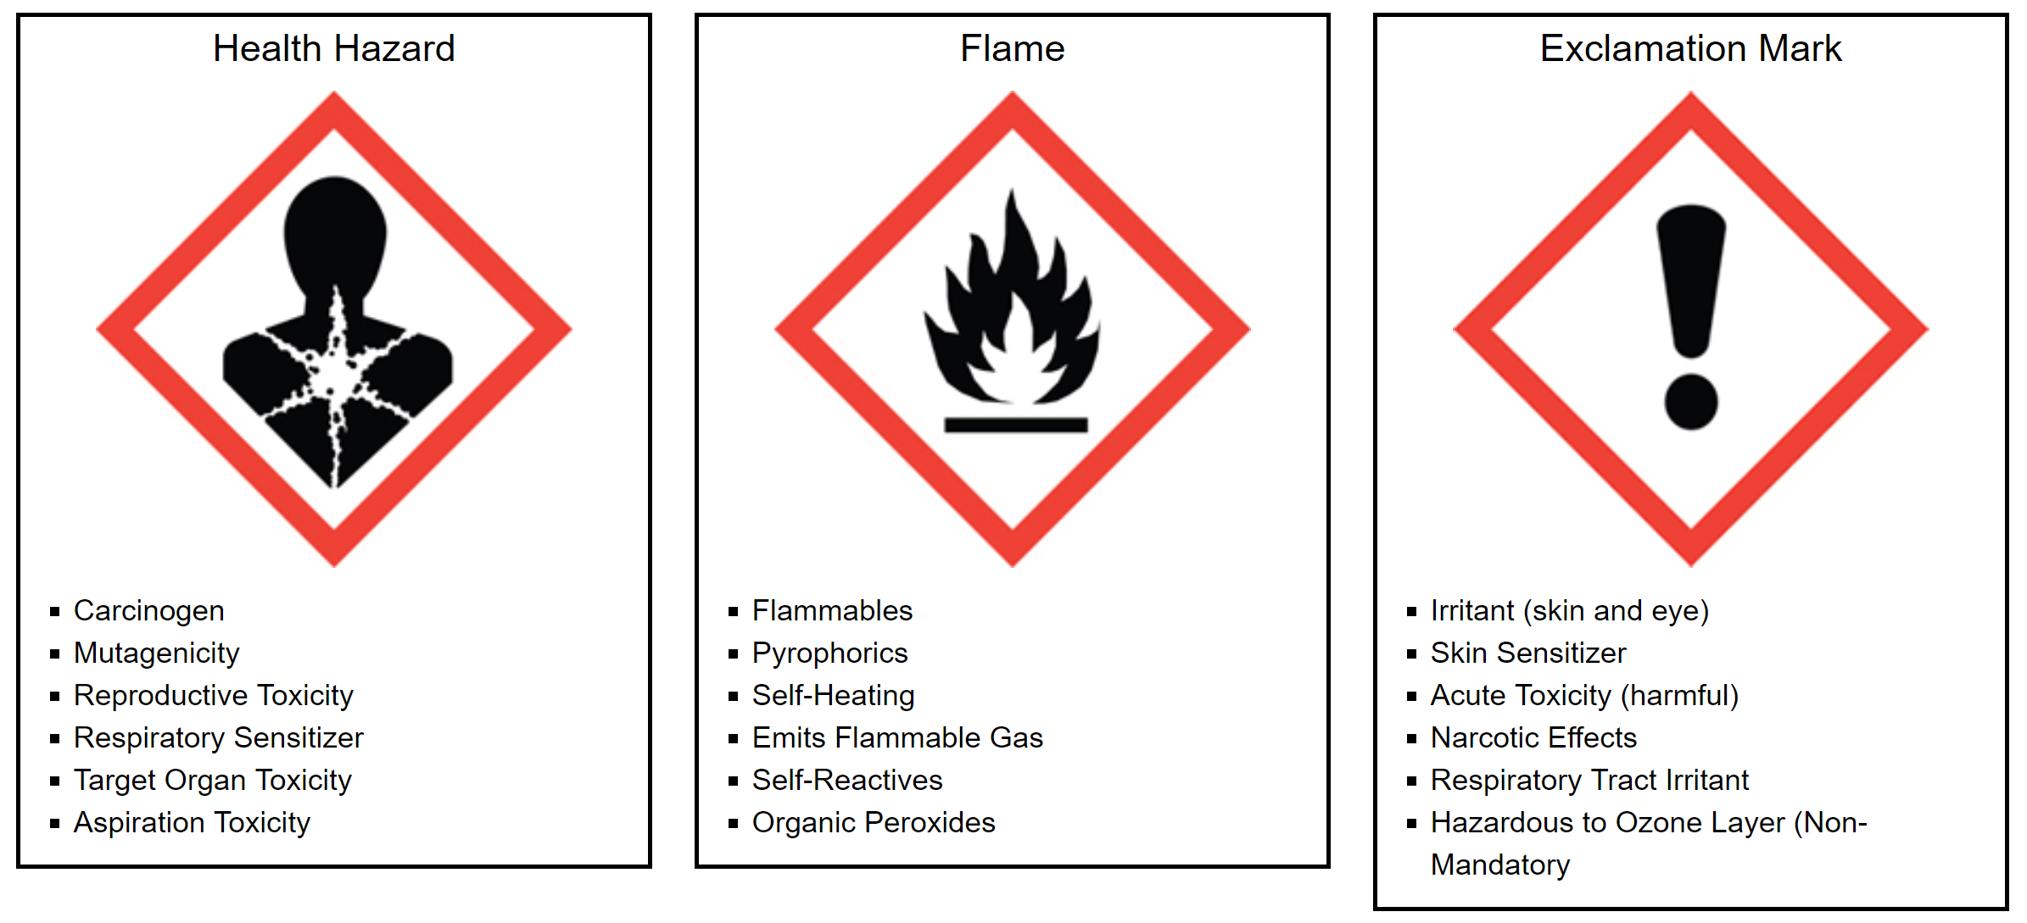

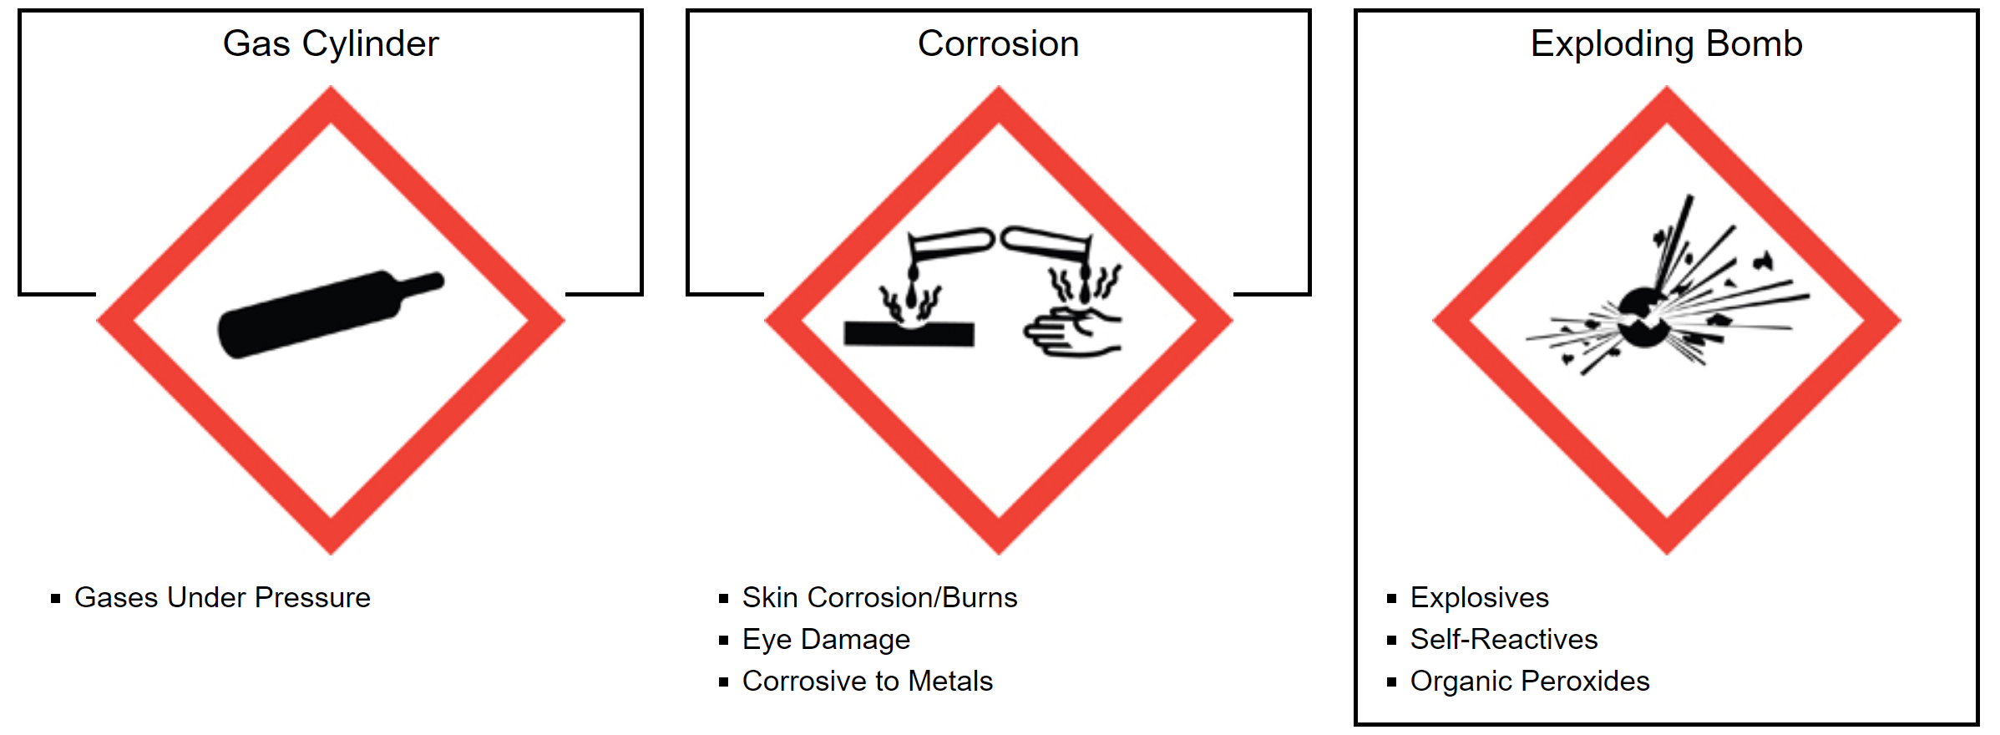
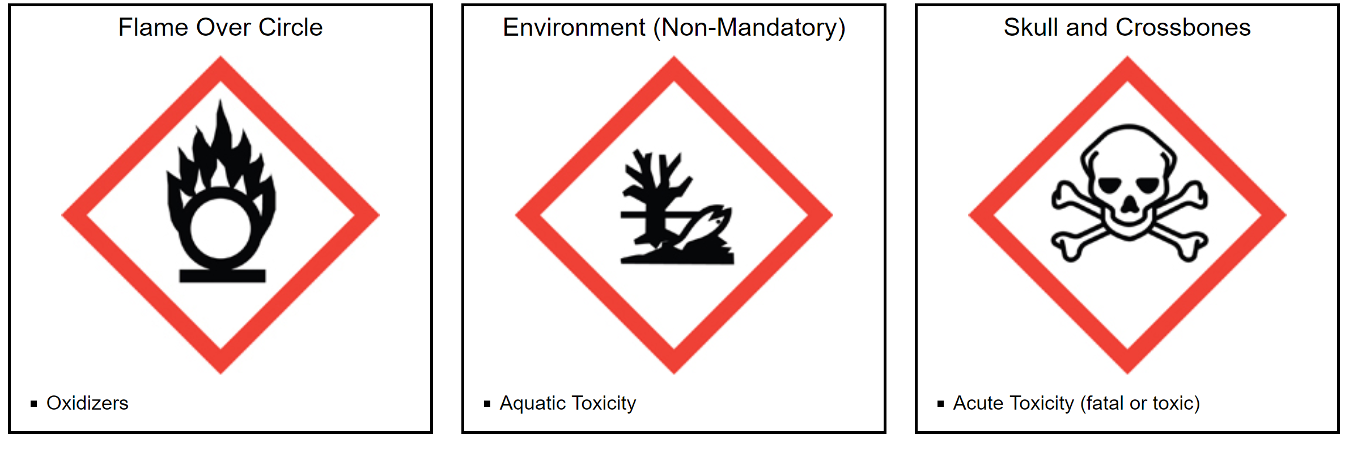

B.5 Chemical Disposal

All chemicals must be disposed of in a safe and environmentally friendly manner. Any chemical substance which is corrosive, flammable, reactive, toxic, radioactive, infectious, phytotoxic, mutagenic, or acutely hazardous must be treated as hazardous waste. Do not dispose of chemicals by evaporation in a fume hood or in the sink! Do not hesitate if any questions occur about the hazards of a material.

Collect and store chemical waste in containers which are clearly labeled. Do not combine containers unless the contents in each container are known, compatible, and it is safe to do so. Combined wastes are much more difficult and costly to dispose of properly.

Ordinary waste such as paper, cardboard, etc., may be placed in the wastebasket. However, contaminated waste must be disposed of separately in a labeled container.

Empty chemical containers must also be disposed of in an acceptable fashion. They must first be cleaned and then either returned to Chemical Stores or disposed through normal trash.

