Local Section CIO Summary - February 2012

Local Section Membership Reports
Would you like to know how many local sections have renewed their 2012 LS memberships with National? Want a list of LS members that have not renewed yet? Looking to expand LS membership and want a list of AIChE members living in the area served by the LS. This password protected information is available. Click on

http://apps.aiche.org/LSDivForumMemberList/Login.aspx?ReturnUrl=%Tom2fLSDivForumMemberList%2fDefault.aspx

Upcoming Events

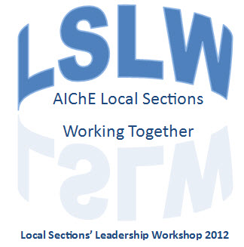

Local Section Leadership Workshop March 31st – April 1st
Houston, TX

http://www.aiche.org/leadershipconference.aspx

February 7-9 | Carbon ManagementTechnology Conference  http://www.carbonmgmt.org/ | Orlando, FL
Multiple Dates | Student Regional Conferences  Email studentchapters@aiche.org to get involved. | Multiple Locations
April 1-5 | Spring Meeting & 8th Global Congress on Process Safety  http://www.aiche.org/Conferences/SpringMeeting/index.aspx | Houston, TX
April 29-May 2 | 3rd International Conference in Stem Cell Engineering  http://stemcell.aiche.org/ | Seattle, WA
June 5-7 | 2012 AIChE Process Development Symposium  http://processdevelopmentsymposium.aiche.org/ | King of Prussia, PA
June 24-27 | 6th Int’l Conference on Bioengineering and Nanotechnology  http://icbn.aiche.org/ | Berkeley, CA

Upcoming Awards and Grant Deadlines

Submission Deadlines | Title
February 15 | Institute & Board of Directors Awards  http://www.aiche.org/About/Awards/InstituteandBoard.aspx
March 31 | John J. McKetta ProjectConnect Grants  http://www.aiche.org/LocalSections/Resources/PCGrant.aspx
March 31 | Program Planning Grant for Local Sections  http://www.aiche.org/programplanning.aspx

For additional information on Awards offered through AIChE, please click here.

Resources for Local Sections
  - Speakers Corner: http://www.aiche.org/LocalSections/Resources/Speakers.aspx
  - Virtual Local Section: http://virtual.aiche.org/
  - Mentoring Programs:
    - Fellows: Please contact Al Wechsler
    - Mentor Center: http://www.aiche.org/mentorCenterRestricted.aspx or contact Camille Belcuore.

AIChE Staff Support
- AIChE Membership Programs: Marty Clancy – 646.495.1330
- Local Section Program Lead: Donia Elsherbeni – 646.495.1331
- Local Section Support: Idell Bryan – 646.495.1333
- Young Professional Program Lead: Arjun Gopalratnam – 646.495.1382
- Student Program Lead: Michelle Marsnick - 646.495.1364
- Local Sections Committee Chair: Alan Zagoria

Featured Local Section – St. Louis



The St. Louis Local Section of AIChE has some very interesting events coming up this spring, including a Trivia Contest, Star Trek Outing, and a Career Day at Washington University. For more information or to ask for advice on throwing interesting events, please contact them at http://stlouis.aiche.org/content/officers.

