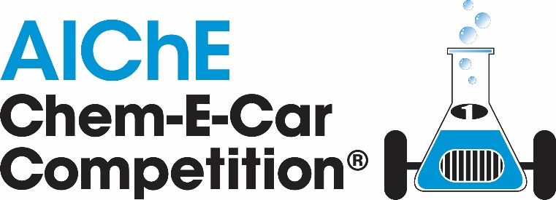

2024 Student Regional Conference Competition Official Rules
 | Date | Checklist of Important Deadlines
□ |  | Find your Conference at www.aiche.org/conferences/student  Review Rules, EDP Document & Safety Training information at www.aiche.org/chemecar  Submit questions at www.aiche.org/chemecarquestions
□ | February 9th - August 31st | All teams are required to complete and submit an Engineering Documentation Package (EDP) 5 weeks before competition date.  Teams will receive EDP Review Feedback on the safety aspects of their design so they can prepare for the On-Site Safety Inspection.  Submission links and deadlines can be found in the table below.  Region EDP Submission link & deadline Conference Dates  Southern February 9th March 15-16  North Central March 1st April 5-6  Rocky Mountain March 1st April 5-6  Mid America March 1st April 5-7  Mid-Atlantic March 1st April 6-7  Southwest March 8th April 12-13  Eckhardt Northeast March 15th April 19-20  Pacific Northwest March 22nd April 26-27  Western March 22nd April 27-28  Middle East (MEPEC) March 17th May 6-8  Brazil June 21st July 29 – August 2  India July 5th August 9-11  Latin America-Procesa July 19th August 26-29  Indonesia TBD TBD
□ | Competition Weekend | Bring all items to On Site Safety Inspection & Competition  - Poster  - Printed EDP, EDP Supplement and MOC Form in binder/folder  - Printed EDP Review Feedback  - Printed Waste Tags to use at competition  - Chem-E-Car  - PPE for all team members  - Portable personal electronic device covers

Summary of Changes, February 2024 Revision

Changes to Competition Rules
No significant changes were made to the Competition Rules for 2024 Regional Competitions.

Changes to Safety Rules
- Safety Rule 1.1.7 updated to provide clearer instructions for Standard/Safe operating procedures page of the EDP Template
- Date requirement added to Safety Rule 1.2.1 Safety Data Sheets (SDS)
- Section 6 Disposal of Chemicals updated and expanded, including updated waste streams and new requirement of waste tags for waste disposal at the competition.
- Rule 13 clarified by specifying “No Specially Regulated Carcinogenic Chemicals”, rather than just “No Regulated Chemicals”
- Clarification on what is intended by Rule 14. No Highly Reactive/Unstable Chemicals

Chem-E-Car Competition Overview

The objectives of the AIChE Chem-E-Car Competition:
- To provide chemical engineering students with the opportunity to participate in a team- oriented hands-on design and construction of a small chemical powered model car;
- To demonstrate the ability to safely control a chemical reaction by changing a chemical reactant(s);
- To design and construct a car that is powered with a chemical energy source that will travel a given distance and stop;
- To encourage students to become actively involved in their professional society;
- To increase awareness of the chemical engineering discipline among the general public, industry leaders, educators and other students.

There are two general competitions. The first is held at regional conferences and the second is held at the Annual Student Conference at the site of the AIChE Annual Meeting.

Please note that the Regional Competitions and Annual Competitions are separate competitions. Passing the safety inspection at the Regional Chem-E-Car Competition does not guarantee that your team will pass the safety inspection at the Annual Student Conference Chem-E-Car Competition.

All Chem-E-Car Teams must be from active Student Chapters that submitted a Student Chapter Annual Report online to AIChE. Visit www.aiche.org/studentchapterannualreport to submit a report.

There is a poster session, safety inspection and a performance session at each competition, as detailed below.

During the competition, each team will be asked to introduce its entry to the audience, giving the school name and briefly discussing the propulsion and stopping mechanisms. Teams will also have the opportunity to submit a video showcasing their team at the Annual Student Conference competition.

Regional Conference Competition

- Schools may be limited to one entry per University, at the discretion of the Regional Conference Host Chapter and Regional Safety Coordinator
- The official rules listed apply for the regional conference competition and the Annual Student Conference Competition.
- An AIChE-appointed safety and rules coordinator will attend each regional competition. This coordinator is the final authority regarding Chem-E-Car Competition® rules, safety concerns, violations, disqualifications, and the like, for that Regional Competition only.
- The coordinator's judgment applies only to the regional competition and is not binding on judgments at the competition at the Annual Student Conference.

Regional Conference Awards

Sponsored by

- Performance Competition: 1st place: $200 & 2nd place: $100
- Poster Competition: 1st – 3rd Place: Certificates

Annual Student Conference Competition

The top teams from Regional Chem-E-Car Competitions will be awarded the opportunity to compete at the global competition taking place at a future AIChE Annual Student Conference in the United States. This is the only way to earn an invitation to this global event.

North America Regionals

- Mid-America: Top 3
- Mid-Atlantic: Top 5
- North Central: Top 5
- Northeast: Top 3
- Pacific Northwest: Top 2
- Rocky Mountain: Top 3
- Southern: Top 5
- Southwest: Top 2
- Western: Top 3

International Regionals

- Brazil Top 1
- China Top 3
- Colombia Top 1
- India Top 2
- Indonesia Top 1
- Middle East Regional Top 3

Only one entry per school, via this qualifying procedure, will be allowed at the Annual Student Conference competition no matter how many compete at regional competitions

NOTES:
- If your team participated in a regional conference but did not qualify, or if your team is located in a region that does not offer a regional conference, you may fill out the Chem-E-Car waitlist form, released annually and linked here, to be added to the waitlist sometime in July or August, 2024.

Annual Student Conference Competition Awards

Sponsored by and the H. Scott Fogler Endowment Fund

The Annual Student Conference Competition associated awards are:
- The H. Scott Fogler 1st place award: $2000 USD and a trophy
- 2nd place: $1000 USD and a trophy
- 3rd place: $500 USD and a trophy
- 4th & 5th place – trophy
- Best Use of a Biological Reaction to Power a Car sponsored by the Society for Biological Engineers- $500 USD
- SAChE Safety Award for the best application of the principles of chemical process safety - trophy
- Spirit of the Competition for the team displaying the most team spirit as decided by a panel of judges- trophy
- Most Innovative Car Design to be decided by judges - trophy
- Golden Tire Award for the most creative car as decided by the teams- trophy
- Best Video – trophy
- Chem-E-Car Poster Award – 1st- 5th place- trophy
- Outstanding Sportsmanship Award- trophy
- Best Team Name- trophy

Chem-E-Car Competition Poster Session & Safety Inspection Rules

- Poster overview:
  - A poster board must be displayed with the autonomous vehicle on the day of the competition. This poster should clearly describe:
    - How the car is powered by a chemical reaction
    - How it stops on a chemical reaction
    - Unique features of the car
    - Environmental and safety features in the design
    - Vehicle design description, drawings and testing results

- Team Members:
  - The poster competition and judging will occur prior to the Chem-E-Car Performance Session. Team members must be present during judging to answer questions from the judges.

- Minimum Score:
  - A team must achieve a passing score in the poster competition to be able to advance to the Chem-E-Car Performance Competition. Posters will be judged according to the following criteria:

- Quality of the poster and team member presentations (50%)
- Design creativity and unique features of the vehicle and safety considerations (35%)
- Demonstration of knowledge of reactions, calibration methods by all team members, and ability by team members to answer questions posed by the judges (15%)

- Winners:
  - Winners of the poster competition will be announced at the end of the performance competition.

- Safety inspection:
  - During the poster competition, an audit team will inspect each vehicle to ensure that all of the safety requirements have been met and that the vehicle will operate without risk to the operators, contest staff and spectators.
  - If the audit team deems the vehicle safe to operate, then the vehicle will be given permission to compete.
  - This permission is not automatic and must be earned by adhering to the guidelines/procedures outlined below. If a car is deemed unsafe, then it will not be given permission to compete.
  - The Chem-E-Car Competition Safety Judges at the competition site have the final say in regard to permission to compete, regardless of whether a car was given permission to operate at a previous Regional competition.

Chem-E-Car Competition Performance Session Rules

- Distance
  - Each car will be given two opportunities to traverse a specified distance.
  - The required distance will be given to each team one hour prior to the start of the performance competition. The distance will be between 15 and 30 m ± 0.005 m.
  - Teams may not make significant changes to their vehicle once the poster session has concluded, unless they have prepared, and have an approved management of change (MOC). Teams are only allowed to adjust "fuel" or chemical reactants used in the car's chemical reaction.
  - The distance will not change for the final round.

- Course Layout and Distance Measurement
  - The course will be no more than 5 meters wide in a straight line. For regional virtual conferences the course may be less than 5 meters wide, depending on the university track location.
  - At the Regional Competitions only 1 track will be used. At the Annual Student Conference Competitions, 2 identical tracks will be set up and run in parallel.
  - The car will start with its front end just touching the designated starting line, with the goal of keeping the car in bounds to a designated finish line. The performance is determined by the distance from the front-most point of the car to the finish line, whether or not the car stops before or after the finish line.
  - A vehicle that goes out of bounds will be given a penalty for that run of 3 meters.
  - “Out of bounds” is defined as when any part of the car crosses or touches the boundary. If tape is used to mark the side boundary or the out-of-bounds after the finish line, the inside edge of tape is considered the course boundary (If a wall is set as track boundary then contact with the wall is out of bounds).
  - If the car starts going backwards at the starting line, the score will count as 0m traveled.
  - The site location may also dictate an out-of-bounds region past the finish line. Vehicles traveling across the plane of the out-of-bounds region will be disqualified for that attempt.
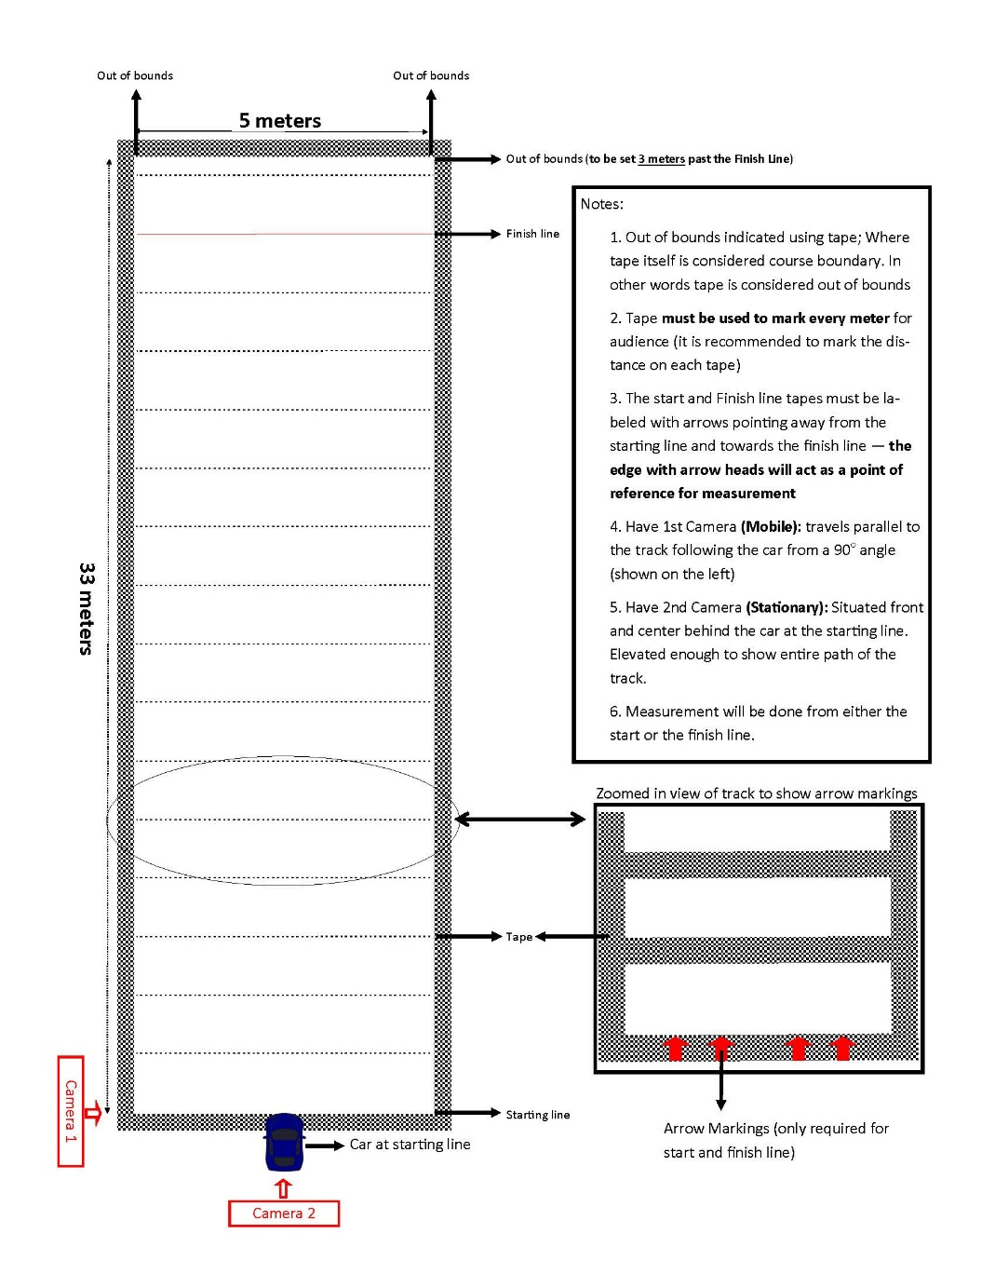

Figure 1: Performance course layout. Camera guidelines apply to Virtual Competition only.

- Race Logistics
  - A Chem-E-Car Competition® judge (or MC) will announce each team just prior to the start of their attempt.
  - Each car will have two (2) attempts to complete the course. Each attempt is limited to a two (2) minute time limited for the car to start and completely stop. Any car that does not stop within the two minutes will be disqualified for that attempt.
  - The best score of the two attempts will be used to determine the winner.
  - In the event that a team fails to show up on the starting line, or the vehicle fails to start, the next team in the order of the competition will be announced and requested to proceed to the starting line immediately.
  - The competition order will not change between the first and second rounds. There will be a short 15 minute break between rounds of the competition.

- Starting Line Procedure
  - The car must start moving, traverse the distance, and come to a stop within a 2 minute time interval.
  - At the starting line, 1 team member will be asked to head to the finish line. Team members are responsible for picking up their car after the distance is measured.
  - Once the car is placed on the starting line and the 2 minute time interval begins, all wheels must remain on the ground. Pushing the car or picking up the car/part of the car will result in a disqualification for that attempt.

- Competition Order Logistics
  - The distance and run order is announced one hour before the competition starts.
  - If a car is disqualified that was scheduled to start before your car, then you will move up one position in the starting order.
  - Five (5) minutes before the start of the competition, the first three (3) teams for each track are called to the start. The first team for each track will be at the starting line, the second team at the ready table, and the third team beginning to move to the “at ready” position.
  - The first team is given a one-minute warning before the competition starts.
  - Each team is given two (2) minutes for the car to start moving from the time they are called to the starting line.
  - Cars are permitted two (2) minutes to traverse the distance and stop.
  - The timing will also stop if the car travels out of bounds.
  - If the car does not stop within the two-minute period, then it is disqualified from that round of the competition.
  - After the car stops, the distance traveled is measured. Once the distance measurement is completed, the next team moves from the ready table to the starting line.
  - Repeat 10.5 – 10.9 for the remainder of the competition.

- Vehicle Drive System
  - An objective of this contest is for students to demonstrate the ability to control a chemical reaction.
  - The only energy source for the propulsion of the car is a chemical reaction.
  - The distance a vehicle travels must also be controlled by a chemical reaction, based on a quantifiable change and direct control of the concentration of a chemical species.
  - This chemical reactant species must be a solid, liquid, or vapor.

- Vehicle Design
  - Vehicles entered into the competition must have a significant and demonstrable student design component, particularly with respect to the vehicle drive system, and the starting and stopping mechanisms.
  - Both the chemical reaction propelling the vehicle and the start/stop reaction (if there is one) must be physically on the vehicle during the competition (i.e., pre-loading of a drive system such as a capacitor assembly is not allowed).
  - The vehicle must be powered by a chemical reaction and must be stopped by a quantifiable change, and direct control, of the concentration of a chemical species.
  - This chemical reactant species must be a solid, liquid, or vapor.
  - Autonomous vehicle: The car must be an autonomous vehicle and cannot be controlled remotely. Pushing to start the vehicle is not allowed. Any forward movement of the car at the start not related to the chemical reaction will lead to disqualification. “Bleeding” the time off at the starting line or prior to the starting line is prohibited. Raising the vehicle at the starting line to allow the wheels to begin turning is not allowed.
  - On-board computer control system (ex Arduino or Raspberry Pi unit) are allowed but must not in any way control/ measure the distance traveled. The program must be loaded onto the controller/computer/processor prior to the competition, and the settings may not be changed after the competition begins, which is defined as the time when the distance is announced.
  - Wired or wireless communication with the on-board computer/controller is not allowed once the competition begins and during the competition.
  - Teams may be asked to provide a copy of their complete programs to the rules committee on the competition day.
  - Encoders: Teams are also not allowed to use an encoder to regulate the velocity of the vehicle in order to control the distance.
  - No Mechanical brakes: No mechanical force can be applied to the wheel, gears, driveshaft, etc., or ground to slow or stop the car (e.g. no brakes).
  - Mechanical or electronic timing devices: There can be no mechanical or electronic timing device(s) to stop the chemical reaction or stop the car. In addition, a timing device cannot utilize what is normally considered as an instantaneous reaction. For example, a constant or draining liquid feed to a sensing cell that employs an instantaneous reaction (such as acid-base or precipitation) would not be allowed. Another example would be a liquid draining out of a vessel to serve as a stop switch. This would be considered a mechanical timing device and would not be allowed.
  - ICE: Internal combustion engines using an alternative fuel (e.g., biodiesel, ethanol, etc.) are allowed. The fuel MUST be completely synthesized by the students (no additive blending is allowed). Succinct safety procedures for the maintenance and operation of this engine must be demonstrated by the team, with considerations to indoor operation. Internal combustion engines are not allowed to emit visible combustion smoke to the competition space and are subject to sound restrictions. See the Safety Rules for a more complete discussion.
  - Thermo-Electric Device (Power system): Thermo-electric thermopiles purchased from a manufacturer must be run with at least one side (hot or cold) controlled by a chemical reaction. NOTE: Phase changes (including melting and crystallization), mixing and dissolutions are not considered a chemical reaction.
  - Fuel Cells: Any vehicle that is purchased from a vendor without major modifications to its operation will be disqualified. For example, a team could not purchase a fuel cell car and race this car without any modifications. Any team that purchases a commercial fuel cell or builds their own fuel cell must synthesize the fuel that is used; example, if the team purchases a commercial methanol fuel cell, they must synthesize the methanol and provide verification of their procedure. Hydrogen for fuel cells MUST be generated by a chemical reaction on site and or on the vehicle and not from a commercial device or pre-loaded canister. Appropriate process safety must be followed during fuel synthesis. The synthesis procedure must be clearly defined in the EDP.
  - Commercial batteries: No commercial batteries of any kind (for example, AA batteries) are allowed as the power source. Commercial batteries are allowed for specialized instrumentation (e.g. detectors, sensors, valves).

- Size of Car
  - All components of the car must fit into a box of dimensions no larger than 40 cm x 30 cm x 20 cm. The car may be disassembled to meet this requirement.
  - If the judges are uncertain whether the car will fit inside the box when dissembled, they may request that the team demonstrate that they can do this.

- Capital Cost of Vehicle:
  - The cost of the all vehicle components and the chemicals must not exceed $3500 USD. The vehicle cost includes the donated cost of any equipment.
  - The time donated by university machine shops and other personnel will not be included in the total price of the car. It is expected that every university has equal access to these resources.
  - The cost of pressure testing is also not included in the capital cost of the car.
  - The method used to estimate the donated cost of the equipment must be shown. It is expected that standard financial procedures will be used to estimate this cost.
  - Teams are required to include their vehicle’s capital cost in their EDP.

- Team Member Status and Conduct
  - All team members must be active AIChE members and must be registered for the Regional Conference or Annual Student Conference.
  - Faculty and graduate students can only act as sounding boards to student queries. The faculty cannot be idea generators for the project.
  - There is no restriction on requesting assistance on vehicle safety – teams may request safety assistance from their faculty advisor, other faculty members, other universities, and professional practitioners in industry and elsewhere.
  - All questions posed by rules and safety judges at the safety inspection and poster session must be answered by the undergraduate student team members. The ability to explain car design, operation, safety and/or rules compliance is the responsibility of the undergraduate students.
  - The students working on the project must sign a statement saying they have read, understand, and abided by the rules. This statement must be included in the EDP.
  - For in-person: During the performance competition session, only five (5) team members are allowed in the pit area at once. Team members can be swapped out during the competition. For Virtual: During the performance competition session, teams are not limited to a specific number of team members that are allowed in the pit area.
  - All team members and the faculty advisor MUST have completed the required safety training course, which is available at www.aiche.org/chemecar. All participating students must retake the course annually.
  - All student chapter teams that are competing in the Chem-E-Car Competition must have submitted a Student Chapter Annual Report online to AIChE. Note: New AIChE Student Chapter established after January 1, 2023 are exempt from this requirement.

- Winning Team and Awards
  - The winning team is the car that stops closest to the competition distance. This is defined as the absolute value of the distance between the front-most part of the car and the finish line, whether or not the car stops before or after the finish line.
  - In case of ties, the team with the best average from the two attempts may be declared the winner.
  - Winners of the Chem-E-Car Performance Competition will be known immediately following the performance competition.

- Onsite Safety Judges and Rules Coordinators: If there is any uncertainty on an issue of safety or other judging criteria, please contact the Chem-E-Car Committee. The decisions of the onsite rules and safety judges are final.

2023 Student Regional Conference Competition Safety Rules

Chem-E-Car Safety Program Overview

The objectives of the AIChE Chem-E-Car Competition Safety Program are to ensure the safe preparation and operation of vehicles during all phases of the competition, including construction, testing and the competition. An audit of your system design and safety compliance will be conducted from the documentation your team provides.

The safety audit of your vehicle will occur in two stages:
- Online audit where teams will submit a fully completed Engineering Documentation Package (EDP) electronically and receive feedback. A member of AICHE staff will communicate EDP instructions to all teams. Failure to meet the posted deadline and by not submitting a fully completed EDP will result in exclusion from the competition. The EDP template is available for download on the Chem-E-Car Competition Rules Website at www.aiche.org/chemecar.
- In Person: Onsite Audit on competition day where teams must bring printed EDP, EDP Supplement, EDP feedback and MOC Form in a folder or binder and be ready to answer questions from safety reviewer. For Virtual: Onsite Audit will be done ahead of the competition day by the Onsite Safety Judge; teams must provide printed EDP, EDP Supplement, EDP Feedback and MOC Form in a folder or binder Failure to pass this stage of the competition will result in receiving a disqualification from the competition.

Competition Safety Rules

- Safety Audit: Online
  - EDP. An engineering documentation package (EDP) for your Chem-E-Car must be fully completed and submitted by the posted deadline. A complete EDP will include the following in the following order:
    - Job Safety Analysis: Includes a description of your car and how it works.
    - Photos: Pictures of your vehicle after construction has been completed. These pictures must be current. The entire car must be visible in the picture. Remove the top to expose electrical controls if necessary. Multiple detailed views of the car are required. A drawing or AutoCAD document is NOT acceptable.
    - Safety Training and Rules Certifications Page: This page must be signed by all team members and your faculty advisor. Judges will use this page to determine: (1) If the starting and stopping mechanisms are compliant with the rules, (2) If everyone has completed the required safety training and (3) that you have identified the major hazards and have controlled them properly. The certification page must be signed by the date of the competition. Note that your group must have a minimum of 10 hrs. of operating time on the car prior to the faculty member signing. Note: The time you spend building the car cannot be counted as operating time.
    - Hazards Analysis: Complete all pages, including attaching the floor plan/diagram of the laboratory where you are building your car.
    - Chemical Information: Includes a description of the chemistry involved, and a list of chemicals to be sent to the competition if in person, or to be used at the competition, if virtual
    - Chemical Hazards and Disposal: This section requires your team to conduct chemical research related to the chemicals you handle. List the properties for every chemical. Refer directly to the SDS for this information Resources like the NIOSH pocket guidebook, CAMEO, and New Jersey Hazardous Substance Fact Sheets can be used for supplemental information as needed.
    - Standard/Safe operating procedures page: Provide step-by-step details for the safe start-up, operation, shut-down, and clean-up of your vehicle. This page should be detailed enough so that someone unfamiliar with your vehicle should be able to safely prepare solutions for and operate it.
    - Equipment Table: A complete list of every piece of equipment on the car in table format, including the manufacturer of each piece of equipment. Include operating limits (max temperature and pressure) for each piece of equipment, and ensure material compatibility where pertinent. When manufacturing spec sheets are absent, students should rely on the material properties for these limits.
    - Pressure: For Cars with Pressure Greater than 5 psig (0.345 barg): Please complete and add the following to your EDP document: A quantitative design basis for pressure relieving load; Sizing calculations for a pressure relief device; and Test procedure and results for a pressure relief. The textbook “Chemical Process Safety” by Crowl and Louvar can be used as reference. Please see Appendix A of the Safety Rules for full instructions on what is required for Pressure Testing.
    - Hydrogen gas discharge calculations (include for any flammable component). If you are using hydrogen gas, and plan to discharge a small amount, you must provide calculations demonstrating that the discharged amount is below the LEL/LFL for the control volume.
    - Management of Change Form: After the online EDP review, you must complete any changes suggested by the EDP Reviewer and document these changes in the Management of Change (MOC) form. This MOC must be presented during the onsite safety inspection.

  - EDP Supplement. Please combine the following information in another single, separate PDF and should be titled “University Name EDP Supplement”.
    - Safety Data Sheets (SDS) made or revised after 2012 for all chemicals used or generated by reaction.
    - Manufacturer’s specification documents or specifications for custom-built components. For any commercial or custom built components, students must list material and compatibility.
    - Safety Training Course Certificates for each team member + Advisor
    - Any additional information you need to save regarding your EDP that is not contained within the original EDP document.

- Safety Audit:
  - Onsite (In-person). On the day of the competition, an audit team will inspect each vehicle to ensure that all of the safety requirements have been met and that the vehicle will operate without risk to the operators, contest staff and spectators. The Safety Judges at the competition site have the final say in regard to permission to compete, regardless of whether a car was given permission to operate at a previous regional competition.
  - Virtual. During the Safety Inspection, a faculty member serving as the Onsite Safety Judge will inspect the team’s vehicle to ensure that all of the safety requirements have been met and that the vehicle will operate without risk to anyone present at the competition site. The safety Judges at the competition site have the final say in regard to permission to compete, regardless of whether a car was given permission to operate at a previous regional competition.
  - Permission to compete. If the audit team deems the vehicle safe to operate, then the vehicle will be given permission to compete. If a car is deemed unsafe, then it will not be given permission to compete therefore rendering it unfit to run during the performance competition.

- Disallowed Chemical Handling/ Illegal Chemical Transport & Storage
    - Transport Chemicals. Teams are not allowed to transport hazardous chemicals by car to the competition site. No chemicals should be transported in private, university or rental vehicles to and from the competition site, even over short distances.
      - Household Chemicals. Common household chemicals, in the concentration in which they are sold, such as baking soda, vinegar, etc., are exempt from this rule. To qualify as a common household chemical, the chemical must be available for purchase and pickup from a retail location such as a grocery or hobby store.
    - Shipping Chemicals. Chem-E-Car teams should work with their University EHS department to make sure everything is shipped according to all DOT Hazardous Material Shipping laws. Make sure everything is properly labeled.
    - Illegal Chemical Storage. Chemicals must not be stored in hotel rooms or other facilities not rated for chemical storage. The exception to this rule is common household items such as baking soda and salt.

- No Compressed Hydrogen Gas Cylinder Usage
  - Hydrogen Generation. All hydrogen used on the vehicles (for instance with fuel cells) must be generated on-site or on the vehicle keeping the pressure below 5 psig (0.345 barg). Appropriate safety precautions and safe operation must be demonstrated. Hydrogen generation cannot begin until chemicals are given out on competition day.
  - Commercial Hydrogen Storage Canisters. Filling of vessels from a compressed hydrogen gas cylinder or commercial hydrogen storage canisters (such as hydrostiks or solid–core hydrogen cartridges) will not be allowed.

- Illegal Testing of Vehicles
  - Testing Location. Testing of vehicles must only be done in a laboratory or other facility with chemical handling capability. Testing in hotel or dorm hallways, warehouses, or other facilities that are not designed for chemical handling is not allowed. No mixing of chemicals, including common household chemicals is allowed in the hotel or in dorm hallways.

- Disposal of Chemicals. Disposal of waste represents both significant risk and cost to the competition. Teams are expected to be knowledgeable in all of their generated waste streams. All chemicals shipped to and waste generated from the competition site must be disposed of in a safe and environmentally friendly fashion in compliance with all local, state and national regulatory measures. Please minimize chemicals shipped to the competition site in order to reduce disposal costs.
  - On-Site Disposal. Teams are responsible to make each of their waste streams safe for disposal in one of the following available waste streams: Acid, Base, Organic, Aqueous, Solid Waste. All team assembled items disposed in solid waste must be separated into their individual components with a neutral pH (pH 6-8) and contained in their own water tight container with a copy of their Team Waste Tag securely attached to the container.
  - Team Waste Tags. Team Waste Tags must be completed ahead of the competition based on anticipated waste streams and included at the end of the teams Engineering Design Package. Team Waste Tags must accompany all discharges of waste into AIChE waste containers and include at a minimum: Description of waste, Concentration, Volume, Team name, Table number.
  - Illegal Disposal. Failure to follow these rules on chemical handling may result in a safety incident being attributed to your team and possible suspension from future competitions. See 28, Accidents/Incidents.

- Flames/smoke/noise. All cars are restricted from having any open flames or emitting any smoke. Cars shall not have internal flames. Any team that generates any open flame or smoke in the prep area or on the track will be disqualified.
    - Internal combustion engines (ICE). The only exception to this rule is that an internal flame is allowed in a commercial internal combustion engine (ICE) that uses an alternative fuel that is synthesized by students. Cars with ICEs are not allowed to produce smoke during the attempt. Succinct safety procedures for the maintenance and operation of this engine must be demonstrated by the team. In addition, cars with an ICE must show a demonstrable and significant student design component.
    - Noise. Noise from internal combustion engines must not exceed 90 db (as measured from a distance of 1 meter).
    - Gas Discharge. Gas discharge from an ICE shall be permitted when the exhaust has been properly filtered by a catalytic converter or other filter media to remove hazardous exhaust materials with including soot, obnoxious odor, and smoke.
    - Gas Discharge from a reaction: Any byproducts with an NFPA health rating of 3 or 4 must be scrubbed or removed prior to discharge.

- Liquid/Vapor/Odor Discharge. No liquid discharge, including water, is allowed. No obnoxious odor is allowed either through discharge or during use. All liquid products of reaction should be properly collected and contained within the vehicle, and properly disposed of (example, use of a scrubber/ holding tank). Discharge should only occur during emergency relief situations to protect the equipment from rupture and/or explosion.
    - Hydrogen Discharge. An exception to the 'no gas discharge' rule is that a small amount of hydrogen discharge is allowed. A 'small amount' is considered a gas discharge below the LFL/LEL of hydrogen for the given volume of the reactor, chamber or fuel cell in which hydrogen is stored. Students should provide calculations in the EDP to prove to the reviewer that any discharged hydrogen is well below the LFL/LEL.
    - Release of Pressurized Gas. Although pressure relief devices are required as a means of protection, the release of pressurized gas during the competition (greater than 5 psig [0.345 barg]) is not allowed. If a PRV functions during the attempt for any reason that attempt will be disqualified.
    - Gas Discharge Unpressurized, untreated gas discharge as a reaction byproduct is allowed without filtration for gases containing an NFPA health rating of 0, 1, or 2. (Example - water vapor, or CO₂ are OK, H₂S and SO₂ are not OK). The onsite safety personnel may disqualify any entry where the gas discharged by a vehicle is deemed improper. Disqualification due to excessive gas production is at the discretion of the observing safety committee, and the ruling is final and cannot be challenged

- Reactive Materials. Teams using any chemicals with potential air/oxygen reactivity MUST purge the system with an appropriate inert gas.

- Open and/or Improperly Secured Containers. All containers on the vehicle containing chemicals (including water) must be securely attached to the vehicle to prevent the container from tipping over during the competition. The lid to this container must also be securely attached to the container and must be capable of preventing escape of the chemical during any phase of the competition, including an accident involving tipping over of the vehicle.

- No Open containers, pipetting, or chemical pouring at the Starting Line or at the ready table. No open containers or manual pouring/pipetting of chemicals is permitted at the starting line or ready table. Built-in chemical reservoirs must be filled at the team’s preparation table and securely attached to the car prior to moving to the ready table and starting line. Manual or automatic valves or switches can be used at the starting line. Violations will result in that run being disqualified – built-in chemical reservoir is still subject to containment requirements, MOC compatibility, double containment, lid, etc., if necessitated based on the chemical(s) contained.” All containers on the vehicle must have a secure lid and must be properly managed to prevent spillage.
  - Starting Line Procedure. All chemicals must be on the car and secured in fixed containment on the vehicle before walking to the starting line. Nothing may be carried away from the start line or left at the ready table. If any parts fall off the car either at the starting line or in competition will result in disqualification of that attempt. All containers, packets, etc. must be properly labeled and contained.
  - No Manually Plunged Syringes at the Starting Line or at the ready table. Teams cannot manually plunge a syringe at the starting line or the ready table. Manually plunged syringes cannot be included in the car design. This rule change is also to promote better and safer design. Labeled syringes or pipettes can be used at the team’s preparation table, but sharp needles are not permitted.
- No Sharp Needles. Sharp needles cannot be used in any capacity (including, but not limited to in the operation and preparation of the vehicle) in Regional or Annual competitions.
- No Specially Regulated Carcinogenic Chemicals. A number of carcinogenic chemicals are listed by OSHA as a special carcinogenic hazard. The handling of these chemicals is outside the scope of the management systems available during the competition. Such chemicals are therefore not permitted. See www.osha.gov for details. These regulated chemicals include:

1,2-Dibromo-3-chloropropane | Beta-propiolactone
1,3-Butadiene | Bis-chloromethyl ether
2-Acetylaminofluorene | Chromium (VI)
3,3'-Dichlorobenzidine | Cadmium
4,4'-Methylenedianiline | Coal tar pitch volatiles
4-Aminodiphenyl | Ethylene oxide
4-Dimethylaminoazo-benezene | Ethyleneimine
4-Nitrobiphenyl | Formaldehyde
Acrylonitrile | Inorganic arsenic
Alpha-napthylamine | Methyl chloromethyl ether
Asbestos | Methylene chloride
Benzene | Methylenedianiline
Benzidine | N-nitrosodimethylamine
Beryllium | Respirable Crystalline Silica
Beta-naphthylamine | Vinyl chloride

- No Highly Reactive/Unstable Chemicals. No chemical, raw material, intermediate or product that is highly reactive or unstable will be permitted. This includes chemicals with any of the following GHS hazard classifications: explosives, flammable liquids (Category 1), flammable solids (Category 1), self-reactive chemicals (Type A or B), pyrophoric solids, pyrophoric liquids, self-heating substances, substances which in contact with water emit flammable gases, oxidizing liquids (Category 1), oxidizing solids (Category 1), organic peroxides (Type A or B), acute toxicity (Category 1), and carcinogenicity (Category 1). This also includes any chemical on the extremely hazardous substances list published by EPA, as well as the following chemicals specifically.
Banned chemical list includes (not exhaustive):

0-Dinitrobenzene
3-Bromopropyne
Acetyl peroxide
Cumene hydroperoxide
Diethyl peroxide
Diisopropyl peroxydicarbonate
Di-tert-butyl-peroxide
Divinyl acetylene
Ethyl nitrite
Nitroglycerin
Nitromethane
Paracetic acid
Ammonia

- No Liquid Hydrogen Peroxide Concentrations Greater than 30%. Liquid hydrogen peroxide is very unstable and difficult to handle at concentrations greater than 30%.

- Pressure Restrictions. Pressurized vessels and vehicle components represent a significant explosion hazard due to the substantial energy contained in the pressure. The student team must also demonstrate that the proper safety systems have been installed to prevent an explosion.

    - The maximum allowable working pressure (MAWP) should be the highest pressure the weakest component of your pressurized system can handle. No vehicle is permitted to have a MAWP greater than 200 psig (13.8 barg). Note that the MAWP for the ‘car system’ may be less than the MAWP the manufacturer listed for the pressure vessel.

    - The maximum operating pressure (MOP) may not exceed 90% of the MAWP for the reaction vessel, and should be 90% of the operating pressure of the weakest pressure rated component in the system. For initial design purposes, the maximum operating pressure (MOP) can be estimated from stoichiometry; however, the actual pressure must be measured once the car is operational. Student teams must demonstrate through appropriate pressure measurements that the pressures during normal operations do not exceed equipment specifications.

- Pressure Gauge. All vessels and equipment with pressures greater than 5 psig (0.345 barg) must have a pressure gauge that reads from 0 gauge pressure to 2 times the MOP.

- Emergency Relief Devices. All vehicles with pressures greater than 5 psig (0.345 barg) must have an industry-standard relief valve set at no more than 1.1 times the MOP of the vehicle.
  - Relief Device Testing. This valve must be tested and evidence must be provided in the safety documentation. If using a fixed set point PRV, the manufacturer specifications must be included in the EDP document. If using adjustable set point PRV, proof that the PRV has been tested to that set point with a faculty member signature must be included in the EDP.
  - Sizing Calculations. All Emergency Relief Devices must be properly sized. Emergency relief system calculations must be included in the EDP documentation and they must be reviewed and approved by your faculty advisor. In addition, the following design specifications for the emergency relief device must be clearly stated in the EDP:
      - Total quantity of reacting material assumed
      - Concentration of the reactant(s) and
      - Initial temperature
  - Emergency Relief Device in Proper Location. The relief device must be properly located. For vessels, the relief valve must be located at the top of the vessel without any valves between the vessel and the relief. Consideration must also be given for any entrained liquid or solids that might carry over from the vessel and prevent proper relief function. If a pressure reduction valve (pressure regulator) reduces pressure downstream to a value above atmospheric pressure, ALL piping and equipment downstream of the pressure reduction valve/regulator must be rated for that pressure or protected by an appropriate relief valve/frangible/rupture disk.
  - Piping. The piping connecting the relief to the vessel must be of appropriate size and must be as short as possible to prevent pressure drop during relief conditions.

Pressure Restrictions Example
A vehicle system has the following components.
- Reactor with MAWP = 1800 psi
- Steel tubing with MAWP = 150 psig.
The MAWP of the Vehicle system = 150psig (weakest component in system)
MOP = 135 psig (90% of 150psig)
PRV maximum set point = 149 psig (1.1 x 135psig)
Appropriate pressure gauge range= 0 to 270 psig.( 2 x MOP)

- Pressure Testing. All components, including vessels, piping and fittings, valves, gauges, filters, must be certified to operate at a pressure greater than your vehicle’s maximum operating pressure (MOP). For most components, the pressure specifications can be obtained directly from the manufacturer. This information must be provided with your engineering documentation package. For vessels, the pressure certification might not be known. In this case, you will need to either have someone test the vessel for you, or complete the pressure test yourself under the supervision of a faculty member. See Appendix A on Pressure Vessel Test Protocol and Procedure.

- Proper Management System to Prevent Over or Mis-Charging Pressure System. Student teams must also be aware that the internal pressure in the vessel is dependent on the amount of reactant(s) charged. Students must demonstrate that proper management systems and controls are in place to ensure that the proper quantity of reactant is charged to the vehicle.

  - Standard Operating Procedures. The following steps must be included in the Standard Operating Procedures of your vehicle to ensure proper charging:
    - The quantity to be charged should be agreed upon by all team members and must be supported by data obtained from operating the vehicle.
    - At least one team member should observe both the measuring and charging operation to ensure that it is done properly.
    - The car should be tagged once the charging is completed. This tag should remain until the attempt is finished.

- No Plastic in pressure service. No plastics such as: PVC, Tygon Tubing, cPVC, polyethylene terephthalate (PETE), ABS, PC, etc. are permitted for pressurized vessels or piping systems or for gases or liquids above manufacturer’s temperature recommendations. NO exceptions to this rule will be allowed.
  - Documentation. If plastics are used on the vehicle they must be certified by manufacture’s data for the particular temperature, pressure, and fluid or gas being used by the team and the data must be available at the safety inspection.

- Chemical Containment
  - Primary Containment. The primary containment must be adequate to prevent leakage of any chemicals during normal transport of the vehicle to the starting line and during vehicle operation during the contest. The lid must be stout enough to provide no more than very limited release of chemicals during emergency conditions, such as a vehicle tip over or collision.
    - Lids. All lids on containers containing chemicals must be securely attached to the container and should cover the entire container opening. Please ensure that any holes in the lid or container are just big enough to accommodate the “through hole item” — seal if possible. Saran™ wrap, Parafilm™, aluminum foil and other similar materials are not adequate for use as container covers. However, caution must be exercised to ensure no pressure build up occurs in a vessel not rated for pressure.
  - Secondary Containment. Secondary Containment is required for all liquids on the car. The secondary containment on the vehicle must be of suitable durability and size to hold the contents of any spilled chemicals on the vehicle. It is not required to have a lid for the second containment however it is good practice. Proper measures must be taken during chemical handling in the vehicle preparation area to prevent human exposure to these chemicals – see Appendix B on Chemical Handling and Disposal.

- Temperature Hazards. All exposed surfaces on your vehicle with temperatures greater than 150ºF (65.5ºC) or under 32ºF (0ºC) must either be insulated or covered to prevent contact with human skin.

- Electrical Hazards
  - Preventing Electrical Shock or Ignition. All wiring and exposed electrical components must be insulated or covered to prevent the possibility of electrical shock or ignition of any component of a vehicle.
  - No Alligator Clips. Alligator clips and twisted wires represent both an electrical shock hazard and an ignition source for flammable vapors and/or liquids and are not allowed. Use more robust electrical connectors such as banana plugs or binding posts.
  - Charging Batteries. The charging of student-made batteries must be done in a safe way and documented within the EDP.

- Mechanical Hazards Guards must be present for any moving parts and pinch points. This includes gears, belts, linkages, actuator arms and any other part that may present a pinch point.

- Oxygen Service All components in oxygen service must be compatible with oxygen at elevated concentrations. This includes vessels, piping, filters, regulators and valves. Electronic components and regulators in oxygen service must be rated by the manufacturer for oxygen service. Metallic components are preferred because nonmetals are more susceptible to oxygen ignition. The equipment must not have been used previously for another chemical service that could leave residual ignitable material. In particular, gas regulators used for hydrocarbon gas service can ignite and potentially explode when placed into oxygen service.

  - Cleaning. All equipment in oxygen service must be thoroughly cleaned before being placed into service. Effective cleaning will: (1) remove particles, films, greases, oils, and other unwanted matter, (2) prevent loose scale, rust, dirt, mill scale, weld spatter, and weld flux deposited on moving and stationary parts from interfering with the component function and clogging flow passages, and (3) reduce the concentration of finely divided contaminants, which are more easily ignited than bulk material. Cleaning of the oxygen system must be done by disassembling all components to their individual parts

- Biohazards If any biological organisms are used during any phase of the design, development, operation, competition and preparation of your Chem-E-Car, they must be no more than Level 1 biological hazards (also called biosafety level 1). This would include any bacterial, fungal, viral, or yeast organisms. Proper handling procedures must be followed to minimize human exposure. All leftover cultures, stocks, and other regulated wastes must be collected, packaged and decontaminated according to local, state and federal regulations.

- Accidents/Incidents. If a safety incident occurs during the competition, the AICHE student chapter advisor of that team will be informed that an incident analysis report must be submitted to studentchapters@aiche.org. This safety incident report must be approved by the Chem-E-Car Competition® Student Chapters Subcommittee before any team from that university is allowed to compete in Regional or Annual Student Conference Chem-E-Car competitions.

- Competition Day Rules
  - PPE: Each team must provide the appropriate personal protective equipment (PPE) for use in the chemical prep area, as identified in their JSA, and must use them properly. This includes lab coats, safety glasses, gloves, masks, face shields, and hearing protection. The personal protective equipment must be used appropriately by all team members depending on the hazards encountered during the chemical preparation.
  - Electronics in prep area: All portable personal electronic devices must be covered while in the prep area. Smaller portable personal electronic devices such as calculators and especially cell phones must be kept in clear plastic bags (e.g. Ziploc bags) throughout the competition. Teams will also be required to place screen covers and disposable keyboard covers over laptop and tablet touch screens and keyboards. The purpose of this rule is to prevent contamination of portable personal electronic devices. Teams are responsible for providing clear plastic bags, screen covers, and keyboard covers for their portable personal electronic devices. Failure to follow this rule will result in all team electronic devices being removed for the remainder of the competition from the prep area.
  - Labeling Containers. All containers with chemicals, including bottles, beakers, and plastic bags must be properly labeled. The label must minimally include the name of the chemical(s), and the name of the Chem-E Car team.
  - Spill Containment at Table. All chemical pouring or mixing in the preparation area must be done with spill containment. Your team must use a large tray compatible with your chemicals, with a volume large enough to hold your chemical quantities.
  - Chemical Distribution. All chemicals will be made available to the teams in the chemical preparation area at least two (2) hours prior to the performance competition. Absolutely no chemicals will be available for any team prior to three (3) hours before start of the competition. This includes battery-operated cars. Any requests to charge batteries overnight or longer than three (3) hours before the competition starts will not be granted.
  - One Car in chemical prep area. Each team is only permitted to have the car that passed the onsite safety inspection in the chemical prep area during the competition.
  - Testing of vehicles in chemical prep area. Once the distance is announced, teams can only test their reactions if the cars are held or supported on a stationary stand. The car wheels are not allowed to touch a solid surface (table or floor) under power.

- Requesting Assistance. There is no restriction on requesting assistance for vehicle safety. Teams are encouraged to request additional safety assistance from their faculty advisor, other faculty members, other universities, other teams, and professional practitioners in industry and elsewhere.

Resources
National Fire Protection Association (NFPA). This method assigns a numerical value to the degree of hazard based on three major hazard groups: toxicity, flammability and instability/reactivity. The numerical values range from 0 to 4, with 0 representing the lowest degree of hazard and 4 representing the highest. See www.nfpa.org for more details on this.

National Institute for Occupational Safety and Health (NIOSH). An excellent source of information on the hazardous properties of chemicals. www.cdc.gov/niosh. In particular, they support a free, on-line guide to chemical hazards called the NIOSH Pocket Guide to Chemical Hazards. This is available at http://www.cdc.gov/niosh/npg/default.html.

Occupational Safety and Health Administration (OSHA) Information about Hazard Communication Standard (HDS), which is now aligned with the Globally Harmonized System of Classification and labeling of Chemical (GHS). Information on Safety Dara Sheets, & labeling can be found at https://www.osha.gov/dsg/hazcom/.
Information on GHS can be found at https://www.osha.gov/dsg/hazcom/ghsguideoct05.pdf

Crowl and Louvar, “Chemical Process Safety”

SACHE module: Emergency Relief system Design for Single and Two-Phase Flow

AIChE Chem-E-Car Competition Safety Training Course: www.aiche.org/chemecar

Appendix A: Pressure Vessel Test Protocol and Procedure
The test pressure is the target pressure specified for the hydrotest. This specification depends on whether the MAWP of the vessel is known or not. See the Pressure Vessel Test Protocol shown below. The manufacturer recommendations for the use of all pressurized components, especially plastic components, for a vehicle must be thoroughly researched and documented. This includes following manufacturer’s recommendations for use of materials.
No plastics such as: PVC, Tygon Tubing, cPVC, polyethylene terephthalate (PETE), ABS, PC, etc. are permitted for pressurized vessels or piping systems or for gases or liquids above manufacturer’s temperature recommendations. All plastics have microscopic defects called crazes that grow into cracks as a result of hoop stresses, which can over time cause failure and therefore represent a hazard. NO exceptions to this rule will be allowed.
A.1 Pressure Vessel Test Protocol
There are three cases involving different protocols:

1. You already know the MAWP of the vessel, and the vessel is less than 5 years old or has been retested within the last five years, and does not show any corrosion, wear or abuse. In this case the vessel is already certified and all that is required is to obtain information related to this certification. There are two ways to get this information:

- The pressure vessel is already stamped with the MAWP or contains a plate indicating the MAWP. This indicates that it has been hydrostatically tested previously. Submit documentation that supports the MAWP rating, or a clear photograph of the name plate or the MAWP stamp and date of testing. See documentation requirements below.
- The manufacturer of the vessel supplies the pressure rating of the vessel via technical specifications. In this case provide copies of this specification. The age of the vessel must also be certified. See documentation requirements below.

The documentation is all that is required for the pressure certification for this case.

- You already know the MAWP of the vessel, and the vessel is more than 5 years old, or has not been retested within 5 years, or shows corrosion, wear or abuse. There are two options available for this case:

- Use a commercial firm to recertify the MAWP via hydrotest. Provide documentation on this recertification with your JSA, including the name of the contractor and the date.
- Recertify the vessel yourself using the hydrotesting procedure shown below. The test pressure in this case is 1.5 times the MAWP. See documentation requirements below.

- The MAWP is not known. This case applies to unlabeled/undocumented vessels as well as custom-built pressure vessels. There are two options available for this case:

- Use a commercial firm to certify the MAWP of the vessel and perform the hydrotest. Provide documentation on this certification with your JSA, including the name of the contractor. See documentation requirements below.
- Certify the vessel yourself using the hydrotesting procedure shown below. Use a test pressure of 1.3 times the maximum operating pressure. See documentation requirements below.

A.2 Hydrotesting Procedure

Hydrostatic testing (using water) is the standard for pressure vessel testing. Pneumatic tests using air, nitrogen, carbon dioxide or other gases is not permitted due to the explosive nature of rapidly expanding gases.

Pressure Gauge Requirements
The pressure gauge must have an indication range of not less than 1.5 and not more than 4 times the test pressure. The gauge must be able to be read to increments of at least 5 psig.

Measurement of Vessel Deformation
During pressure testing a gauge must be configured to measure any deformation of the vessel. This gauge must be visible to the operator applying pressure. Use a dial gauge accurate to at least 0.001 inch (0.0254 mm). Ensure that the dial gauge is in good working condition and properly calibrated.
To confirm that plastic yielding (expansion) has not occurred during pressurization, the vessel must be measured along its centerline in three directions (x, y, z) both before and after hydrostatic testing. Measurements shall be taken using a caliper or mechanical gauge accurate to 0.001 inch or less.

Test Area
The test area should be restricted and barricaded. The vessel being pressure-tested should be oriented so that bolts, flanges, and other possible missiles point away from people and other equipment. All pressure tests must be conducted remotely. A barrier (sand bags, lumber) must be used to limit the potential from flying projectiles should the vessel fail the test. The barrier should be around all four sides of the vessel and should extend above the vessel.

Test Procedure
- Provide a vent to allow air to leave the vessel while filling with water. You might consider providing a bottom drain to remove water when the testing is done.
- Fill the vessel with water and remove the air. Make sure the vessel is completely filled with liquid prior to the test.
- First, increase the pressure to a maximum of one-half of the test pressure. Then, raise the pressure in increments of 0.1 times the test pressure until the test pressure is reached. The final test pressure must be held for a minimum of 30 minutes. Pressure should hold steady and not change significantly during the test. A change of 10% of the test pressure or 5 psig is significant. No water leaks or drips should be observed.
- The pressure should then be lowered to the operating pressure of the vessel and held for a visual inspection of all joints and connections. No water leaks or drips should be observed.
- Take appropriate vessel measurements, accurate to within 0.001inch (0.0254mm), both before and after testing to show that detectable plastic yielding has not occurred during pressurization.

Documentation of Test
Provide the following documentation in support of the hydrotest.
- Identification of vessel(s) or system..
- MOP or test pressure of vessel(s) or system, if known.
- Planned test pressure.
- Supporting calculations.
- Date and time that test started.
- Date and time that test was completed or failed.
- Maximum pressure attained.
- Chart of test-pressure sequence (optional).
- Test liquid.
- External temperature of system.
- Temperature of test liquid.
- Organization conducting test.
- Signature of Chem-E Car Advisor Certify the completion of the test.

Vessel Labeling
At the completion of the test a pressure test label must be affixed to the pressure vessel. Information on the label must include:
- Identification of the Vessel (Car Name, Vessel Purpose)
- MOP or test pressure, and temperature
- Working fluid
- Test engineer
- Test Date

Appendix B: Chemical Handling and Disposal

B.1 Introduction

All ChemE car students who handle chemicals either at their host institution or at a regional or Annual Student Conference competition must understand the hazardous properties of these chemicals. Before using a specific chemical, safe handling methods must always be reviewed. Faculty advisers are responsible for ensuring that the equipment needed to work safely with chemicals is provided.

B.2 General Rules for Chemical Safety

A. Safety Data Sheets (SDS) must be available in the laboratory for all chemicals, including those in storage in the laboratory.
- When purchasing chemicals, purchase the smallest quantity necessary to complete the planned experiments. The cost of disposal of unused chemicals far exceeds the savings from quantity purchases.
C. Skin contact with chemicals must be generally avoided.
D. No more than 2-gallons of flammable solvent should be out in the laboratory at any one time. Store bulk flammable containers in a flammable storage cabinet.
E. All containers (including those in storage) must be labeled – see the section on labeling below. Any unlabeled container must be treated as a hazardous substance.
F. Wear compatible gloves and apron when handling strong acids and bases.
G. Use a grounding strap and/or dip leg when transferring flammable chemicals into a storage tank.
H. Transport all chemicals using a safety carrier. The chemical must be in a closed container.
I. Chemical containers must be kept away from high temperatures, the edge of the lab bench, and other areas where an incident might lead to loss of containment.
J. Mouth suction for pipetting or starting a siphon is not allowed.
K. Unknown substances must be treated as toxic and flammable.
L. Do not taste or smell any chemicals.
- Operations involving chemicals should generally be done in a laboratory hood.

B.3 Chemical Storage

A. SDS's must be available for all chemicals stored.
B. ALL chemicals stored must be properly labelled.
C. No chemicals shall be stored on the top of lab benches or out in the open. Chemicals must not be stored over eye level height to prevent accidents from dropping containers.
D. Flammable and volatile chemicals must be stored in a cabinet designated for flammable storage. See the discussion of flammable storage cabinets in the Safety Equipment section. Refrigerated storage of these chemicals requires a refrigerator rated for storing flammables.
E. Acids and bases should be stored separately.
F. Acid-resistant trays shall be placed under stored acid containers.
G. Acid-sensitive materials such as cyanides and sulfides must be separated from acids.
H. Oxidizable materials should be stored away from acids/bases and flammables.
I. Stored chemicals must be examined on a regular basis by the laboratory personnel (at least annually) to inspect for deterioration, container integrity, and expired dates. Chemicals which are not being used should be disposed of or returned to Chem Stores for recycling.
J. An inventory of stored chemicals must be maintained by the laboratory owner at all times. Leftover items shall be properly discarded or returned to Chemical Stores. Store only what you are using.

B.4 Chemical Labeling

All chemicals must be labeled, even during temporary transport. This includes lab samples, temporary containers, etc. A proper chemical label must include:

▸ Name, address and telephone number
▸ Product Identifier
▸ Signal word
▸ Hazard statement(s)
▸ Precautionary statements
▸ Pictograms

Pictograms are required on labels to alert users of the chemical hazards to which they may be exposed. Each pictogram consists of a symbol on a white background framed within a red border and represents a distinct hazard. Here are examples of pictograms you may encounter.

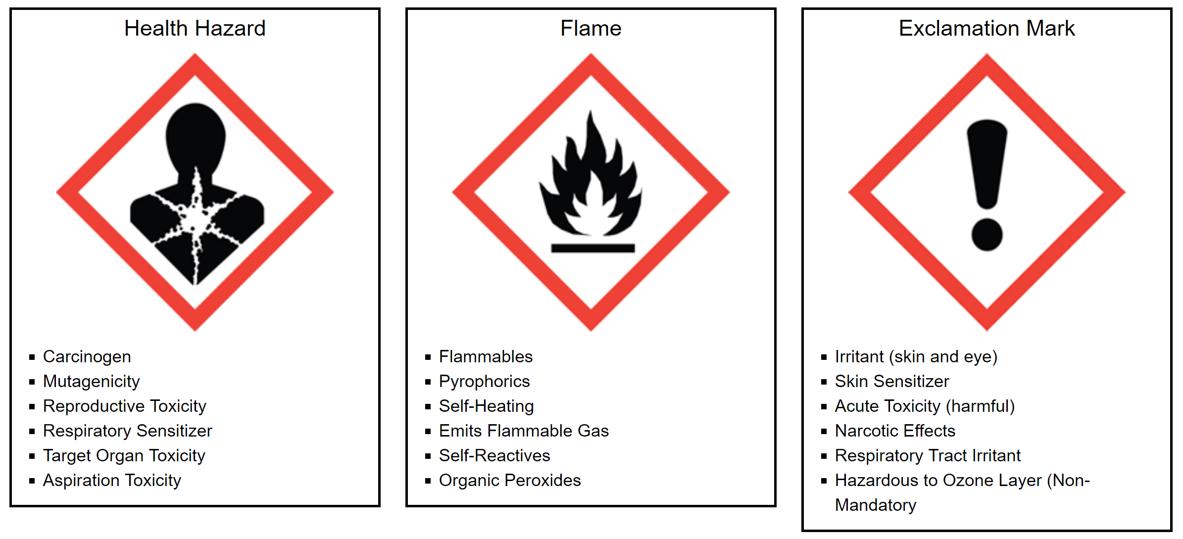

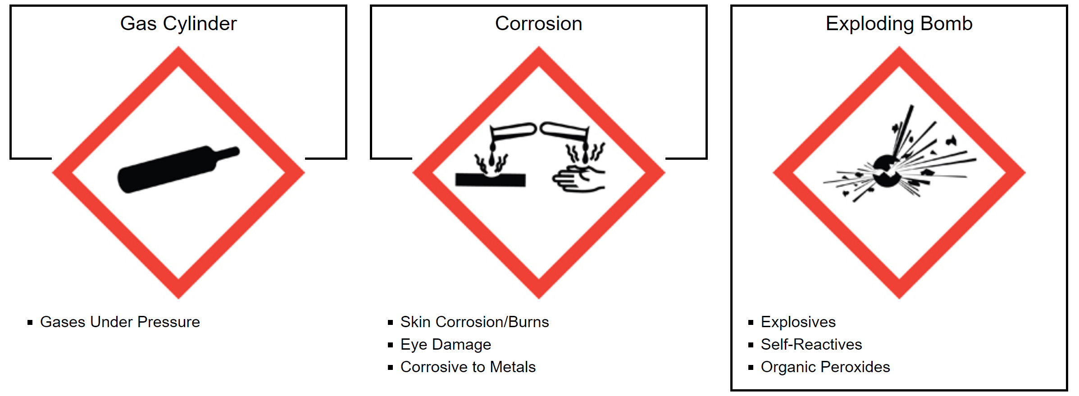
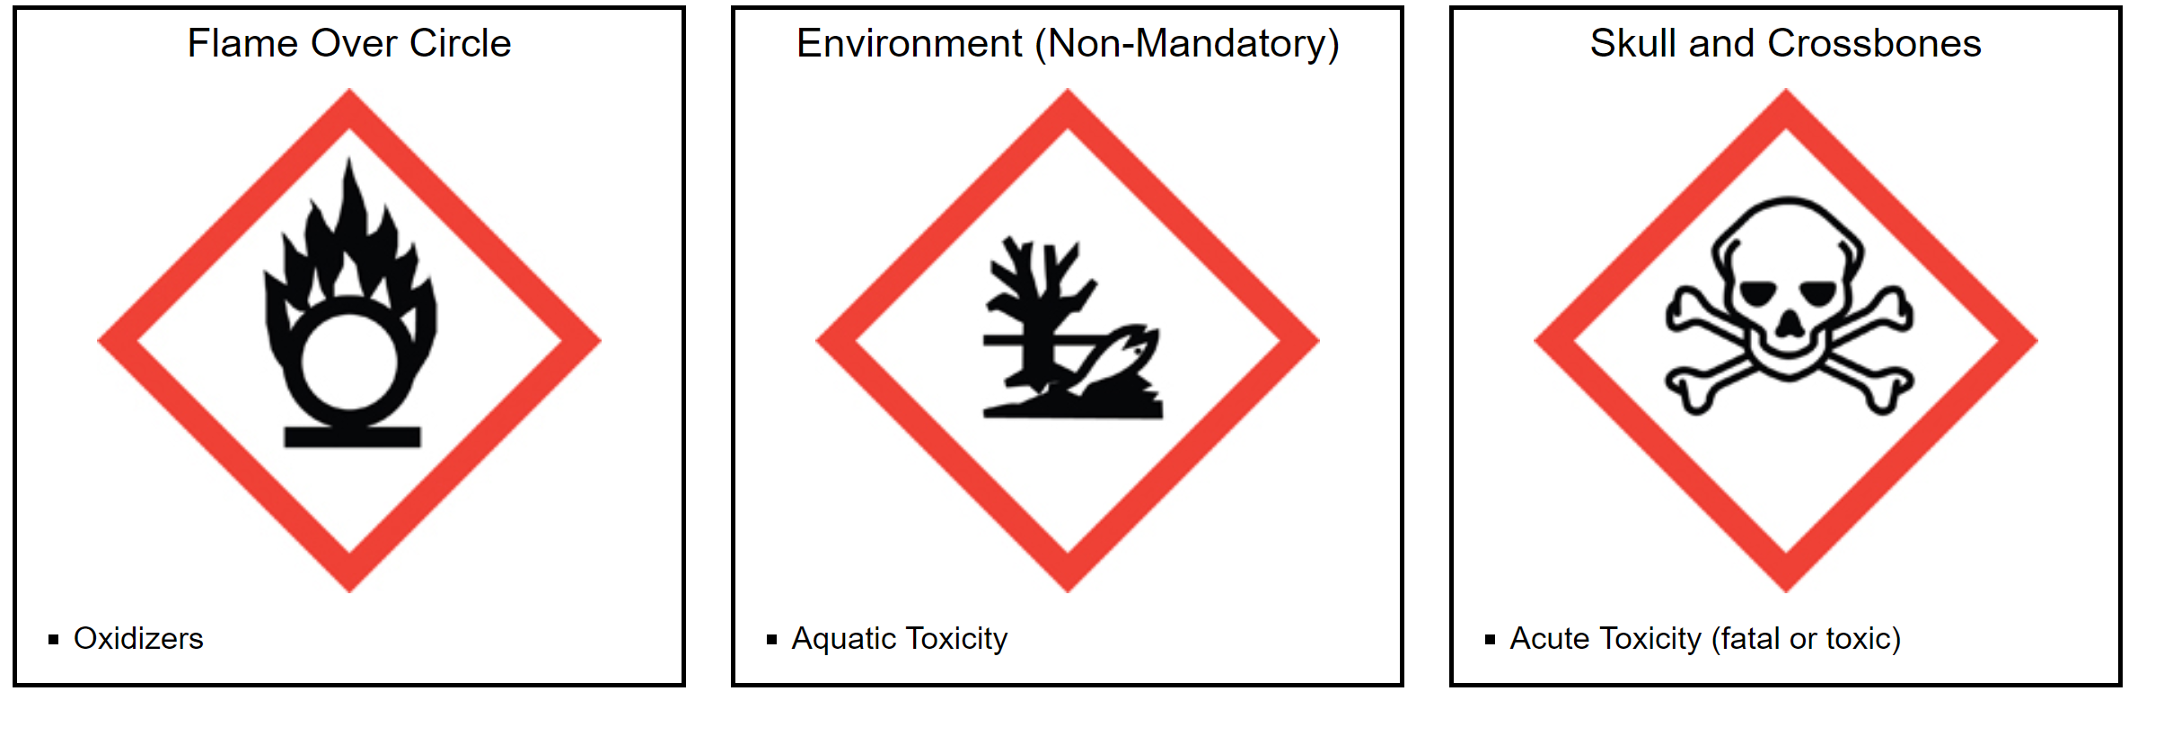

B.5 Chemical Disposal

All chemicals must be disposed of in a safe and environmentally friendly manner. Any chemical substance which is corrosive, flammable, reactive, toxic, radioactive, infectious, phytotoxic, mutagenic, or acutely hazardous must be treated as hazardous waste. Do not dispose of chemicals by evaporation in a fume hood or in the sink! Do not hesitate if any questions occur about the hazards of a material.

Collect and store chemical waste in containers which are clearly labeled. Do not combine containers unless the contents in each container are known, compatible, and it is safe to do so. Combined wastes are much more difficult and costly to dispose of properly.

Ordinary waste such as paper, cardboard, etc., may be placed in the wastebasket. However, contaminated waste must be disposed of separately in a labeled container.

Empty chemical containers must also be disposed of in an acceptable fashion. They must first be cleaned and then either returned to Chemical Stores or disposed through normal trash.

