2021 Chem-E-Car Spotlight Video Competition Instructions

Build excitement for your participation in the Annual Student Conference Chem-E-Car competition by submitting a quick intro video, profiling your team, your car and your participation in the competition. The focus of the video should be explaining the Chem-E-Car design and what makes your car unique.

This video will be posted to ChEnected, the AIChE student page, shown on the ChEnected YouTube Channel, tweeted, and shown on Facebook. The video will also be broadcasted during the 1 hour countdown at the Competition in Boston.

After all of the Chem-E-Car Team Videos are posted on YouTube, all teams will have the opportunity to cast their vote for the favorite video. Please note that each team cannot vote for themselves in the video competition. Also, to make sure we get all the votes in, if the team does not submit a vote, they will be ineligible to win the award.

Instructions:

- Video should be no longer than 60 seconds
- Video should be a quick, fun introduction to your car, your team and your school. What makes your car special? The focus of the video should be explaining the Chem-E-Car design and what makes your car unique.
- Video must show your school and car name
- Video must be uploaded on to your chapter’s YouTube channel and submitted on Box.com October 7th, 2021. The earlier the better so we can start featuring these online!
- Video should be submitted in an .mp4 YouTube-friendly format.
- Please email studentchapters@aiche.org if you need additional instructions uploading your video or are having issues uploading your video.

Pay Special Attention:

- Videos submitted must comply with YouTube copyright policies.
- DO NOT USE music or video purchased for your personal collection or taken from other videos online
- DO NOT USE photos grabbed from Google Images
- You can use music from creative commons provided you follow proper attributions. See 2nd page for instructions.

If you submit a video that does not follow what is outlined above, it cannot be used or considered for the competition.

Here are the Chem-E-Car Spotlight Videos from 2018 to give you an idea of what teams have done in the past:
https://www.aiche.org/chenected/series/chem-e-car-spotlight-series-2018-competitors
Instructions for Searching for Music on Creative Commons
- Go to http://search.creativecommons.org
- Rather than search a specific known artist’s name, it’s better to search a type of music like “surf music”, “lounge music”, “punk”, etc. and click on either Soundcloud or Jamendo.
- Within the actual video, they could link to the artist’s webpage and credit them in the video.
- Soundcloud doesn't have an option for "non-commercial use". With this being the case, I would opt for “To modify Commercially in the search”.
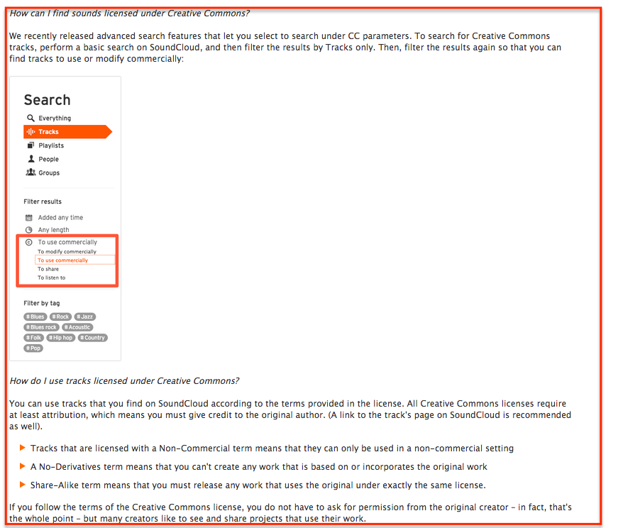
- Here is what the instructions say on Jamedo: