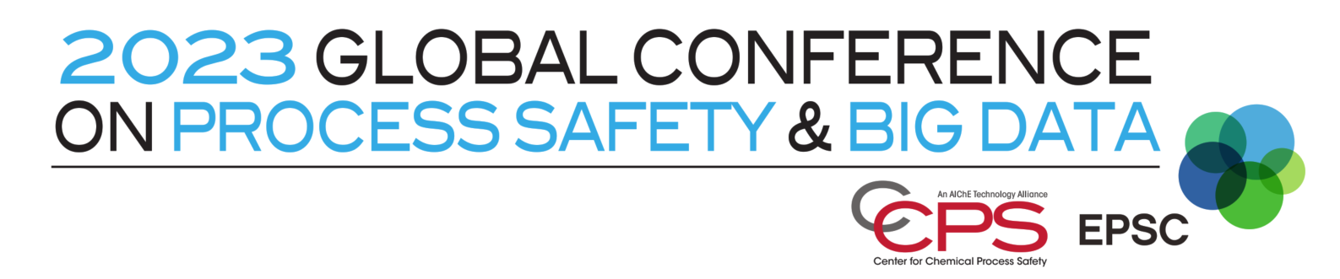

Conference on Process Safety and Big Data 2023, Abstract Submission form

Topic (choice your topic from Call for Abstracts/Papers)*:

Title*:

Authors and Affiliations*:

First Name | Last Name | Organization | Department | City | Country | Status (Submitting Author, Presenting Author and/or Co Author)

Authors of the abstract come from*:
University or Research Institution
Industry
Both University and Industry

Submit your abstract below (max. 400 words)*:

Type of presentation*:
Oral
Poster
No preference

You can add figures: (2 figures max)

Keywords: (choose 4 keywords)*:

Bibliograhy:
Reference 1:
Reference 2:
Reference 3:
Reference 4:

