 | Award Nomination Form  Herb Epstein Award for Technical Programming  George Lappin Program Committee Service Award  Award Qualifications Available at http://www.aiche.org/community/awards | 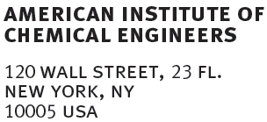
Nominee Background
Name of the Award: |  | Today’s Date:
Name of the Nominee:
Present Position: |  | Telephone No.:
Affiliation: |  | Email:

University Education
Institution: |  | Degree: |  | Year/Major:

Positions Held
Affiliation: |  | Position or Title: |  | Dates of Employment:

Technical Programming Contributions (including past AIChE awards)

Nominator Information
Name: |  | Telephone No.:
Affiliation: |  | Email:

Citation (no more than 50 carefully edited words that reflect specific achievements)
Please email the nomination form to programming@aiche.org.
Deadline: February 14th

