AIChE VIRTUAL LOCAL SECTION 2021 CANDIDATE STATEMENTS

This year, Virtual Local Section members are electing a Senior Vice Chair, a Vice Chair, a Treasurer, and three Directors. VLS members who are caught up on their dues are eligible to vote in the election. This year’s candidate statements are provided on the following pages. I hope that you acquaint yourself with these officers and directors and vote in the upcoming election, even though there is only one candidate for each position! The ballot will be sent to you via SurveyMonkey in October.

Note that six of the twelve members of the Virtual Local Section’s Executive Committee (shown on next page) are continuing their current terms. Let me know if you’re interested in getting involved in making the section thrive!

Dan Lambert, 2021 Immediate Past Chair and Chair of the Nominating Committee

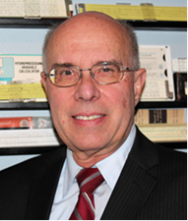
Steve Treese
2022 chair
2021 vice chair
2021 senior vice chair pro tem

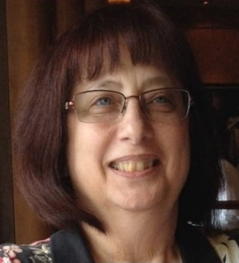
Laura Gimpelson, Secretary

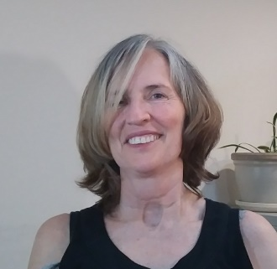
Kirsten Sinclair Rosselot
Director, Programming Co-Chair

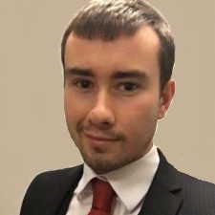
Scott Clarke, Director
Programming Co-Chair

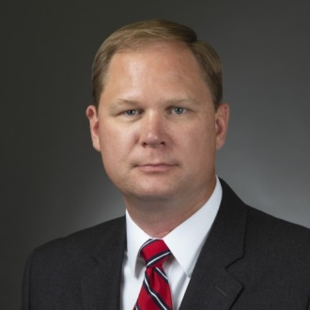
Paul Adamson, 2021 Chair
2020 vice chair

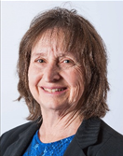
Jennifer Brand
Treasurer

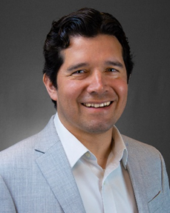
Mario Arredondo, Director
Newsletter Chair

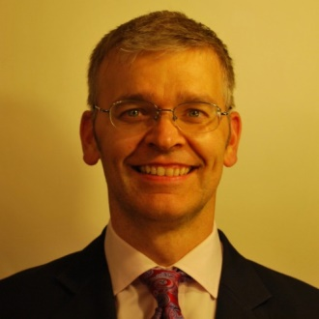
Paul Wissman, Director
Website/Social Media Chair
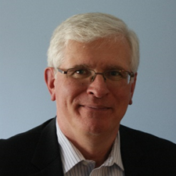
Aaron Sarafinas
2020 vice chair
2021 senior vice chair

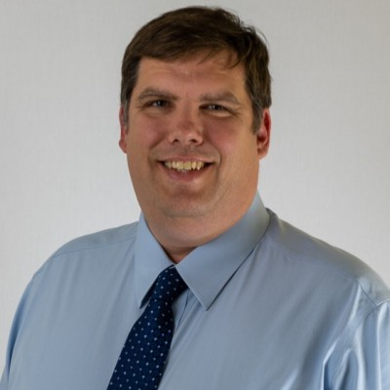
Rich Evans, Director
Member Feedback Chair

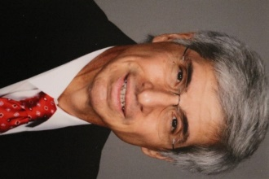
Fred Fischl, Director
Membership Chair

Dan Lambert, 2020 Chair
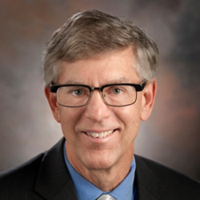
2021 Immediate Past Chair

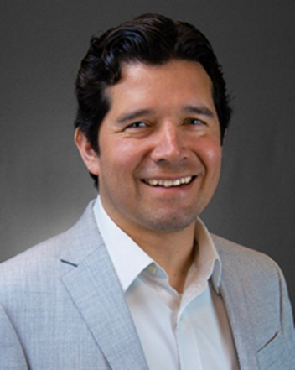
SENIOR VICE CHAIR CANDIDATE STATEMENT

Mario Arredondo
Mexico

Last year meant to the whole world a challenge to the Status Quo, pushing us to bring changes into our culture, customs, and behaviors. Looking back, the last 10 years many things changed: Data Analysis has been taking more and more ground, as well as automated systems that we use every day as chat bots, self-driving vehicles now are an everyday thing. Who could imagine that home office would be a reality? During last year humans have been challenged by an uncommon situation and the response back has been amazing. It is very uncertain to guess what would happen during the next 10 years, artificial intelligence? mars exploration? renewables?
Virtual Local Section began as an offer to use technology to include all the engineers beyond any social or geographical border into a single community, under the common objective of “No engineer left behind”. That ideal seemed too far to become a reality, today VLS has set a standard on what is possible through the collaboration and engagement of a community.
If elected to be senior vice chair of the Virtual Local Section, I will work on the following objectives:
- Improve section’s members interaction and participation using technological tools
- Promote the active integration of our Spanish speaking members
- Promote new and different interest topics for the community members
- Impulse the awareness of VLS and its events through social media
- Attend board meetings and contribute with management and program decisions
In addition to my Process Engineering duties I have been supporting the Kiewit’s Mexico Office start up through the Localization of company’s standards, coordinating, and integrating teams from Mexico and the United States in a single community, also, I have been supporting as a Subject Matter Expert some estimates to help the company to assimilate the industrial projects’ practices in Mexico. I have been an AIChE member since year 2006. I graduated as a Chemical Engineer at Instituto Politecnico Nacional’s Chemical Engineering School. I got an MBA degree from ITAM and had followed several training programs towards project management and Marketing. I began my career as a Process engineer in year 2000 before graduation and served in different companies. I had supported my project teams interpreting and defining a work philosophy of collaboration and interaction at all levels. I have experience in the upstream, midstream, downstream, and power projects. I had co-authored two papers promoting the use of transient simulations with new applications: “Performance testing data interpretation using Markov Chain Monte Carlo methods for Natural Gas Transmission Pipeline with Compressor Station” and “Simulation Based performance test of natural gas transmission pipeline with compressor station” both papers were presented with the Pipeline Simulation Interest Group (PSIG) annual meeting, also had contributed to the Gas Processing magazine.
Feel free to contact me if there is any new topic or new dynamics that could be implemented among the section at ma.ar.arce@gmail.com
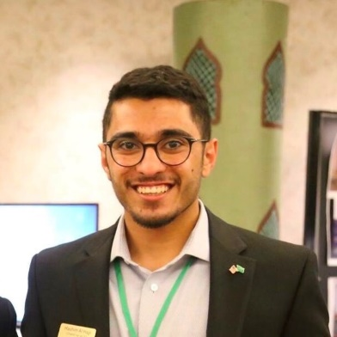
VICE CHAIR CANDIDATE STATEMENT

Hashim AlHajji
Kingdom of Saudi Arabia
I am running for the Vice Chair Position of the AIChE Virtual Local Section (VLS) executive committee. I am pleased to run for this position and serve the VLS as its structure fits perfectly with my current location. As an introduction, I am a chemical engineer who has served the AIChE since 2014 at different roles as a student during my university tenure. I graduated from the University of Colorado at Boulder (CU) with a B.S. in chemical engineering in 2017. Between 2014 and 2017 I served as a student chapter events coordinator as well as vice president. And, I was the workshops chair for the 2014/15 AIChE regional student conference for the
Rocky Mountains Region. Also, I was chair of international liaisons for the Executive Student Committee of the AIChE where, with the help of regional liaisons, I was looking after international student chapters excluding USA chapters. After graduation, I served in the AIChE Saudi Arabian Local Sections Young Professionals Committee (SAS-AIChE YPC) as a communication subcommittee member where I was the publisher for the newsletters and of the monthly technical knowledge exchange meetings' reports. In addition to that, in the SAS-AIChE YPC we have organized and ran several young professionals activities and co-organized conferences such as the ChemME section for youth development in the Middle Eastern Process Engineering Conference.
I currently work in Saudi Aramco in the field of digital transformation where we handle digitalization projects by integrating several technologies into an integrated system in order to achieve operational excellence goals. Previously, I was working in a refinery as a process operation engineer for 3 years where I was area responsible engineer for the Crude Distillation Unit, High Vacuum Distillation Unit, and Flare System Unit. During these times I came up with several energy optimization solutions, troubleshooted critical safety issues and prepared longterm plans for some of the persistent issues at those ares.
I look forward to joining the VLS executive committee and bringing several initiatives to the table. I intend to work on plans to increase the membership count by offering distant learning opportunities for members. And, continue supporting the quality monthly technical sessions by keeping up the level of presenters as well as engagement of the members from across the globe. Finally, I believe that I can make the Podcast initiative raised by the VLS leadership happen by organizing the sessions with the speakers and moderating it or inviting an executive committee member to moderate it, then, upload it to the different podcast platforms and market it for the general public.

SECRETARY CANDIDATE STATEMENT

Laura Gimpelson (currently serving as Secretary)
United States

Ms. Laura Gimpelson, P.E., is President of LG Environmental Engineering, a woman-owned engineering firm providing sustainable solutions to environmental compliance and remediation challenges. She has been part of the sustainability movement since college when it was called waste minimization, energy conservation and pollution prevention.

Currently, she is specializing in conducting site assessments, green remediation plans and regulatory compliance audits.

Laura received her Bachelor of Chemical Engineering degree from the Georgia Institute of Technology.

She is a life member and Fellow of AICHE and SWE. She is also a voting member of the ASTM Standard Revision Task Group for E-50 – Risk Assessment and Remediation. She has served as a member of the Winter Park Environmental Advisory Board and the Metropolitan Transit Authority of Houston Texas Small Business Advisory Board.

Ms. Gimpelson has been honored with the Distinguished Service Award from AICHE and SWE local sections and the Lifetime Achievement Award from the 2010 Central Florida Engineers Week Committee for her work in environmental engineering. In her long service to AIChE, she has been awarded two Gary Leach Awards: The first for creating the Plant Process Safety Symposium and the second for creating the Virtual Local Section.

Statement

The Section Secretary is the keeper of section files and history. This is especially important for a section that exists within the online community. I am running for reelection as Secretary to continue my efforts to record and maintain section records such as executive council meeting minutes, electronic voting results for matters that need a decision before the next executive council meeting and the section bylaws in a timely matter and further the goals of the Virtual Local Section.

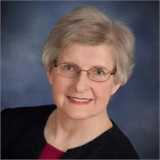
DIRECTOR CANDIDATE STATEMENT

Shannon Brown
United States

Bio
Shannon E. Brown, P.E., AIChE Life Member & Fellow, retired after 42 years working for a variety of E&C companies doing process design, precommissioning, commissioning, start-up, operator training, and validation. Industries she worked in include refining, petrochemicals, pharmaceutical, food, and nuclear power. She currently fills her time with local volunteer activities and the senior dog she adopted during the pandemic. She looks forward to serving the VLS as Director working in whichever area is most in need of assistance.
Ms. Brown is a member of the Virtual Local Section (VLS), Chicago Local Section, the Fuels and Petrochemicals Division, and the Climate Solutions Community. Her past service to AIChE includes 2016 Chair of the Career and Education Operating Council (CEOC), 2012 Local Sections’ Leadership Workshop Meeting Chair, Meeting Program Co-Chair for the 2011 AIChE Spring Meeting, and member of the committee that proposed creation of the Women’s Initiative Committee (WIC). During its early years, she served one term as Director of the Virtual Local Section (VLS). She has served the Chicago Local Section in many roles including Chair 1992-1993 and Director 1994-1997 & 2005-2006. She was involved in planning the Chicago Section Symposium (now Midwest Regional Conference) either as Co-Chair or Advisory Committee Member for over a decade. Shannon received her B.S ChE from Michigan State University, M.S. ChE from Northeastern University, and her M.B.A. from the University of Chicago

DIRECTOR CANDIDATE STATEMENT
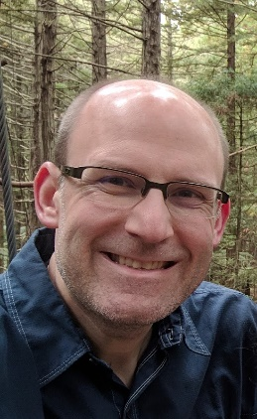
Andrew Riederer
United States

I am running for a Director position of the AIChE Virtual Local Section (VLS). I have been a member of AIChE since 1996, including serving as Treasurer and Vice President of the student chapter at the University of Notre Dame, from which I received my B.S. in Chemical Engineering. As a professional, I have lived in some areas with active local sections and enjoyed participating in those activities. I have also lived in areas without active local sections. The ability to participate in the VLS as a complement to local section activity or as a primary means of interaction with AIChE is a great asset for all of us, and one that I am eager to have the opportunity to help develop even further.
I have spent most of my career in the pharmaceutical industry. I am experienced in pharmaceutical product scale-up, transfer (development to operations, and site-to-site), process performance qualification, and lifecycle support. My recent roles have been in Quality Assurance, with a particular focus on Data Integrity for the last several years. I currently work for Boehringer Ingelheim in the US (Columbus, Ohio), having recently returned from an expatriate assignment in Greece. Participation in VLS monthly meetings was an important way to stay connected to the organization during my assignment, and one than sparked my interest in working more closely with the VLS.
If elected Director, I will be able to contribute towards further progress by participating on the Executive Committee and chairing one of the section’s standing committees. I want to promote the VLS as a valuable resource for us as chemical engineers, regardless of location, experience, profession, etc. I believe the VLS can play a vital role for us to be connected with AIChE as an organization, as well as to connect with our fellow engineers as peers, friends, and sources of information and inspiration. I look forward to the opportunity to work with the VLS and to serve our membership.

DIRECTOR CANDIDATE STATEMENT

Marc Clithero
Kazakhstan / Uzbekistan

I joined VLS as I am constantly overseas and the webinars are an interesting way of keeping up with what is going on outside my regular working field (Oil & Gas) and also a good way of meeting fellow members, its always good to see how many members are actually outside of the USA.

I am fortunate to be a member of the highly active AIChE VLS as I live outside of the USA and can’t join a local section. I know first-hand that VLS provides a valuable network for overseas (we’re never forgotten!) AIChE members. I feel that the VLS should continue its great efforts with all process / chemical engineers irrespective of location. If elected, I will contribute my best efforts on the Executive Committee with an insight from overseas to ensure the continued excellent contribution of VLS to overseas engineers.

Marc Clithero is an expert expat in process design / operational support of oil gas / refinery facilities across the Middle East and Kazakhstan / Uzbekistan region. He has 26 years’ experience and is chartered engineer, mostly outside the UK (where he’s from) and in countries he doesn’t speak the native language!

Meet Process Engineer Marc Clithero | AIChE

Thanks to Scott Clarke, Rich Evans, Aaron Sarafinas, and Dan Lambert for their support of the VLS. They will be leaving the executive committee and look forward to seeing them at our future VLS meetings.
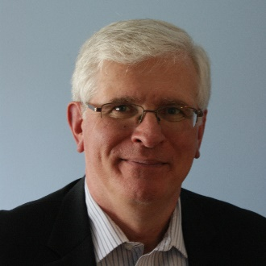

Aaron Sarafinas
2021 Senior Vice Chair

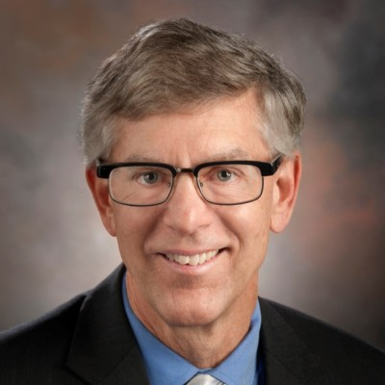
Dan Lambert, 2020 Chair
2021 Immediate Past Chair

Rich Evans, Director
Programming Co-Chair
Scott Clarke, Director
Programming Co-Chair

