

2022 UC Chemical Engineering

**Senior Design Exposition**

April 7, 2022, 5:00 pm - 7:00 pm

Mantei Center, Fourth Floor

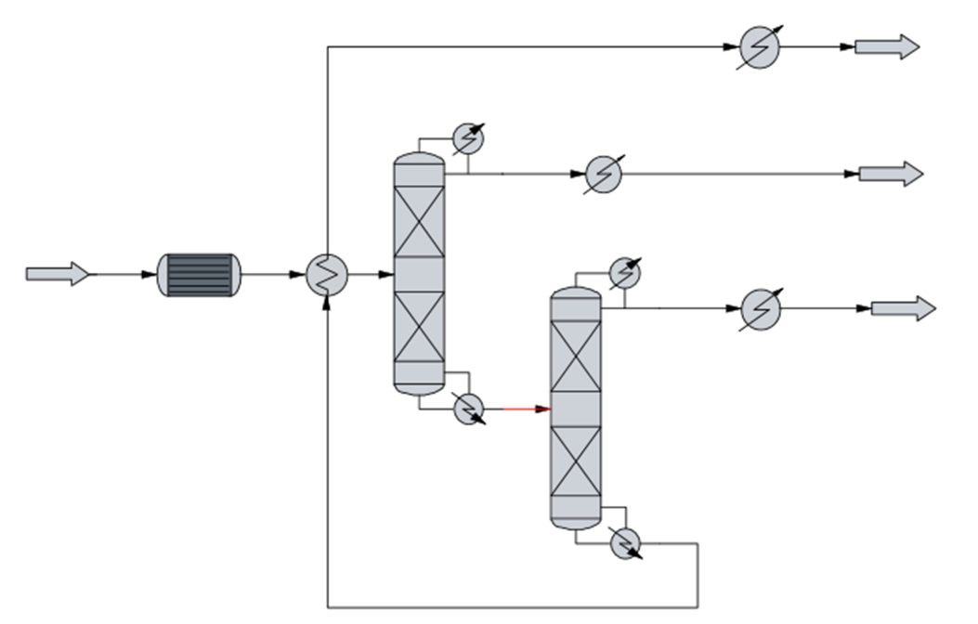

**Sponsored by:**

Department of Chemical and Environmental Engineering

American Institute of Chemical Engineers

Ohio Valley Section

For More Information, Contact [Stephen.Thiel@uc.edu](mailto:Stephen.Thiel@uc.edu)

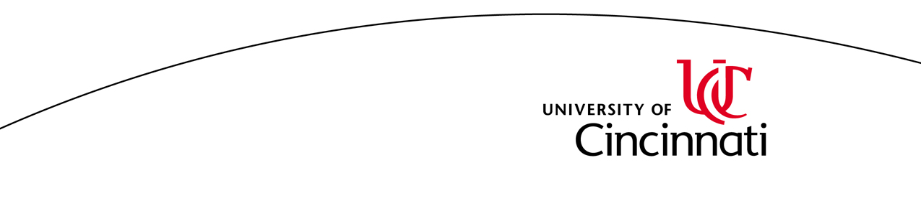

**2022 PROJECTS**

**Sustainable Fuels**

**2201: Separations Design for the Production of Synthetic Aromatic Kerosine (SAK), Bioform™ Diesel, and Bioform™ Gasoline From the Virent Process**, Mitchell Harris, Ryan Pearce, Nathaniel Noll, Michael Watson, Gage Kramer. *Proposed by Marathon Petroleum/Virent*

**2202: Carbon Capture and Biofuel Production Based on Algae Cultivation,** Hannah Campanelli, Jack Gardner, Alec Kasza, Hope Schaljo, Eric Thomas. *Student-Proposed Project.*

**2203: Renewable Diesel Formation,** Meaghan LaBarre, Oliver Struger, Vanessa Manrique, Caitlyn Cusick, Robert Marshall. *Student-Proposed Project.*

**2204: Conversion of Waste Organic Material Using Anaerobic Digestion to Produce Natural Gas to Convert into Residential Electricity,** Aaron Beglin, Marie-Claire Muxfeldt, Noah Rolfes, Trevor Simpson, Matthew Sodd. *Proposed by Prof. Smirniotis.*

**2205: Photocatalytic Conversion of Captured CO2 to Liquid Fuels,** Esteban Angel, John Carver, Nicholas Neville, Colin Slaboden, Isabella Vallone.

**2206: Converting Landfill Gas to Liquid Fuels using Fischer-Tropsch Synthesis,** Nicholas Hoffmann, Matthew Scowden, Waruna Wanigasekara, Alex Anderson, Jack Baltzersen.

**Use of Captured CO2 as a Feedstock**

**2207: Production of Ethanol from a Captured Carbon Source,** Mason Roman, Samuel Speece, Justin Clarke, Evan Lamb, Braeden Wittich. *Student-Proposed Project.*

**2208: Elecrochemical Conversion of Carbon Dioxide to Petrochemical Feedstocks Via Cationic Exchange Membrane Elecochemical Cell,** Ryan Connolly, Vivian Johnson, Adam Lewis, Mitchell Swisher, Khanh Tran. *Proposed by Prof. Wu.*

**Glycerol as a Feedstock**

**2209:** **Production of Liquid Fuels from Crude Glycerol,** Nigel Adams, Ngawang Dorjee, Joseph Fehrman, Nathaniel Hollingsworth, Vincent Prescenzi.

**2210: Conversion of Glycerol to Lactic Acid Using a Pt/ZnO Catalyst,** Sidney Sutton, Hallie Malsam, Tim Good, Vaughn Richter, and Maverick Dziadkowiec.

**2211: Process Design for Production of 1,2-Propanediol from Biodiesel Crude Glycerin Waste,** Hannah Todd, Samantha Kainec, Andrew Marsee, Evan Richards, Priya Modgil.

**2224: Production of Glycerol Carbonate via Glycerolysis of Urea,** Anthony Polizzi, Katherine Sullivan, Jordyn Strange, Ashay Shah.

**2226: Oxydehydration of Glycerol into Value-Added Compounds,** Nathan Hensel, Landon Nardi, Jacob Wallace, Caleb Witte. *Student-Proposed Project.*

**Green and Renewable Manufacturing**

**2213: Production Of Biodegradeable Poly (Lactic Acid) from Microalgae and Biowaste,** Jarod Rausch, Celine Schmitt, Pablo Lemus, Leah Fletcher, Chloe Siewe. *Student-Proposed Project.*

**2214: Renewable Hydrogen Production via Hybrid Sulfur Process,** Alex Ruiz, Takeshi Ito, Garrett Baumgardner, Justin Lai, Pongkhun Prommart. *Proposed by Dean Weidner.*

**2215: Green Ammonia Process,** Katherine Armour, Isabella Camberos, Connor Daly, Rachelle Kuebel, Katlyn Sanders.

**2216: Production of Green Methanol through Hydrolyzing CO2 with Hydrogen from Electrolysis,** Kevin Hamburger, Henry Diep, Robert Bach, Jamie Allen, Yen Cao.

**Waste Reclamation**

**2217: Recycling of Spent Lithium-Ion Batteries,** George Gates, Quynh Nguyen, Noah Padro, Nhat Phan, Tyler Price. *Student-Proposed Project.*

**2218: Enzymatic Recycling of Polyethylene Terephthalate,** Miread Brandes, Chelsea Ker, Margaret McCluskey, Amanda Sauls, Robert Newman. *Student-Proposed Project.*

**2219: Production of Biochar and Biodiesel from Spent Coffee Grounds,** Janani Arulmani, Kaeley Fagan, Jordan Foxworthy, Haley Marcum, Corinne Smith. *Proposed by Prof. Lu.*

**2220: Recycling of Wind Turbine Blades Using Pyrolysis Reactor,** Tien Dinh, Aaron Ha, Sarah Preisler, Anthony Rizzo, and Duong Tran.

**2221: Conversion of Phosphogypsum to Fertilizer,** Katie Henry, Kevin Johnson, Matthew McKenzie, Billy Martin, Evan Penrod.

**Other Topics**

**2222: Production of Glacial Acrylic Acid from Propylene,** Cathryn Caldwell, Lia Conlin, Tylor Eaton, Brandon Foley, Steven Pappenheimer. *Student-Proposed Project.*

**2223: Industrial Scale Up of Southern Sake Production,** Sarah Nwaobasi, Allison Kossen, Ore Odubola, Paige Myer, Uyen Vu. *Student-Proposed Project.*

**2225: Water Purification by Forward Osmosis,** Josh Cramer, Lauren David, Chad Furderer, Joshua Otten, Maggie Sullivan. *Proposed by Prof. Guliants and Prof. Thiel.*