Business Meeting: 6:30 p.m. – 7:15 p.m.

1. Call to Order and Welcome Kent Grove

A general introduction was made with an explanation the Christina was not attending this meeting as she was not feeling well. Embedded below is the sign in sheet for this meeting. Double click on the icon to open.



1. Review of last meeting’s minutes Christina Jackson

Kent Grove made a general update on the minutes from the February, 2016 meeting. The banking account for the local section has been switched over to Kent Grove and Mark Vaccari per requirements from AIChE national. The local section leadership is making some good progress on the administration issues to get the local section back in compliance with all the proper documents.

1. Financial Report Mark Vaccari

Mark Vaccari gives an overview of the financial status. The Tulsa LS has about $7000 in the account at the date of this meeting. The yearly treasury report has been prepared by Mark and submitted to the AIChE national per the requirements. Mark will make an application for reactivation of the nonprofit status around the end of June to the IRS which requires submission of all the non-completed tax returns for the years where the nonprofit status was lost. A tax account was recommended to help us with this process: Arron Tanner with Providence Consulting. Telephone #: 918-557-2769.

1. Current Activities Executive Team
   1. TU awards Mark Vaccari

The Tulsa LS leadership team did agree to sponsor two TU chemical engineering students with scholarships.

Ryan Decook, Outstanding Senior, $200 award

Jack Yungbluth, Outstanding Underclassmen, $150 award

* 1. Change in leadership Kent Grove

Kent Grove informs that Jeff Arnoldi who was vice chair has resigned his position for personal reasons. Christina Jackson will leave the position of LS secretary and take over the position of LS vice chair. The Tulsa local section is now in need of someone to take the responsibilities for the secretary position. The responsibilities of the positon per AIChE are as follows:

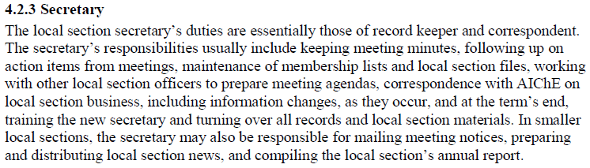

If you are interested in the positon and would like more information concerning the efforts required, please contact Christina Jackson. You can also contact any of the LS leadership if you are interested. The LS does need to fill this position.

* 1. AIChE Fellow nominations Christina Jackson

A general announcement was made concerning the national request to offer candidates for AIChE fellow. At this time, no candidates were offered.

* 1. Review of By Laws (??) Kent Grove

Kent Grove is in the process of taking the 1985 LS by laws and updating these to the new template.

1. Additional Topics Kent Grove

-Heather Holler gave great feedback concerning the Chemical Switch competition (spring of 2016) which our LS helped sponsor. The participation level was very high and all the teams came up with unique ideas to achieve the target. All agree that we should continue sponsoring this event in the future.

-A request was made to all members present to look for opportunities for companies to sponsor one of our local section meetings. Since the meeting an offer has been made by Rama Challa for Matrix PDM to sponsor the meeting preliminary planned for early October. Thanks to Rama and Matrix for this support. Other sponsors are appreciated for future meetings so all members please continue to investigate possibilities.

-David Korvick has done a great job getting our LS web page up and running. He will continue to be the focal point for this website. If you need content added, please contact David.

1. Moving Forward Kent Grove
   1. Next Meeting: Sept. 1, 2016

Jamie Hestekin, U. of A. (local TBD)

-Our local section wants to build a better relationship with the TU student chapter. We plan to work toward setting a joint meeting in the fall of 2016.

* 1. Adjourn

Fab Lab Tour: 7:15 p.m. – 8:30 p.m.

A fantastic tour! If you are interested in joining Fab Lab please go to their website at the following link: <http://fablabtulsa.org/>