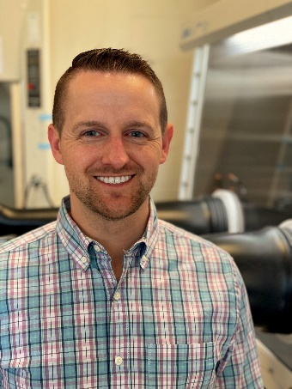
David P. Hickey
Asst. Prof. Department Chemical Engineering and Materials Science
Michigan State University
HickeyLab.org
Dr. David Hickey is an Assistant Professor in the Department of Chemical Engineering and Materials Science at Michigan State University. The Hickey Group is focused on the design of electroactive small molecules and polymer materials for a variety of applications related to energy storage, catalysis, and biosensing. Their research aims to elucidate electrochemical mechanisms and understand molecular interactions at electrode interfaces. These interfaces are vital for the development of next-generation technologies to address global problems ranging from large scale energy storage to the sequestration of greenhouse gases. Dr. Hickey received a PhD in Chemistry from the University of Oklahoma in 2014 under Daniel Glatzhofer and was a postdoctoral fellow with Shelley Minteer at the University of Utah. Prior to arriving at MSU in 2019, Dr. Hickey was a Research Assistant Professor at the University of Utah. Dr. Hickey has authored or coauthored more than 70 publications, 5 book chapters, and holds 2 patents. His research has been featured on the covers of the Journal of the American Chemical Society, ChemElectroChem, and the AIChE Journal, and it has been highlighted several times in Chemical Engineering Progress (CEP) and Chemical & Engineering News (C&EN) Magazines.

