Surface Tension
Mid-Michigan AIChE Section

Deboleena Chakraborty, Patrick Heider, Balamurali Sreedhar

Objective
In this 50-minute module, we introduce the concept of surface tension to students through three simple experiments: In the first experiment, students attempt to place as many drops of clean water as they can on a penny and learn that it is something called surface tension holding the blob of water together. In the second experiment, students use soap to weaken the surface tension of milk and observe the induced flow patterns traced by streaks of food coloring. In the third part, students apply the knowledge gained from the first two parts and repeat the first experiment using soapy water. Students will also practice aspects of the scientific method in this lesson.

Materials

For each student:
    - Clean penny - 1
    - 2-oz cup to hold water or soapy water - 1
    - Plastic pipette – 1
    - Cotton tip – 1
    - Petri dish – 1 (can use either the top or the bottom of the petri dish)
    - Post-it® notes (minimum one of each color per student: orange, green, pink, and blue.)
    - Pencil

For a group of students to share (packaged as a kit for quick distribution in class):
    - Access to faucet and sink in lab, or 8-oz cylindrical bottle of water with flip top pour spout – 1
    - 8-oz cylindrical bottle of milk with flip top pour spout – 1
    - Food dyes in small eye dropper bottles– one of each color: red, blue, yellow
    - Soap in a small eye dropper bottle – 1

For demonstration (Optional):
- Latex balloon

Procedure
Water on a Penny: “How Many Drops of Water Can We Put on a Penny?”
- Students will perform a simple experiment to find out how many drops of clean water they can put on a new penny before the blob of water breaks and spills. (Municipal tap water works well; distilled, deionized, or reverse osmosis filtered water may yield better results.)
- After describing the experiment but before letting the students do it, review the scientific method with them. Ask them what the first step is. If they respond with “define the problem”, accept this and recap that we want to find out how many drops of water can be placed on a penny.
- When they respond with “hypothesis”, ask them or remind them what a hypothesis is. Then ask them to predict the number of drops of water they will be able to put on the penny and encourage them to use an educated guess.
- How can the students come up with an educated guess? Ask for students to describe their reasoning, or prime them with models for thinking:
  - Draw a big circle for the penny, then estimate how many smaller drop-sized circles can fit inside. Is this a good way to make the prediction?
  - If they still need more priming, start talking about filling in gaps and putting drops on top of drops.
- Ask them to write their guess on the orange Post-it® note, then bring the students to the front of the classroom and place their stickers on the poster-sized graph paper to construct the bar graph. They have learned about bar graphs in math class, but “histograms” is not in their vocabulary. Do a quick review of what type of information is shown in a bar graph (“the number of times…”), then ask them to look at the bar graph and report on what they see. The students’ guesses will typically fall mostly in the < 30 range. See Figure 1.
- Let’s do the experiment and find out!
  - Have the students use pipettes to place drops of clean water onto a clean penny until the blob of water collapses and spills.
  - Don’t forget to count the number of drops!
  - Ask the students to sketch what they see as they add more drops of water. Don’t tell them what to draw but nudge them into paying attention to the size and shape of the blob of water. “Look at it from the side!” See Figure 2.
- When everyone is done, ask them to write down their count on the green Post-it® note, and bring the students to the front to construct the second bar graph (overlaid on the first one). See Figure 3.
- Compare the predictions and the results. What discrepancies do the students see? Which columns have the greatest counts? Are the numbers more spread out for the predictions or the results?
- Are the students surprised by the much higher counts they actually observed? (Most of the data points will be in the 30–60 range. We have been able to put nearly 70 drops on a penny, and some students had reached 80. What do they now think about the reasoning they used to come up with guesses?
- What about the sketches they made? How did the shape of the blob change as they added more water? Did anyone notice how water hangs over the edge of the penny near the end?

A Different Experiment to Visualize Surface Tension
- Reiterate that “surface tension” is the force that was holding together the blob of water on the penny. Recall the resemblance between the jiggling blob of water and a water-filled balloon. It looks as if there is an invisible skin wrapped around the blob of water on the penny.
- We can pop a balloon by piercing it, and we can break surface tension with soap.
- Instruct students to begin the milk demonstration.
  - Pour about 1.5 oz. of whole milk into a small Petri dish.
  - Carefully place one drop of each color of food coloring in the milk at the center of the Petri dish. See Figure 4.
  - Take a cotton swab and dab it with some liquid soap, then dip it into the center of the Petri dish.
  - Watch the surface tension break, causing the milk to flow. The food coloring will flow with the milk and create visually striking patterns. See Figure 5.
- Ask students to explain what is happening:
  - Use the popping of a balloon as an example. When the balloon is pierced, the rubber retracts away from the hole just as the surface of the milk did after it was touch with soap. Therefore, the soap broke the surface tension in the milk.
  - Have the students pretend that they are molecules at the surface of the milk, holding hands and tugging at each other using a force called “surface tension” and playing tug-of-war. When the surface tension is weakened, it is like the students letting go off their hands, and they fall away from each other. Have another student pretend to be a soap molecule and come in and pull apart students who were holding hands.
  - We do not talk about “surfactants” with grade 7 students in the limited class time that we have. Use the word “soap” instead. Do not use the words “hydrophobic(ity)”, “hydrophilic(ity)”, “oleophilic(ity)”, “oleophobic(ity)”, etc.
Soapy Water on a Penny: Revisiting the First Experiment
- Now tell the students that they will repeat the penny experiment but use soapy water this time. Ask the students to predict the number of drops of soapy water they can put on the penny before the soapy water spills.
- Ask the students to write their predictions on the pink Post-it® note and have them bring their stickers to the front to construct the third bar graph. See Figure 6.
- Discuss with the students why they think they can put more or fewer drops of soapy water on a penny compared with clean water?
- Repeat the first experiment with soapy water. Don’t forget to count the number of drops and observe the shape of the puddle of soapy water on the penny. See Figure 7.
- Write down their count on the blue Post-it® note and construct the final bar graph (overlaid with the third). See Figure 8.
- Ask students to describe what they see in the bar graphs. How well do their predictions agree with experimental results?
- Ask for observations of what they saw about the shape of the blob of soapy water. Why is the shape different?
- If time permits, engage with students on the importance of surface tension and its applications (water-repellant clothing, spray paint, the use of soap to clean greasy dishes, etc. Answer any question the students have.
- Clean up.
Figures:
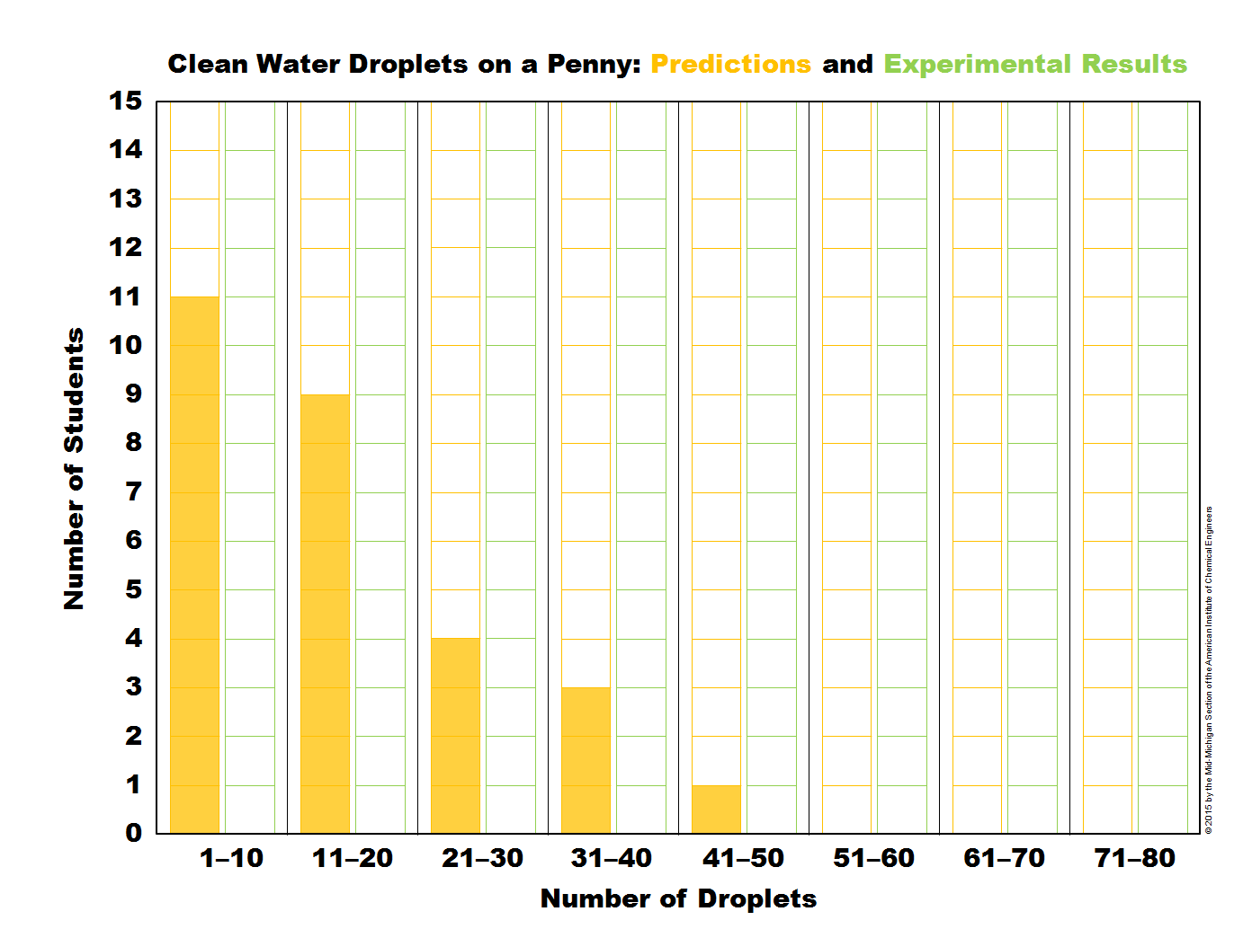 | 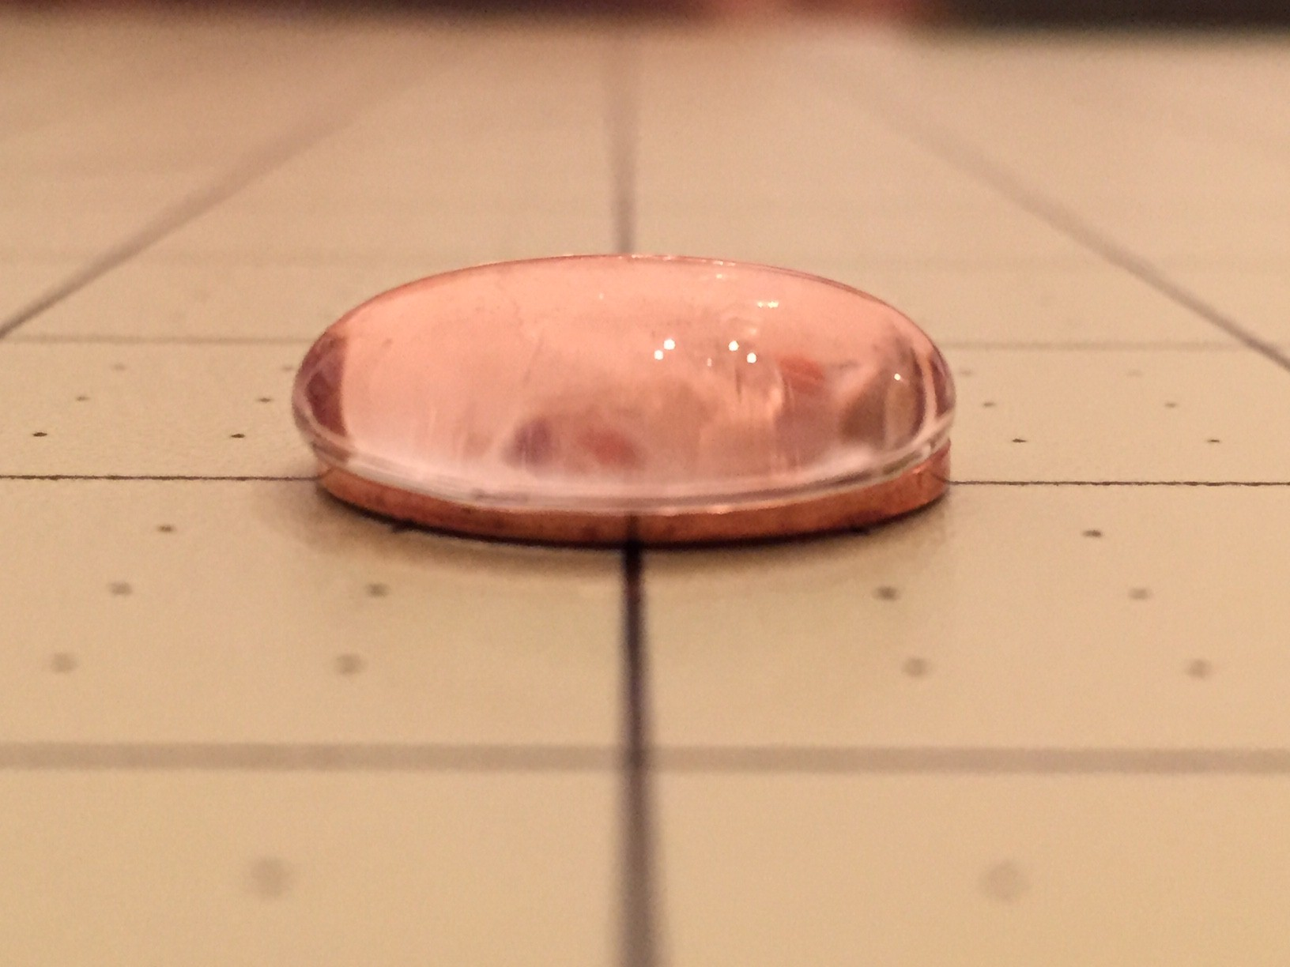 | 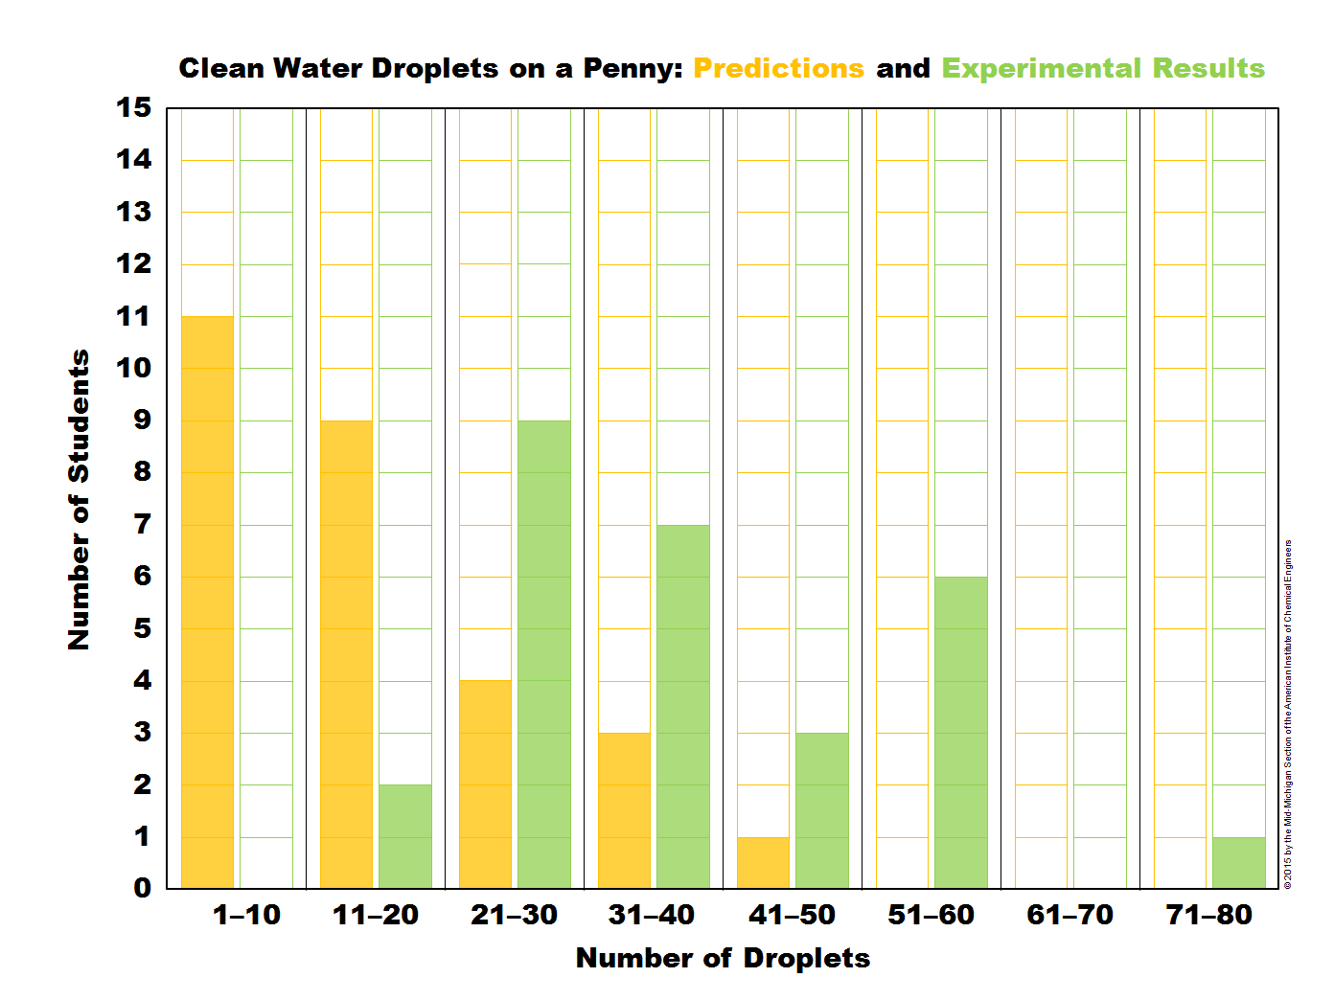
1. Bar graph of predicted number of drops of clean water on a penny. | 2. Blob of clean water on a penny. | 3. Bar graph of actual number of drops of clean water on a penny.

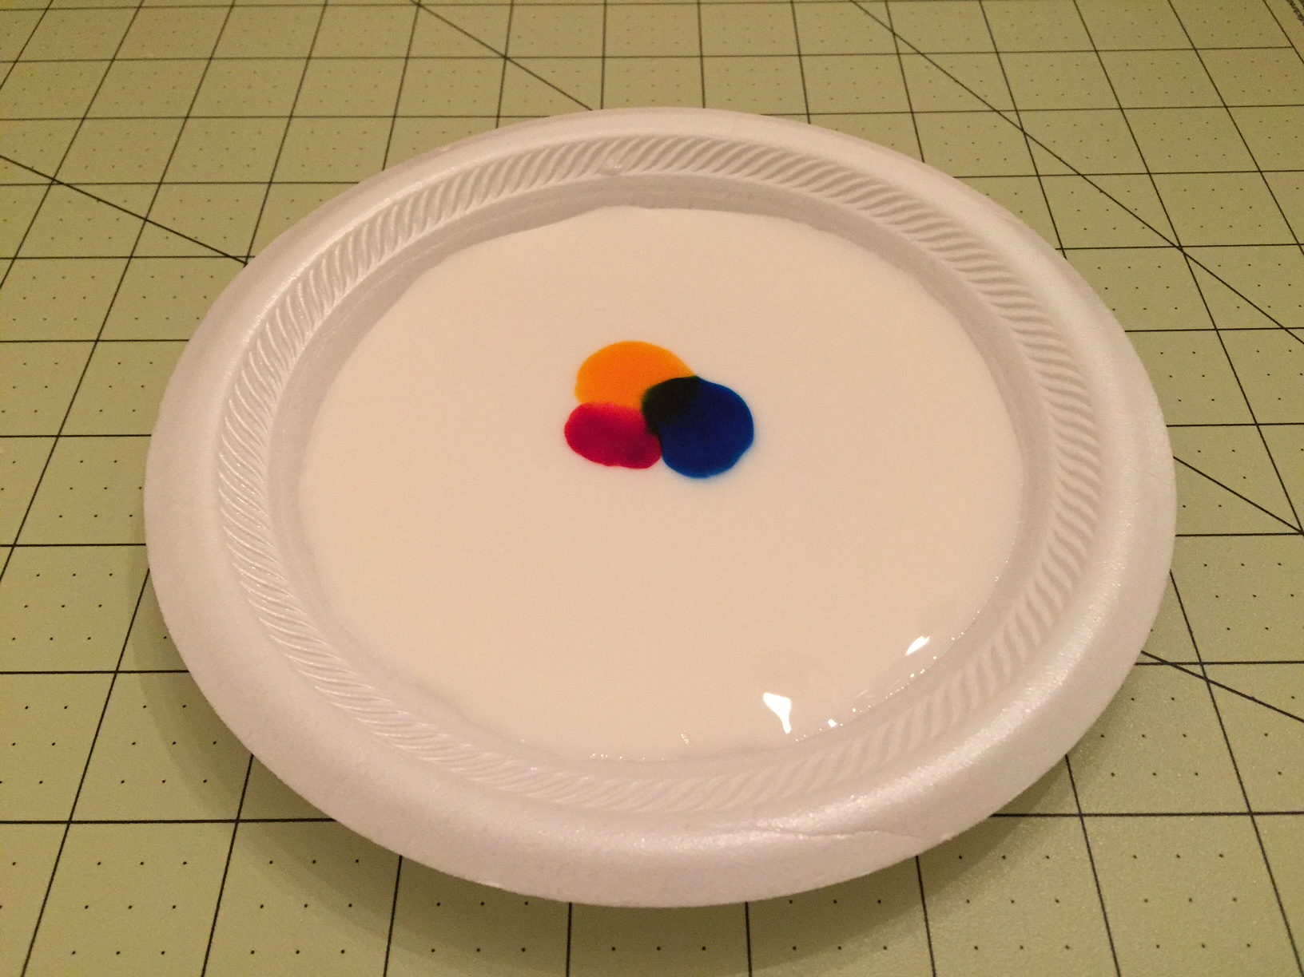 | 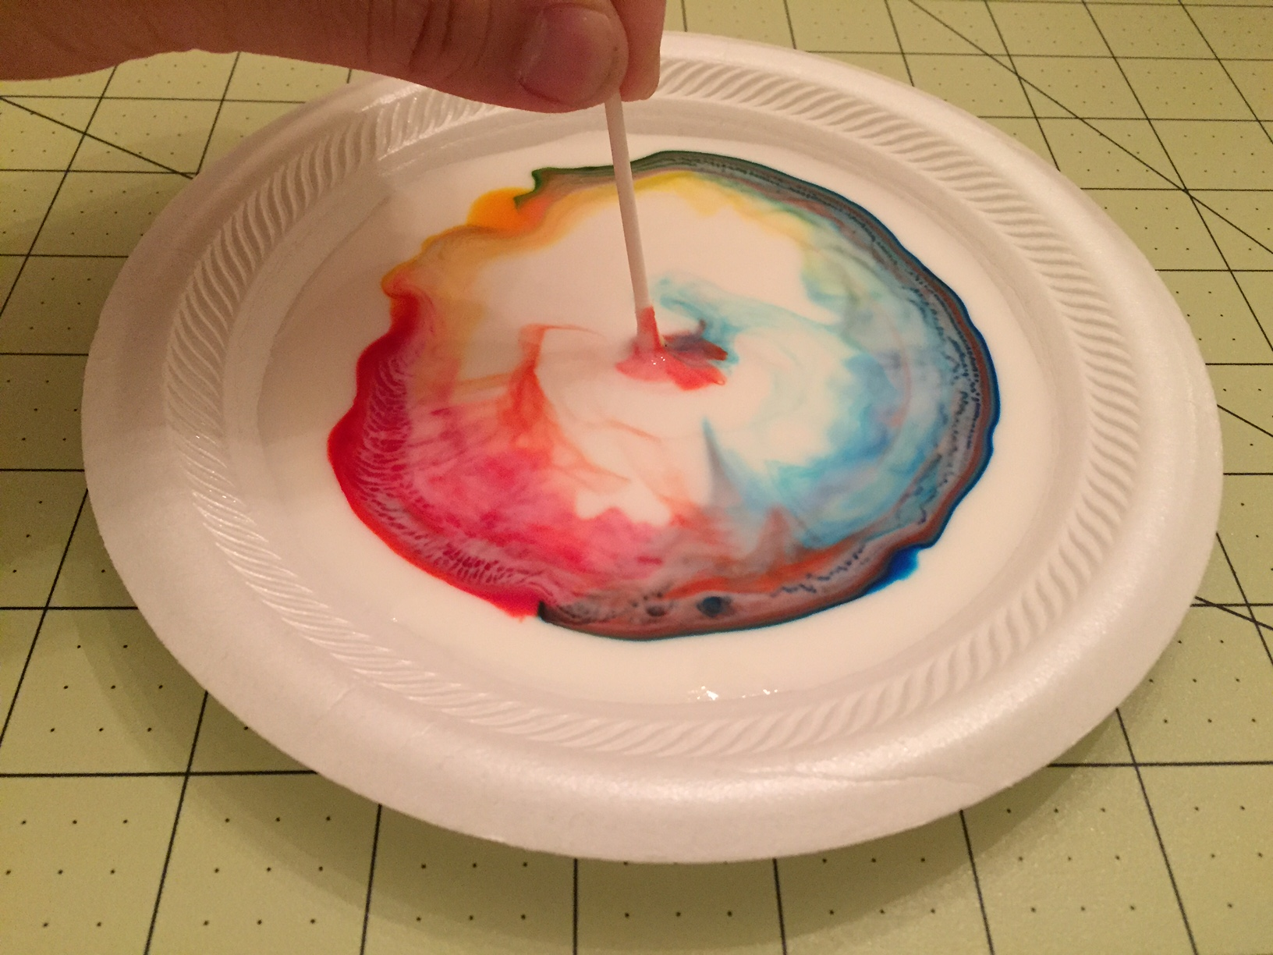
4. Drops of food coloring added to a plate of milk. | 5. Surface tension of milk broken by soap.

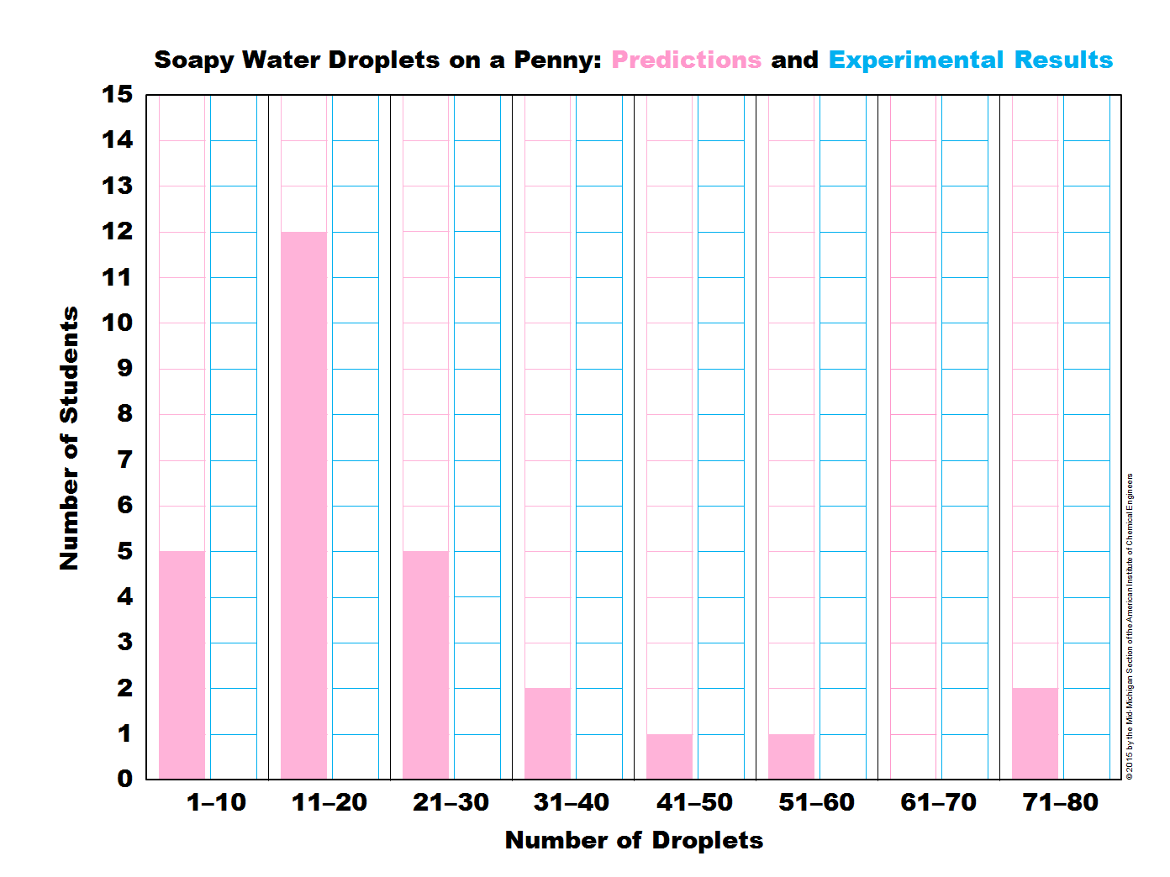 | 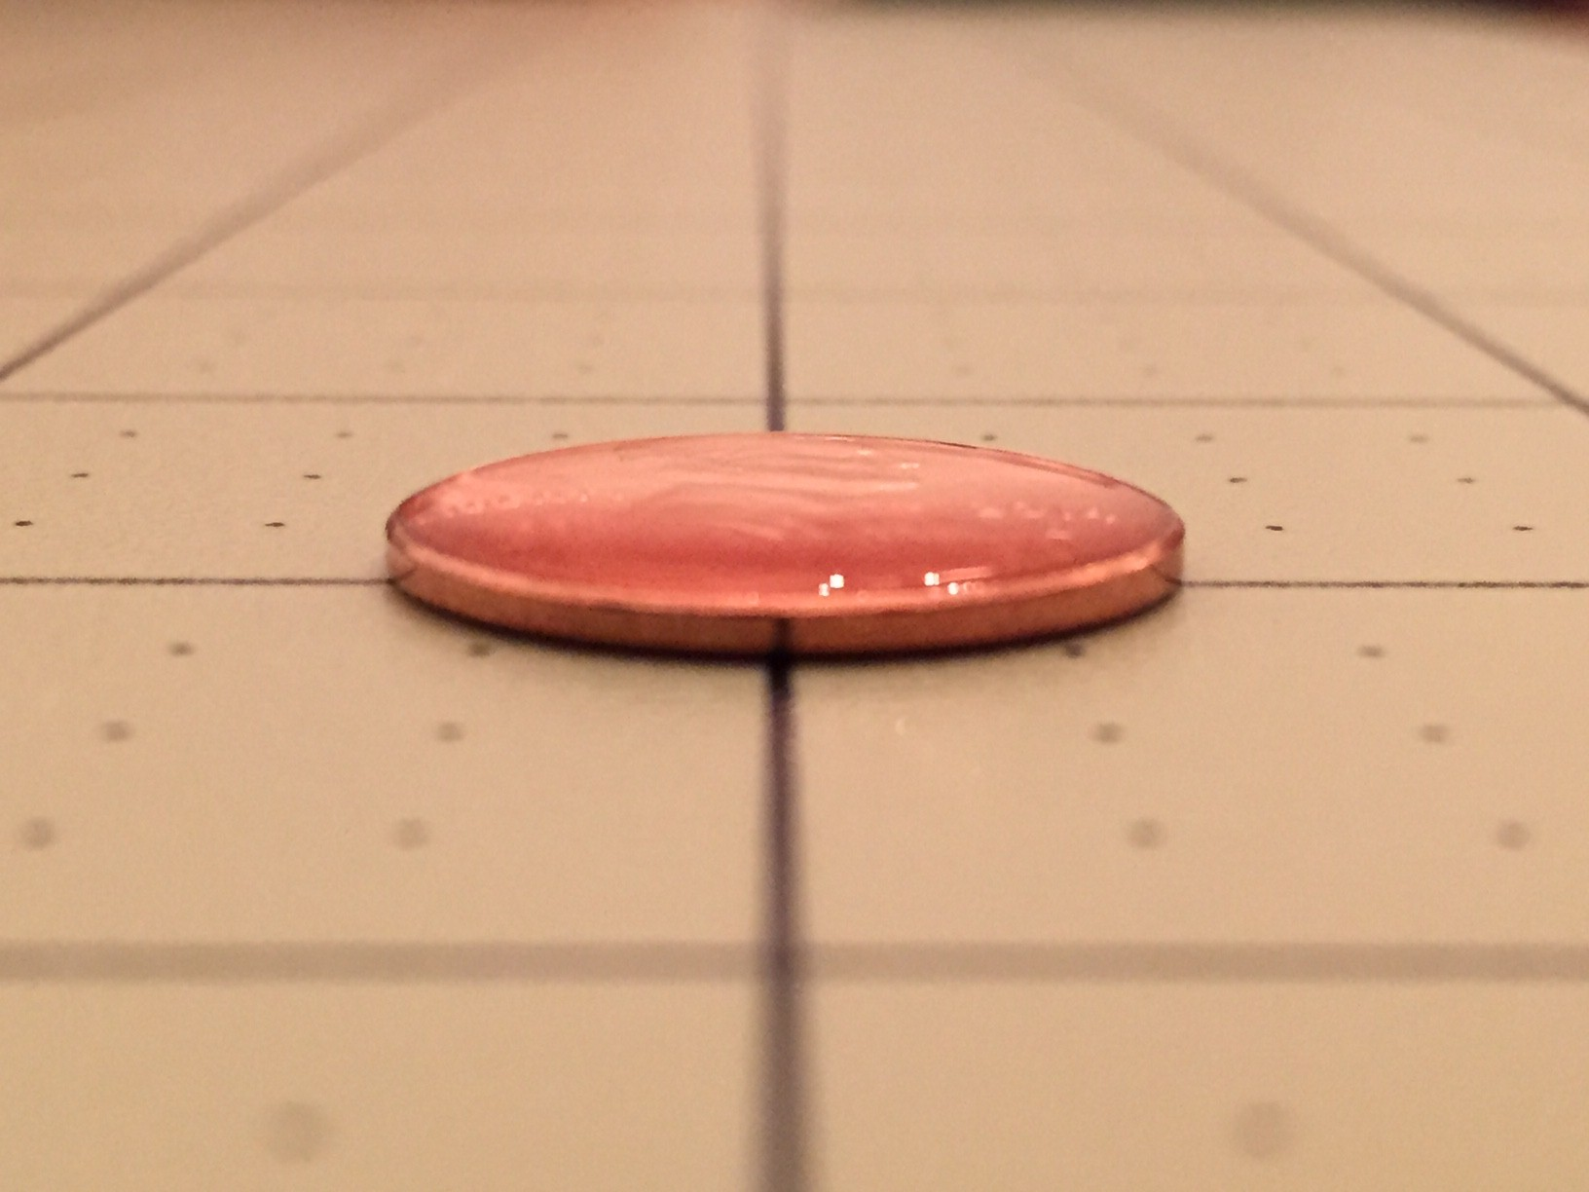 | 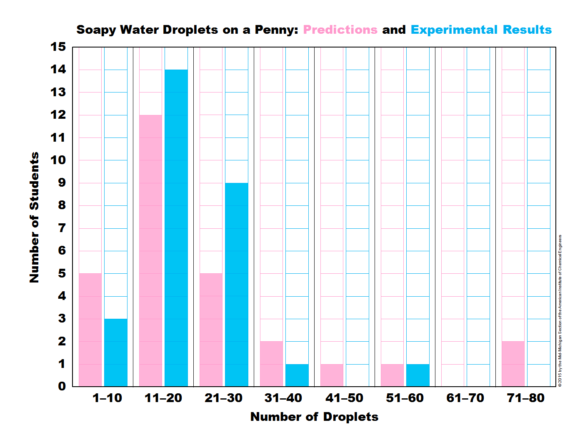
6. Bar graph of predicted number of drops of soapy water on a penny. | 7. Blob of soapy water on a penny. | 8. Bar graph of actual number of drops of soapy water on a penny.

Theory
Surface tension is a phenomenon in which the surface of the liquid acts as a thin elastic sheet. The cohesive forces between liquid molecules are responsible for this phenomenon: the molecules at the surface do not have other like molecules on all sides of them and consequently, they cohere more strongly to those directly associated with them on the surface. This forms a surface "film" which makes it more difficult to move an object through the surface than to move it when it is completely submerged. In this module, students can understand and visualize the concept of surface tension by creating and looking at the blob of water on a penny. Surface tension is the force that holds the blob together.
Surface tension exhibits in many aspects of life and changing surface tension for certain applications is a common challenge that engineers and scientists deal with. Surfactants in soap can be used to lower the surface tension of oil or water droplets and aid in the cleaning and drying of pots and pans. In the second experiment of this module, the soap at the tip of the cotton swab breaks the surface of milk and dyes when in contact. This can be visualized by seeing the colored dyes move away from the position where the tip touches the surface. In the third experiment of this module, the surface tension of water is weakened by the presence of soap in it, therefore, the blob created with soapy water on the penny is much smaller in size because the lowered surface tension cannot hold that many drops of water.

Histograms (sometimes called “bar graphs” in the middle school mathematics curriculum) is a graphical display of data using bars of different heights, making it easy to visualize trends and compare different sets of data at a glance. In this module, students learn to use bar graphs to collect data about the number of drops on a penny and compare their prediction with experimental results. The students are also asked to look at the distribution of the data and provide educated guess or explanation. The students can see how repeating experiments can give different answers and propose sources of error.

Scientific method is the process used in examining surface tension in this module. Students are posed with a problem: “How many drops of water can one fit on a penny”. They then construct a hypothesis or educated guess. They gather data and draw conclusions on how more drops fit on a penny than most predict. A new observation is made about how soap affects surface tension and the process is repeated taking in new information to inform the hypothesis for a new problem.

