**Mid-Michigan AlChE**

**Fundraiser**

A great cause

and some great food

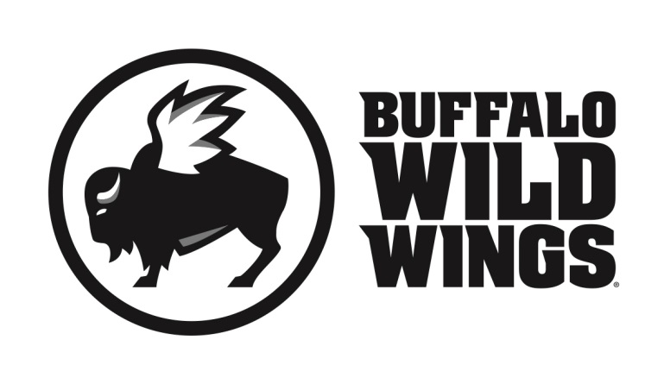

All friends, family and supporters of Mid-Michigan AlChE

are invited to participate in their fundraising event on

**Wednesday, April 19, 2017**

Everyone is invited to gather at Buffalo Wild Wings in Midland (6728 Eastman Ave.) for lunch, dinner, or a snack. On this day, 20% of purchases* accompanied by the certificate below will be donated to

**Mid-Michigan AlChE.**

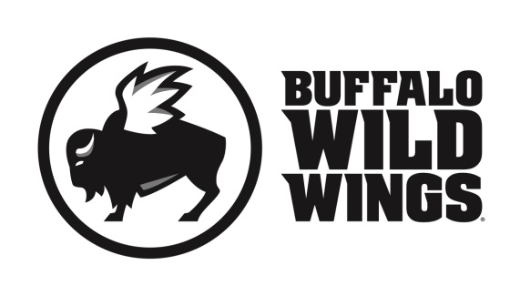**Mid-Michigan AlChE Fundraiser**

**Wednesday, April 19, 2017**

Present this certificate to your server at the

time of your order and 20% of your

purchases* will go to support

**Mid-Michigan AlChE.**

*Valid towards Dine-In and Carry-Out. Not valid towards gift card purchases. Flyers are not permitted to be distributed inside or outside the restaurant

**Only valid at 6728 Eastman Avenue, Midland, MI (989) 633-9464**