&

Presents

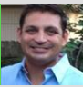

Brady Brown

Sr. EHS Specialist BASF Corp

Responsible Manufacturing

We don’t do it because we have to, We do it because it’s the right thing to do!
Hilton Americas Houston: 1600 Lamar St Houston, TX 77010
Light Refreshments will be served
APRIL 12, 2016 7PM CDT

MEET US IN HOUSTON
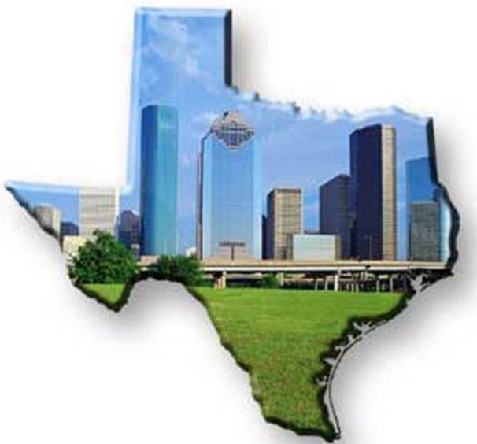
Too many times in today’s manufacturing, we read about companies having major process safety incidents because of inconsistent application of their administrative programs that guide their operations. Current and future leaders need to be aware of the long term consequences of these inconsistencies that work against their message and insure that their intentions of doing the right thing don’t get lost in the fray of everyday.
Can’t make it to Houston? Join us online! WebEx
Meeting Number 634 167 017
1-866-469-3239 Call-in toll-free number (US/Canada Global Call-in Numbers
VISIT THE VLS WEBSITE or TGCS WEBSITE FOR MORE INFORMATION

