K-12 Project
AICHE
Shaving Cream ARt
1) Theoretical framework

Through the understanding of hydrophobic and hydrophilic interactions (or polar vs non-polar depending on the age of the audience) this demonstration essentially screen print designs from shaving cream and food coloring onto a piece of paper.

2) General Objective
2.1) Demonstrate the difference between hydrophilic and hydrophobic.

3) Specific Objectives
3.1) Identify the hydrophilic substance
3.2) Identify the hydrophobic substance

4) Materials
a) Shaving cream
b) Paper plates
c) Rulers
d) Food coloring
e) Toothpicks
f) 3x5 notecards
optional: gloves (your hands will get messy)

5) Procedure

1. Spray shaving cream on paper plate and level out with a ruler. About 1cm thick of shaving cream is sufficient.
2. Pick as many colors as you would like and put a drop or two of food coloring spread across the plate.
3. Take a toothpick and swirl the food coloring into a fun design
4. Take a notecard and place it blank side down on the design, press gently to ensure the notecard is completely in contact with the shaving cream.
5. Pull the note card off the plate and scrape the shaving cream off so it only the design from the food coloring remaining.

6) Explanation

Definitions:
Hydrophobic: Breaking the word apart, “hydro” means water “phobia” is fear. Put it together, fear of water. In this context we would be looking at non-polar compounds, or compounds that won’t mix with water.
Hydrophilic: Similar as before “hydro” means water, “philic” means attracted to. These are substances that are attracted to water of polar compounds.

This transfer of the food coloring works because shaving cream is hydrophobic and paper is hydrophilic. When the food coloring (water based)) comes in contact with a hydrophobic substance they will not mix. Another explanation for this is water is polar and the shaving cream (hydrophilic) is non-polar, therefore they will not mix. When the food coloring is in contact with hydrophilic substances or other polar substances they will be attracted to each other. This is what allows the food coloring to easily be transferred from the shaving cream (the non-polar substance) to the paper (the polar substance).

Lessons Learned:
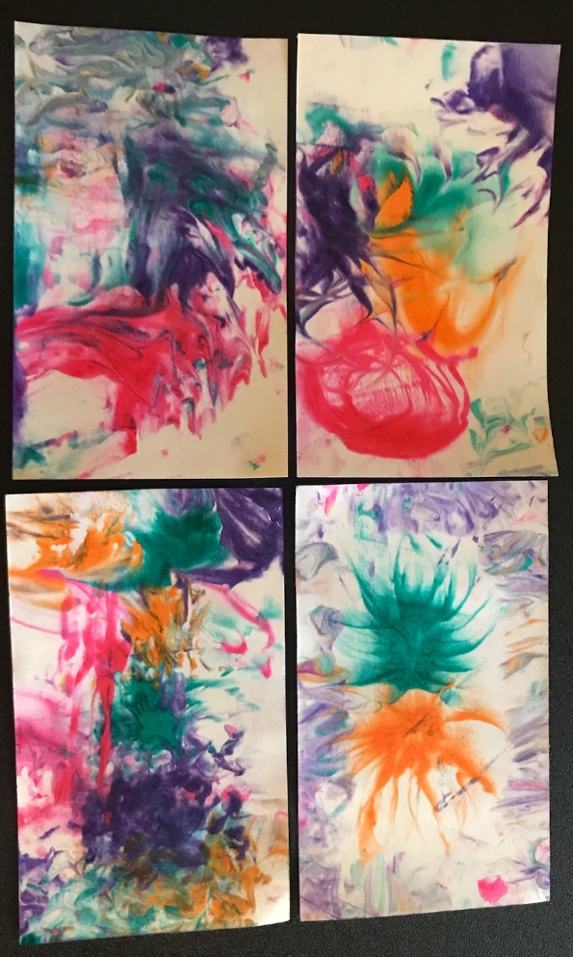
- If your audience is young hold the food coloring with them as they squeeze drops onto the shaving cream. Often times they do not understand how far one drop of food dye goes and they will squeeze half the bottle onto the shaving cream. Limiting the food coloring to 1-2 dots is the key to success.
- Encourage people to make designs as opposed to mix the colors together. Don’t forget the design on the shaving cream will be what shows up on the notecard.

