K-12 Project
AICHE
Dragon’s Breath
1) Theoretical framework

Combustion reactions are in our everyday lives from cars to grills most any age of audience will be able to relate to a combustion reaction. In this demonstration isopropyl alcohol serves as a fuel source. In a 5 gallon water jug isopropanol vapor is ignited to produce a loud whooshing sound and a flame that the audience can watch travel down the jug.

2) General Objective
2.1) Explain the fundamental concepts of a combustion reaction.

3) Specific Objectives
3.1) Demonstration of a combustion reaction
3.2) Demonstration of conservation of energy (chemical energy heat, sound, and light)
3.3) Explain the fire triangle (oxygen, heat, fuel)

4) Materials
a) 5 gallon water jug
b) Isopropyl Alcohol
c) Shrink wrap
d) Lighter (something with a long neck, like a grill lighter)
e) Proper PPE (safety glasses, face shield, thermal gloves, fire retardant lab coat)
f) Fire extinguisher

5) Procedure

1. Add approximately 200ml of isopropyl alcohol to the 5 gallon jug
2. Close the opening of the jug with shrink wrap
3. Shake/ swirl the jug so that the isopropyl alcohol coats the inside of the jug providing more surface area for the alcohol to vaporize and reach saturation (a good indicator you have swirled the bottle long enough is there will form a slight bubble in the shrink wrap).
4. Place jug on flat surface and make sure everyone is at a safe distance, minimum of 10 feet.
5. With proper PPE, remove the shrink wrap and ignite the vapor at the opening, then quickly step back.

6) Explanation

Isopropyl alcohol vaporizes quickly at room temperature, the vapor expands rapidly filling the closed jug. There should still be some liquid at the bottom, this means oxygen will be your limiting reactant and you will get combustion rather than an explosion. The alcohol fulfills the fuel portion of the fire triangle. The lighter is the heat portion and oxygen exists in the atmosphere as the oxidizer.
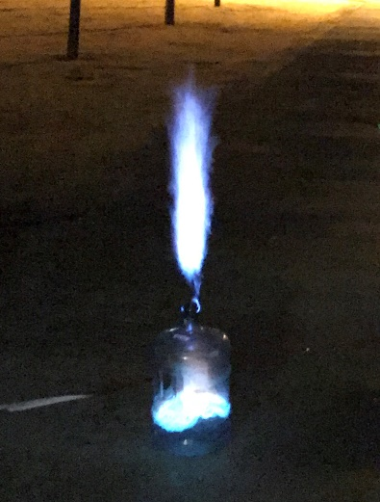
A combustion reaction takes place as follows:

C₃H₇OH(g) + O₂ (g) H₂O (g) + CO₂ (g) + CO (g)

The escaping gas creates a loud whooshing sound. This is because as the gas is heated in the confined volume the pressure increases. In order to maintain atmospheric pressure in the jug, the gas rapidly escapes through the top.

At the end you will be left with water in the bottom of the jug.

Tips for successful experiment:
- Before performing the demo again, keep in mind all the oxygen inside the jug was used. Leave the bottle sitting for ~1 hour in order to have oxygen inside the bottle for the second round. If you need to reuse the bottle immediately either ventilate it with a small fan or fill the jug with water then dump out.
- Trying to perform this reaction on a warm day (or simply leaving the jug with isopropyl alcohol in the sun for too long) will cause too much of the isopropyl alcohol to vaporize. The contents of the jug will most likely be above the upper flammability limit so the vapor will not light or will burn very slowly and ruin the effect of the demo.
- This demo is more interesting when it is dark as the flame is much more visible.

