**Please join us for boiled shrimp & catfish on Middendorf’s deck!**

**The Louisiana Section of the Air and Waste Management Association**

**will hold its May Dinner Meeting with AIChE New Orleans Section at:**



**Highway 51 at Pass Manchac (Exit 15 off I-55)**

**985-386-6666**

**Date: Thursday, May 18, 2017**

**Time: Social begins at 5:30; Dinner Served at 6:30**

**Reservations: You may now make your reservations and pay by credit card online.** [Click here](https://laawma.wufoo.com/forms/la-section-awma-july-2015-dinner/) **to register using this preferred method of payment. Reservations may also be made by faxing this form to (225) 213-1280 or calling Paige Huggins at (225) 987-7369.**

**In order to complete your registration, we must receive your full name, company, and credit card information. If you do not attend, your credit card will be charged for the number of people for whom you made a reservation. If you wish to use email to indicate your intent to attend the meeting, you are welcome to do so; however, please remember that your reservation will not be confirmed until your credit card information is received via telephone, fax, or mail.**

**Please note: The Section cannot accept email messages containing credit card information and any such messages received will be deleted immediately for your protection!**

*Name/Company_________________________________________________________________________*

*Email _______________________________________________________ Phone ( ____ )______________*

* ***Please check here if you would like a Vegetarian Entrée***

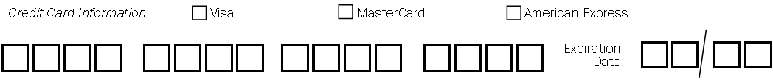

***Meeting Registration Fee:***

*$45 Members/Corporate Sponsor $50 Nonmembers $55 at the door $20 LDEQ/Students*