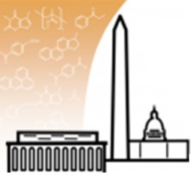
High-Temperature Nuclear Fission Reactor Systems
Seminar Location: CHE 2145, 4418 Stadium Drive, College Park, MD 20742-2111
Zoom Link

AIChE | National Capital Section
Hybrid Event: Apr. 28th (Thursday), 2022 at 7 pm EST
The AIChE National Capital Section (NCS) is excited to host Dr. Steven A Arndt, a Distinguished R&D Staff Member at the Oak Ridge National Laboratory, and he will be speaking at a special dinner time event at 7 pm EST on Apr. 28th, Thursday. Enjoy your dinner (or snack) while listening to Dr. Arndt’s talk on his journey and discuss it with the audience!
REGISTER: https://www.eventbrite.com/e/high-temperature-nuclear-fission-reactor-systems-tickets-308878432707 This event is free to attend! Please register through the Eventbrite link.
EVENT AGENDA (Time in EST):
- 7:00 pm – AIChE NCS Announcements
- 7:10 pm – Presentation by the Speaker
- 8:00 pm – Question & Answer Session
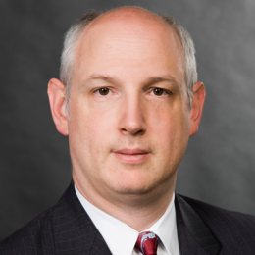
Abstract:
Dr. Arndt currently serves as a Distinguished R&D staff member at the Oak Ridge National Laboratory where his research involves advanced reactor design readiness. Previously he spent 31 years as a senior scientist with the NRC, leading a number of key research efforts and providing authoritative advice to NRC management and staff in the areas of digital instrumentation and control, software reliability, emergency response, cyber security, and numerous other technical areas, for which he was awarded the NRC Distinguished Service Award. Prior to his work at the NRC, Dr. Arndt was a Professor at the U.S. Naval Academy. Additionally, Dr. Arndt serves as an Adjunct Professor of Nuclear Engineering at the University of Tennessee. In 2012 Dr. Arndt was named the Federal Engineer of the Year by the National Society of Professional Engineers, the first nuclear engineer to ever be awarded this honor. In 2020 Dr. Arndt was awarded the “NSPE Award” the highest honor given specifically to a professional engineer.
In his 40 years in the nuclear industry, Dr. Arndt has worked as a researcher, educator, consultant, and regulator, including extensive experience in Russia and Ukraine. He leads the United States’ support programs to the states of the former Soviet Union following the Chernobyl accident and as part of the Nuclear Regulatory Commission’s response to the Fukushima accident.
BIOGRAPHY: Dr. Arndt holds a B.S. in engineering physics and a M.S. and Ph.D. in nuclear engineering all from The Ohio State University, where he was honored by the faculty of the College of Engineering in 2004 as a Distinguished Alumnus. Dr. Arndt also holds a M.S. in reliability engineering from the University of Maryland. Dr. Arndt is a Fellow of the American Society of Mechanical Engineers (ASME), the American Nuclear Society (ANS), the Association for the Advancement of Science (AAAS), the American Society for Quality (ASQ) and the National Society of Professional Engineers (NSPE). Dr. Arndt is a registered professional engineer and was appointed by the Governor of Maryland in 2006 to the Maryland Board for Professional Engineers, where he served for fifteen years (three years as Chairman).
NCS LinkedIn: https://www.linkedin.com/groups/8952605/
NCS Webpage: https://www.aiche.org/community/sites/local-sections/national-capital

