Meet other Young Professionals at Lucky’s Pub! Drinks! Appetizers!
These are all great reasons to register for the Young Professionals Speed Networking Social during the 2012 AIChE Spring Meeting in Houston. Young Professionals will mingle and meet other YPs as well as division and forum representatives at Lucky’s Pub in Houston. Lucky’s Pub is just blocks away from the conference center!
2012 Young Professionals (YP) Speed Networking Social
Tuesday, April 3, 2012
6:30 - 10:30 PM
Lucky’s Pub
801 St. Emanuel
Houston, TX 77003

Registration Fee: $5 on AIChE Conference Registration
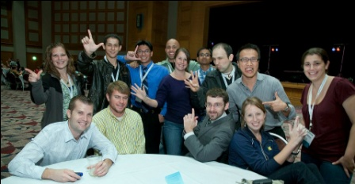

Sponsored by: AIChE YPC, AIChE South Texas Section, Environmental Division, Fuels & Petrochemicals Division, Management Division, Separations Division, Chemical Engineering and the Law, Sustainable Energy Forum, Transport and Energy Process Division

